**Senior Design Research Document**

Senior Design I

EEL 4914

**Smart Table**

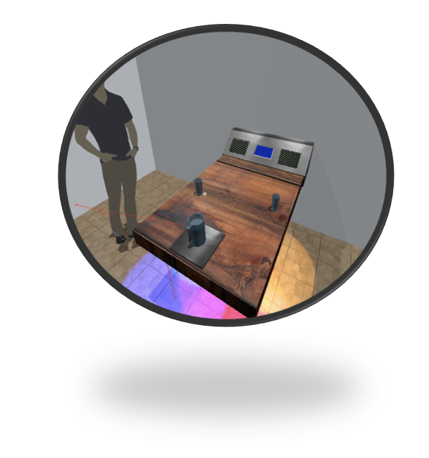

**Group 16**

Theodore Cox

Christopher Corley

Dhaval Desai

Mikey Garrity

**Table of Contents**

Contents

1.0 Executive Summary 5

2.0 Project Description 5

2.1 Motivation 5

2.2 Proposed Solution & Objectives: 6

2.2 Requirements Specifications 8

2.3 Major Roles and Subsystems 9

2.4 Top Level System Diagram 10

2.5 House Of Quality 15

3.0 General Research 16

3.1 Market Research 16

3.2 Principles of Ergonomic Design 19

3.3 MCU Hardware Research 21

4.0 Research MY BALLZ 25

4.1 Signal Lighting Research 25

4.5 Human Perception 29

4.3 Communicating with WS2812B LED Strip 31

4.4 Diffusing Light 33

5.0 Functionality II Information Display 34

5.1 Information Display Viewing Angle Analysis 34

5.2 TFT LCDs 35

5.3 OLED Displays 36

5.4 LED Matrix Displays 37

5.5 LCD 7-Segment Character Displays 38

5.6 Comparing Components and Final Display Selection 39

5.7 Smraza 2004 LCD Display Module 40

5.8 Touch Sensor FUCKED UP!!! 42

6.0 Functionality III - Smart Beverage Detection 46

7.0 Functionality IV Waiter Tracker 49

7.1 WiFi Protocol 50

7.2 Bluetooth Protocol 51

7.3 RFID Protocol 52

7.4 Comparing Components and Final Selection 53

*8.0 Functionality V - Motion and Light Detection 54

9.0 Functionality VI - Structure and Materials Research 62

9.1 Materials Types 62

9.2 Wood 62

9.3 Metal 63

9.4 Glass 64

9.5 Final Material Selection 64

9.6 Wood Finishing and Construction Practices 65

9.7 Sanitation Standards 65

10.0 Functionality VII - Power Considerations: 67

11.0 Functionality VIII - Misc / Creature Comforts: 69

12.0 Command Center 76

13.0 Hardware Design 77

13.1 Signal Lighting Design: 78

13.2 Information Display Design (include cap buttons) 80

13.3 Smart beverage detection 82

13.4 Waiter Tracker Design 83

13.5 Motion / Ambient Light Detection Design 84

13.6 Sound Buzzer Design 84

13.7 Programmer Design 85

13.8 Power Design 85

13.9 Main Overview 87

13.10 PCB Suppliers / Part Suppliers: 89

13.12 Bill of Materials 90

14.0 Software Design 93

14.1 MCU Software Design: 93

14.2 Mobile Application Design 96

14.3 Application User Interface 96

14.4 Backend Mobile Application Development 98

14.5 Signal LED Logic: 101

15.0 Construction Design 103

15.1 Smart Table Hub Dimensions 104

15.2 Smart Table Waterproofing, Sealing, and Ventilation 106

15.3 Modularity, ease of replacement, access, and repairs 106

15.4 Aesthetic Decisions: 108

16.0 Realistic Design Constraints 110

16.1 Economics and Time Constraints 110

16.2 Safety, Ethics, and Social 112

16.3 Manufacturability, Sustainability, Portability, and Ease of Assembly 113

16.4 Facilities and Equipment 114

17.0 Standards 115

17.1 General Safety Standards 115

17.2 Component Standards 116

18.0 Prototyping and Testing 118

18.1 Signal Lighting Test Plan: 118

18.2 Signal Lighting Initial Test Results 119

18.3 Motion and Light Detection Test Plan: 120

18.4 Motion and Light Detection Test Results 121

18.5 Information Display Test Plan: 122

18.6 Information Display Initial Test Results 123

18.7 Smart Beverage Detection Test Plan 124

18.8 Waiter Tracker Test Plan: 125

18.9 Waiter Tracker Initial Test Results 126

18.10 Overall System Test 127

19.0 Product Operation 128

19.1 Safety Precautions 128

19.2 Using the Smart Table 128

19.3 Troubleshooting Tips 129

20.0 Administrative Content 131

20.1 Finances and Budget 131

20.2 Milestones 134

20.3 Personnel Overview 135

21.0 Project Summary and Conclusion 135

22.0 Appendices 136

23 References 136

24 Copyright Permission 137

# 1.0 Executive Summary

# 2.0 Project Description

The project description section below will give a top-level overview of the smart table project as a whole. This will include the motivations, proposed solution, objectives, requirements, top level system diagram, and the house of quality. The sections will outline the project from a high-level point of view and grant insight to the project as a whole. First the motivation for the smart table project will be discussed in the section below.

## 2.1 Motivation

Waiting tables is not a trivial skill. Servers only have a split second to look across a restaurant to determine if a table needs attention. Timing and multitasking is essential. Simply put, a waiter bussing an arm load of dirty plates is going to find it difficult to juggle refilling a patron’s water. All group members have experience with customer service, and quite frankly the cognitive load of waiting tables can be to high even for four engineers. In an ideal world a waiter would always know which tables need service so they can plan their trips in and out of the kitchen efficiently.

On the flip-side, customers can become frustrated when they must interrupt their meal or conversation to flag down a waiter. The goal is to make sure customers don’t have to turn around in their chair, and flail their arms. When a customer must physically get up and ask for a refill, the experience becomes “self-service”, and the chances of a tip are greatly diminished. Essentially, customers should always feel “heard”. In elevators there are redundant buttons for “door close” that don’t actually make the door close faster. These buttons do however, light up give the user an illusion of control. If users had a button to push or the table automatically summoned assistance, they would feel in control. Also, even with the very best service, delays are inevitable. Why not make the customer more comfortable in the meantime? The perceived “atmosphere” of a venue is almost as important as the food. There is a myriad of establishments, particularly bars, using neon fluorescent and LED lights to make their dining areas more interesting. Some places have offered customers places to charge their phones. In less service oriented places there are even interactive kiosks.

## 2.2 Proposed Solution & Objectives:

We propose a "smart table" that will capitalize on the growing shift towards integrating technology into restaurants. As seen in image 1.b, a variety of new technology has ended up in the contemporary restaurant. The smart table will be capable of communicating with the servers as well as providing a more satisfying customer experience by enhancing the environment. The core functionality desired is a table that gives customers more control of their dining experience. We would like the table to give visual cues to waiters via integrated decorative LEDs underneath the table rim. This way a server can discern when a party needs service at a glance. Ideally the table could also keep track of which servers are the most attentive. To further improve the customer experience, the table should check certain conditions, and summon waiters automatically.

When the customer sits down at the table, there should be a “welcome routine” that intelligently adjusts the illumination within the table controls and decorative elements. While the customer is waiting they should also be able to charge their phones.

As far as electronic design is concerned, we wish to make use of a technology like Bluetooth technology and a mobile application to detect when a particular server reaches the table. We could also monitor the beverage pitcher with a scale, and detect new customers with embedded passive infrared motion sensors. We would also like the table to utilize an ambient light sensor to intelligently adjust decorative lighting in the user controls / bezels. To furnish the phone charging, we would have to regulate the power to the ports or even wireless pads. In addition to the ambient lighting on the table top for the customer, we propose embedding addressable RGB LEDs in the underside of the table. These LEDs should be programed to have a unique idle state as well as a distinct pattern that indicates the need for a visit from the server. We are also considering allowing the table to generate a report for management detailing how long it takes for a server to respond to a call as well as logging which server responded. The table could use a technology like RFID tags to detect that a particular server has visited a table. Better servers could be then rewarded by management.

Lastly at the top of the table we will construct a box aka the “command center” which houses a central custom designed PCB. We would like to house the “summon waiter button” as well as the charging ports here. Depending on the complexity desired, we could flex our engineering muscles by making a non - traditional knob like a HALS sensor to control the volume of speakers. We could also potentially embed a 7 inch raspberry pi powered screen to display “daily specials” or more interactive content if desired. An early conceptual rendering of the smart table with “Command Center” is pictured below in image 1.a.

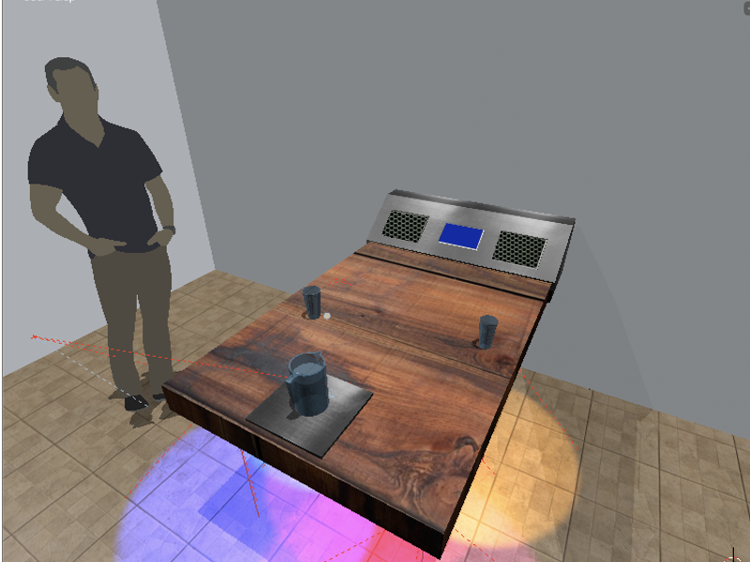

Figure 1- image 1.a is the early conceptual rendering of the proposed “smart table” with “command hub” and integrated electronics.

As far as the aesthetic vision, we are looking to make a table for a trendy bar or restaurant. Specifically dark wood, metal (steel), illuminated frosted glass would achieve the desired look and feel. We would like to take design cues from a vintage home radio. Frosted glass, and user controls backlit in a warm amber / white light would be soothing in a dark bar. Most importantly, making intelligent ambient lighting would be a good engineering exercise. As a matter of personal interests across the group, we would like to incorporate beautiful woodworking. One member has experience in woodworking (image 1.c).

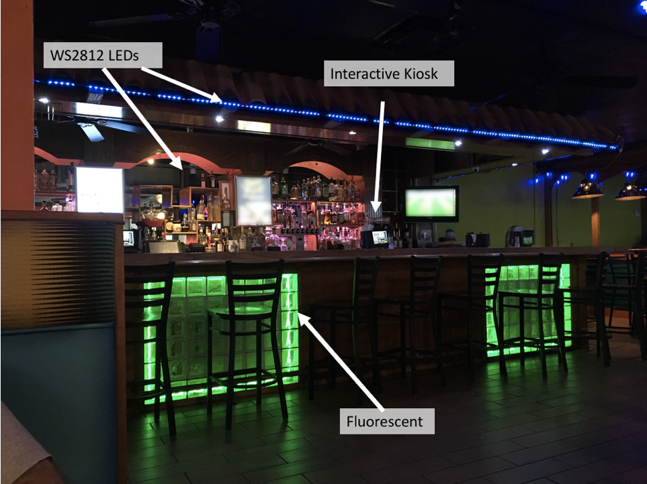

Figure 1.b- image 1.b is of a modern bar that has utilized WS2812 LED strips, Neon fluorescent lamps, and even interactive kiosks.

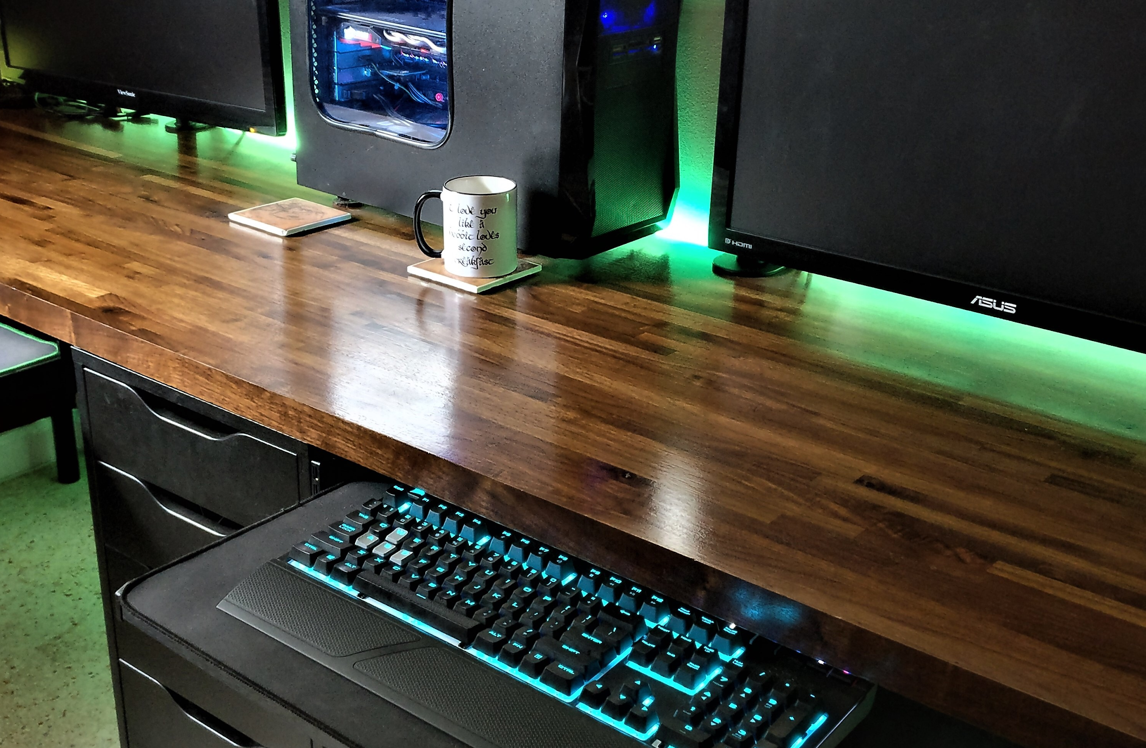

Figure 1.c- image 1.c is a sample of the woodworking done by a group member that showcase the aesthetic vision.

Created by Christopher Corley

## 2.2 Requirements Specifications

In this section the technical requirements of the smart table project will be outlined. These requirements are different than the objectives because they explicitly define quantitative values and measurements that the project is designed to. The list of requirements below will be verified at the end of development to ensure that these specifications have been met.

1. The table shall have dimensions of 32” by 28” by 1.5”.
2. The table shall stand at least 27” from the ground.
3. The lighting on the table shall emit at least 200 lumens.
4. The table shall seat at least two occupants.
5. The total cost of the system shall not exceed $600.
6. The system shall use less than 10 watts of power.
7. Table shall recognize when a server visits table by using the mobile application.
8. The table shall communicate with the server with a distance of at least 20 feet.
9. The table shall have at least two user buttons that are capacitive.
10. The user buttons shall be illuminated with red and green light.
11. The lighting on the table shall have at least 3 lighting profiles.
12. The lighting on the table shall be adjustable based on the ambient light sensor.
13. The table shall use a load cell sensor to detect that a beverage pitcher is empty.
14. The table shall not weight more than 125 lbs.
15. The table shall include a LCD screen of at least 1” by 2”.
16. The table shall include two 5-volt USB charging ports, that may be implemented, with minimum current output of 200 milliamps.
17. The table shall include a guest operated audio speaker with at least 1 form of connectivity (aux, Bluetooth, etc.).
18. The system shall include a mobile application that is compatible on Android operating system for the server.
19. The printed circuit board design shall have regulators that support 5 volts and 3.3 volts outputs.

## 2.3 Major Roles and Subsystems

**Light Signaling-** The core functionality of the smart table is the ability to utilize the ever-popular decorative LED lighting now found in bars and restaurants to signal serving staff. Attention to cognitive load, and the way humans perceive light will be required for this task. Additionally, the issues related to managing potentially rapid state changes in lighting will be explored.

**Ambient Lighting/Motion Detection-** In addition to controlling the signal lighting, there is a need to dim the ambient lighting found in the user control interfaces appropriately. The table will also need to actually detect that it is occupied by utilizing an infrared sensor.

**Information Display-** To give users more control, a readable screen will have to be provided to allow customers to override automatic summoning of servers for refills. This display could also potentially provide diagnostics or even display messages to customers such as “Welcome”.

**Waiter Tracking-**  It is desired that the smart table keep track of waiters coming to serve tables. Essentially the table will signal the waiter with light, and the waiter will be able to turn the light off or back to a “does not need service” mode of lighting. To achieve this functionality many types of wireless communication has been explored. Waiter tracking may also include the development of a mobile application in which the server can have a means of communication with the tables sensors and guests.

**Smart Beverage Detection-** To make the table “smart” it is desired that the table monitor the status of a communal pitcher. Lack of beverages is cited as one of the most irritating delays in a dining scenario. With the popularity of communal pitchers for water, tea, or beer it makes sense to implement this feature. The goal is to have the table detect that the pitcher is almost empty and either ask the user if they want a refill or automatically summon a waiter on its own volition via integrated signal lights.

**Power Considerations-** Although a development board such as an Arduino or clone is suitable for testing the various sensors, most development board can only output less than 1 amp at 5V without risking damage. As designing and implementing a custom PCB is a goal of senior design, a custom PCB will be designed featuring a MCU paired with additional power regulators to distribute power to the various peripherals.

**MCU Selection-** To achieve core functionality a basic embedded microcontroller unit or “MCU” will need to be included into the design. This component will need to integrate all the sensors and produce the appropriate output signals to drive a variety of lights. Further considerations needs to researched to ensure that the number of pins for our sensor suite is fulfilled.

**Construction Considerations-** As this project is unique and has many functional and aesthetic requirements, much of the housings and mounts will have to be custom fabricated. The proposed use case dictates that a great deal of attention will be paid to creating a prototype that could theoretically survive the rigors of cleaning and abuse. Additionally, due to the delicate nature of the sensors and other integrated electronics, most components will have to be waterproofed and mounted so as not to move or vibrate.

## 2.4 Top Level System Diagram

As seen in figure 2.4.b, a housing called the “command center” will be constructed to hold the custom designed PCB along with facilitating the secure mounting of peripherals. The command center is essentially a box that can be mounted seamlessly with a table. Inside the command center the MCU will handle incoming data from several different sensors and control both ambient and signal lighting elements. The status of the sensors will be stored in memory, and periodically used to update table status.  The user (restaurant customer) will be able to interact with the table via a screen and buttons embedded in the surface of the command center. The screen and accompanying “yes” and “no” buttons will allow users to call their water or cancel a request for service such as an undesired automatic drink refill. Depending on the input command, the MCU may adjust outputs to various sensors and devices or log information. The PCB will contain power regulators to deliver the required power for higher draw peripherals such as signal lighting.  The 5V bus will also deliver power to the USB charging subsystem. Additionally, the PCB will feature a Bluetooth module for communicating with an external smartphone and application. figure 2.4.a shows a rendering of the command center.

External from the command center will be the Bluetooth enabled mobile device and corresponding application responsible for indicating when a table has been serviced. Also outside the command center, will be the addressable signal lighting elements. Ideally though as many elements should be mounted directly on the PCB as possible and within the confines of the command center’s protective shell.

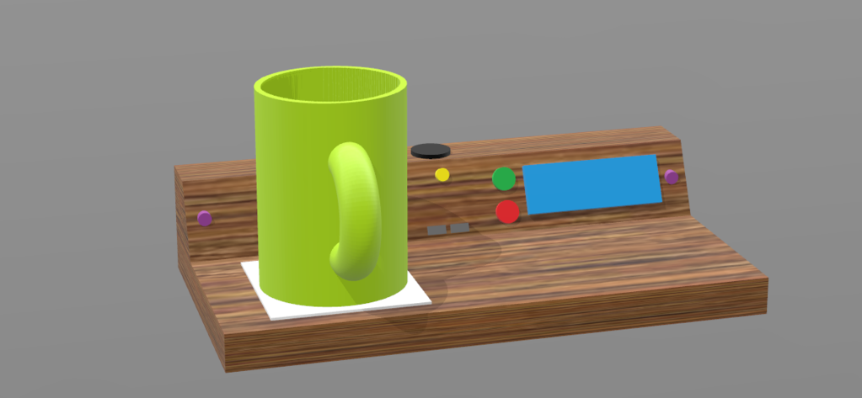

Figure 2.4.a- shows a conceptual layout of the “Interactive Dining Table”

Created by Christopher Corley

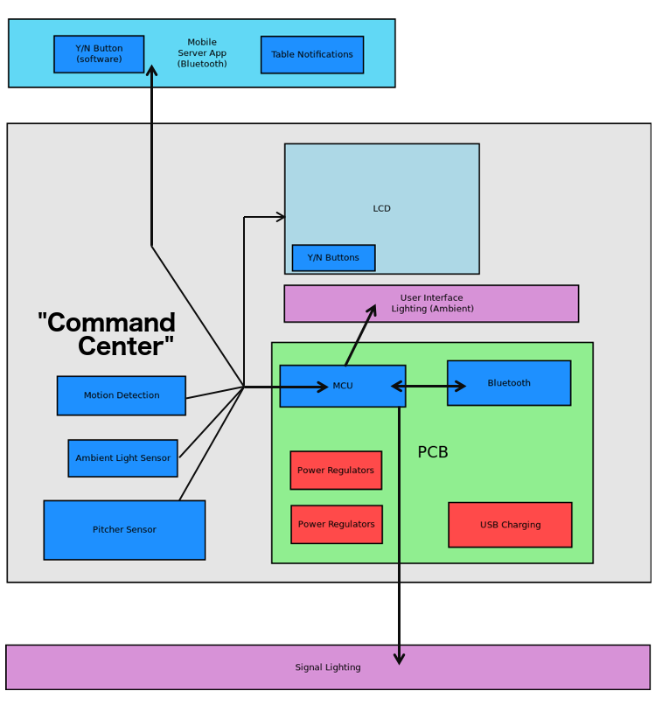

Figure 2.4.b- shows a high level overview of all major components and the general way they communicate.

Created by Mikey Garrity

**Triggers-** The smart table will respond dynamically to a variety of triggers. Triggers will come from not only the automated input from sensors, but also from customers and serving staff. Figure 2.4.c shows states and triggers to be implemented.

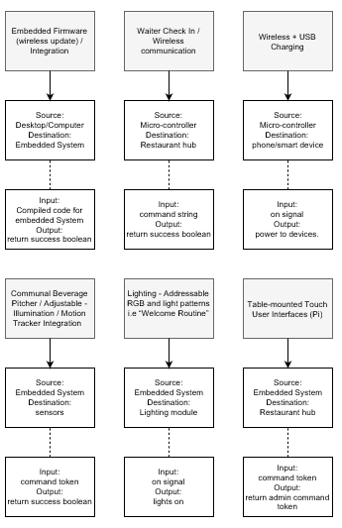

Diagram 2.4.c- shows a high level overview of some of the states, and triggers being eventually accommodated in the design.

Created by Theodore Cox

**Desired States-** Preliminary research indicates that the correct triggers in different states should illicit particular responses. Diagram 2.4.d lays out the goals for the eventual design in terms of the minimum responses that need to be implemented.

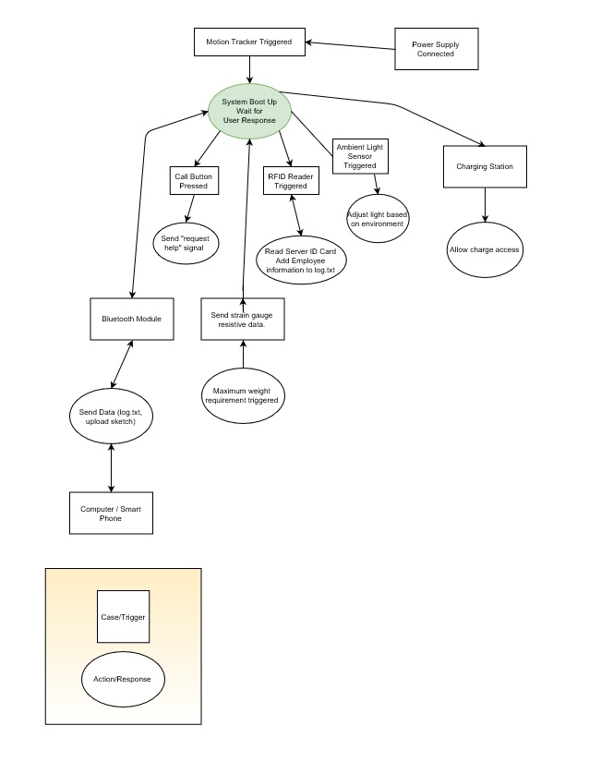

Figure 2.4.d- shows a high level overview of some of the states, and triggers being eventually accommodated in the design.

Created by Theodore Cox

## 2.5 House Of Quality

Below is the preliminary house of quality assessment of the smart table project. The major trade offs of this project are related to dimensionality and quality. The quintessential example is the cost of complex dynamic lighting. The cost for the myriad of lighting choices varies from mere cents (loose 5050 LEDS) to nearly twenty dollars for a strand of many LEDs.

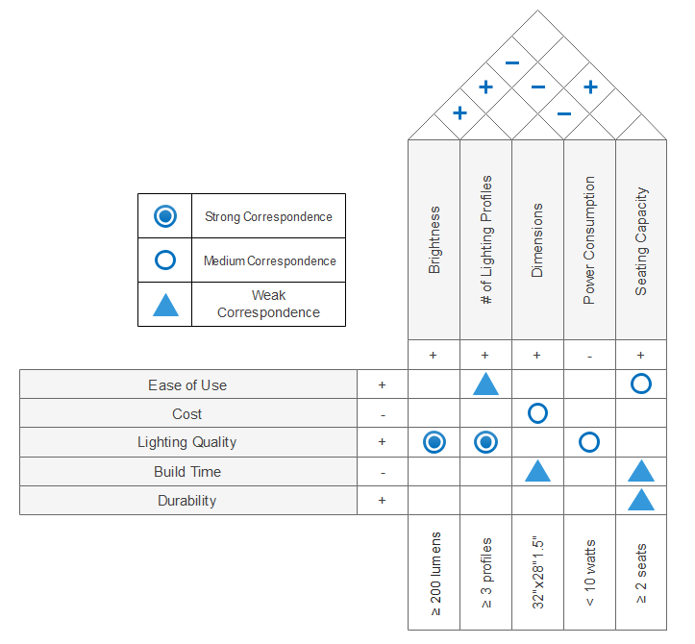

Figure 1 – House of quality

Created by Christopher Corley

# 3.0 General Research

This section exists to verify that the initial project aspirations are feasible in terms of not only the underlying technology but the receptivity of the market to such a project.

## 3.1 Market Research

In order to make the smart table project a success, insight from other similar products, or at least products that might coexist in the same context is beneficial. The technology and features planned in this project have been around in different formats for some time. While evidence of a smart table for a restaurant has not been discovered, there are several “smart tables” on the market. The hope is that by reviewing these products is that the prototype will reflect the market needs and for many mistakes to be avoided.

**SOBRO Smart Side Table-** In 2018 a crowd funded project was started to make a smart side table for the bedroom. The primary constraints were keeping the components silent while bedroom occupants are sleeping as well as having the lighting elements cater to a sleepy setting. Otherwise, many of the goals and features of this project align perfectly with those in our smart table for restaurants. The features of this side table are: charging for devices wirelessly, and wired charging (complete with elegant cable management), decorative adaptive lighting via “smart LEDs”, motion sensor enabled lighting, Bluetooth speakers, and finally noiseless refrigeration. The tables are supposed to be shipping in October of 2018 for about $400. Below in image 3.1.1.a is both a front and top down view of the most important features in the smart side table.

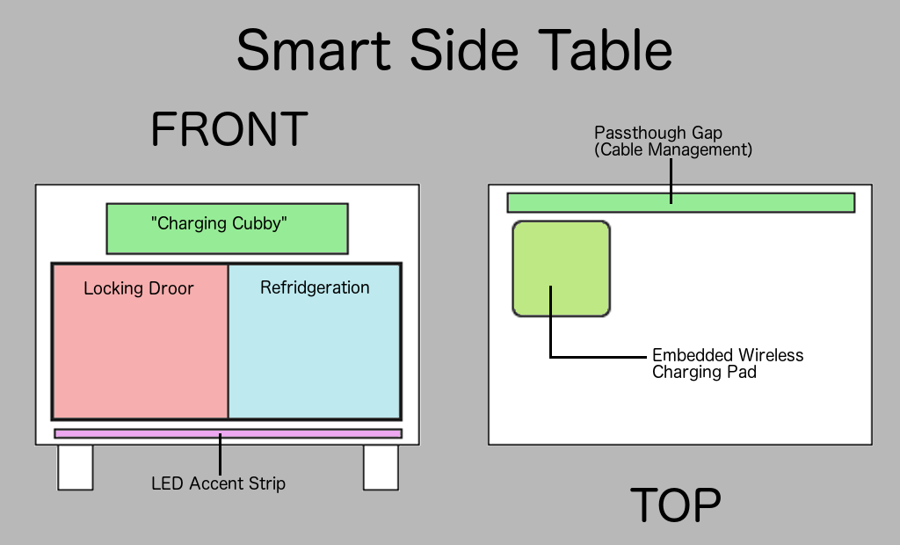

Image 3.1.1.a- shows a features/layout of the “Smart Side Table”.

Created by Mikey Garrity

**SOBRO Smart Coffee Table-** There is also a coffee table that has already been available for some time with slightly different features. This table also offers programmable LED accent lighting, in addition to USB charging ports. Where this table differs in dimensions and construction. The table also features a durable tempered glass surface along with a small touch screen interface.

**Augmented Reality Table-** In 2013 a group of researchers at the University of Regensburg used off the shelf components to make an interactive dining table similar to some of the original ideas for this project. Ultimately a project of this nature was to dependent on off the shelf technology to include significant design in terms of printed circuit boards, however this experiment proves that “smart tables” even if not commercially viable.

With a budget of no more than $500 US dollars the group mounted a projector and tracking system above a generic dining room table in a domestic setting. To capture the user interactions the group used an Xbox 360 generation Kinect array. The Kinect array furnished several RGB-D, or cameras with an infared depth sensor included. Amazingly the group was able to support up to four users at one time along with tracking various objects placed on the table. An overview can be seen in image 42.a.

The purpose of the project was entertainment as opposed to functional, but the project sheds light into some of the obstacles inherent to making a “smart table” Highlights of the paper include some of the issues faced relating to light and occlusion. The observation that blue light form the projection system can be unappealing when projected on food was particularly relevant. Additionally the group had to implement object recognition to accommodate plates and other objects taking up space needed for interactive projections. Overall the group was successful in reaching their goals with their prototype. Interestingly they were able to conceal the Kinect sensor array and projector in a custom made lamp that was not obtrusive.

**Tablets and Kiosks-** In 2018 it is becoming more commonplace to see self service kiosks in casual and fast food dining venues. The majority of these products are little more than the standard point of sale terminal a server uses to charge cards, the difference being that the units are small an portable. While the direction of this project has diverged significantly from this class of devices, there are still many valuable insights to be gleaned.

**Ruggedizing-** Across the kiosks examined it is expected that they can survive the rigors of the dining environment. Specific features noticed would be the rubberized bezels, sealed enclosures, and materials used. Without fail, all of the products seem to have at least some rubberized part for either shock absorption or grip. Supple rubber might seem an interesting choice given the harsh chemicals used in the industry (mentioned in the sanitation section). A similar design choice was made in the first generation of Apple’s iBook G3 (image 42.b). While purchased in large quantities by the education market, the rubberized coating was easily damaged and discolored thus making pristine examples rare today. It would seem that either silicone rubber is used, or the value of a rubberized component is worth the drawbacks that come with a petroleum/naturally derived rubber. The decision to include rubber would indicate that preventing equipment from sliding or falling off tables outweighs the disadvantages of using softer materials. The major deviation from the larger single POS kiosk is use of a sealed fan-less enclosure. Making a device that is almost always running, and running it off lithium batteries no less seems to be an odd candidate for a sealed fan-less setup. This decision points to prioritizing moisture protection before overheating. It also contradicts the requirement that commercial grade equipment be long lived as the batteries would be operating in higher temperatures. The most logical explanation that these kiosks pay for themselves with saved labor long before the typical seven year life span of most commercial grade furnishings.

The other big takeaway from this family of products is the color palette. For a device meant to set on any table regardless of décor, the color black is best. The only other alternative colors offered are white, and metal tones. No products featured any complicated skeuomorphic textures such as artificial wood. For the smart table design, any breakaway modules should be black or at least neutrally colored. The last and perhaps most important observation is that these devices are always bottom heavy. To further reduce the chance of falls, laying heavier components above a rubberized surface would be ideal.

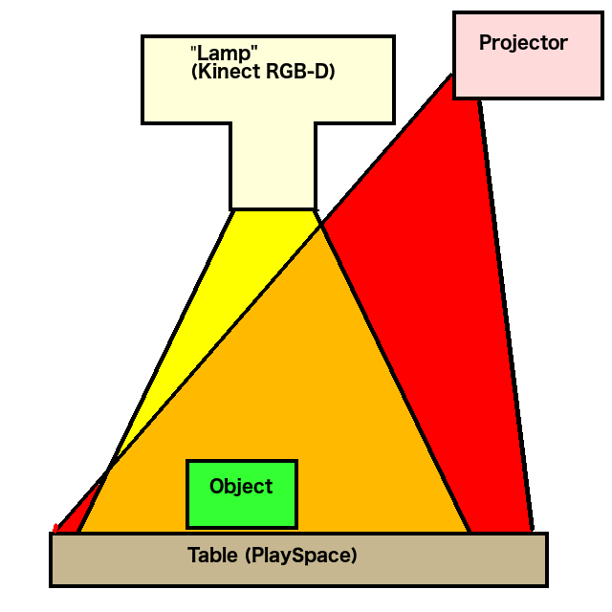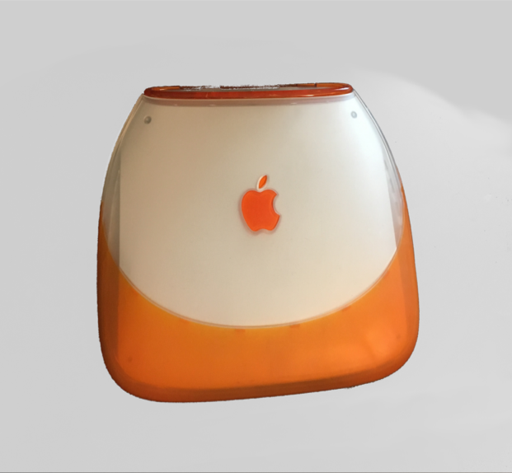

Image 42.a- shows a conceptual layout of the “Interactive Dining Table”.

Created by Mikey Garrity

Image 42.b- shows the 1st generation iBook a.k.a “Barbie’s Toilet Seat” featuring a rubberized coating that was widely panned.

Created by Mikey Garrity

## 3.2 Principles of Ergonomic Design

Ultimately the success of the table design will come down to whether it can be part of environment that makes customers feel comfortable and thus more likely to return. While the table will be restricted to seating only two people due to the prototype nature of the build, there is significant interest in achieving the ideal dimensions. Ideally, the table should also have its embedded components laid out in a useful and unobtrusive manner.

In addition to the desire to make a table that is comfortable for the user, it is important to consider ways to actively reduce the cognitive load servers experience. Decisions regarding the hue, intensity, and complexity of signal lighting will have to be made.

**Reducing Cognitive Load-** Reducing the cognitive load can be achieved by avoiding unneeded complexity, and reusing established social conventions regarding visuals. Intricate patterns that could be subjectively considered “beautiful” could certainly add to an establishment’s appeal, however such patterns could be distracting to staff. Essentially each individual signal pattern should be limited to only one or two colors. These two colors also need to be as far opposite as possible on the color wheel to be perceived as distinct. Mauve and purple would be an example of two poor color choices. Lastly in regard to simplicity, a minimum number of possible distinct table states would be preferred. Ideally a table can either be “nominal” or “needs attention” rather than waiting special states like needing a “refill” or “ready for bill”.

A good example of utilizing existing social conventions would be the use of “traffic lights” in the windows decorations of Apple’s aqua interface (figure 40.a). Using colors like red for closing a program is intuitive because red has been established socially as the color of stopping in brake lights, stop signs etc. Signal patterns of a predominantly red pattern might make sense for indicating that a party needs attention. A poor example of re-using establish social conventions would be the floppy disk save icon used in many word processing suites. As a general design rule iconography is a more difficult aspect.

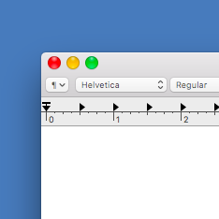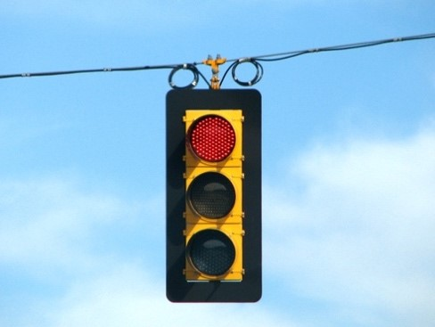

Figure 40.a- shows the “traffic lights” in OS X next to a real traffic signal.

*Created by Mikey Garrity*

**Ideal Dimensions-** While this build will be a prototype, it makes sense to be aware of the established norms. It is likely that the prototype’s dimensions arise from functional and budgetary concerns, but ADA recommended dimensions would be better than any arbitrary ones when freedom of choice is available. Much of the literature, and requirements for dining furniture is related to height. The prototype will most likely be made in a detachable way so height will not be a factor. The dimension that still applies is the restrictions on obtrusive electronics mounted under the table. For a table to be accessible there needs to be a minimum of 27 inches of clearance from the floor to the bottom of the table. Most importantly this 27 inch clearance needs to extend 19 inches towards the center of the table. Essentially this means a customer will need a 27 inch x 19 inch pocket to fit their legs and chair under. As a design consideration, this would mean mounting electronics to the side or making sure the table is minimum of 38 inches wide in addition to any space occupied by electronics. Overall this stipulation may support a decision to locate electronics and housings on top of the table.

**Ideal Layout-** With the addition of creative lighting it would seem unlikely that this project would be at home in a fine dining establishment. There are however some norms even without a formal table setting. Regardless of how casual the venue, drinks are going to be placed behind the plate. Most restaurants aim to collect the condensation from cold drinks, but inevitably there is usually more wear and tear to the center of the table. Even without condensation, the action if users repeatedly banging their glass back down in this area could cause scuffs. The other zone of interest would be the edge closest to the serving side. When bussing tables servers stack plates on this edge. In some restaurants, particularly those similar to the imagined use case, it should be expected that the table will have very hot dishes set on it. Those dishes that are hot, but could still theoretically be touched would go to the individual patron’s place settings. Other items such as “Hot pots” or “fajitas” might be set in the middle of the table to reduce the risk of spilling onto a patron. Ideally in designing the prototype it should be anticipated that these areas as depicted as red in the heat map called image 41.b, will need to be the most durable. More importantly this heat map will be the basis of many decisions of where to place any electronics and associated housing so as not to be obtrusive.



Image 40.a- shows a “heat map” of the areas of the table most subject to wear from items being placed on it.

Created by Mikey Garrity

## 3.3 MCU Hardware Research

**The Microcontroller Unit (MCU)**- The microcontroller (MCU) selection is one of the most important decisions when designing an embedded system. The MCU will control and process all the signals throughout each hardware module. The MCU selected should have high performance, be reliable, and low power consumption. The processing speed should be adequate to allow for ideal data processing. The microcontroller should be compatible with the other hardware devices and components used in the embedded system. Voltage and current tolerances of the MCU pins should not be compromised by the peripheral interfaces. Sufficient memory space is necessary for a complex embedded system that deals with monitoring pins, data processing, and stores needs to log information. High reliability and a large backing community are necessities in determining a microcontroller for the senior design project.

**Competing Devices-** There are many microcontrollers out in the market that can accomplish the functionality needed for our application. Companies like Microchip (PIC), Atmel (ATMEGA), Texas instruments (MSP), and others all have competing devices for us to choose from. After testing multiple company’s development boards, we found that the ATMega series microcontroller to be the best choice for its large open-source libraries/drivers and the helpful electronics enthusiast community that follows the platform, the Arduino. There were two different ATMega chips that were attractive to our project; the ATMega2560 and the ATMega328. After more research and more components added to our embedded system we came to only one final selection which we will discuss below.

**Our Original Selection: Microchip ATMEGA328P-** The Atmega328P is a low-power 8-bit microcontroller based on the RISC architecture. This MCU can operate at speeds up to 20-MHz and has 32-Kbytes of programmable flash memory. The MCU has 23 programmable I/O lines, 6 PWM channels, and 6 ADC channels. The microcontroller offers various sleep modes including; IDLE, ADC Noise Reduction, Power-save, Power-down, Standby, and Extended Standby. The different sleep modes allow for low power consumption on inactive time periods of the MCU operation. The MCU will operate at voltages from 1.8V to 5.5V and only draws 0.2mA of current during its active mode. During sleep mode the microcontroller may only consume 0.1μA of current. The ATmega328/P has been designed to be optimized for low power consumption versus processor speed. This is fine for our projects needs because we are do not have a lot of fast data processing needs. The main necessity for our MCU is that it is reliable and have low power consumption. The selected MCU is known for its high performance, low power, and 8-bit processing.

Fix tables!!!

Table 1- ATMEGA328p Power Usage

|  |  |
| --- | --- |
| Description | Value |
| Operating Range | 1.8V – 5.5V |
| Active Mode | 0.2mA |
| Power-Down Mode | 0.1uA |
| Power-Save Mode | 0.75uA |

RISC

|  |  |
| --- | --- |
| Assembly Instructions | 131 |
| Execution | 1 Clock Cycle |
| Registers | 32 8-bit |
| Max throughput | 20 MIPS @ 20 MHz |

Large Volatile Non mem segs

|  |  |
| --- | --- |
| Execution | 1 clock cycle |
| registers | 32 8-bit |
| Max Mips throughput | 20 at 20MHz |
|  |  |
| Flash memory | 32-Kbytes |
| EEPROM | 1-Kbytes |
| SRAM | 2-Kbytes |
| Write/Erase Cycles; Flash | 10,000 |
| Write/Erase Cycles; EEProm | 100,000 |
| Data Retention | 20 years |
| Programming security lock | Yes |
| Cap Touch support | Yes |
| touch sense channels | 64 |
|  |  |
| timers | 2 8-bit, 1 16-bit |
| real time counter | Yes |
| PWM channels | 6 |
| ADC channels | 8 |
| temp measurement | yes |
| SPI interfaces | 2 |
| USART | 1 |
| I2C | 2 |
| watchdog timer | yes |
| analog comparator | 1 |
| interrupt/wake up | yes |
|  |  |
| Power-on reset | yes |
| brown-out detection | yes |
| internal oscillator | yes |
| multiple interrupt sources | yes |
| sleep modes | 6 |
|  |  |
| input/output lines | 23 |
| pins for TQFP package | 32 |
|  |  |
| temperature range | -40C to 105C |
| operating voltage at 20 MHz | 4.5V |
| operating voltage at 4 MHz | 1.8V |

Key Differences:

|  |  |  |  |  |  |  |  |
| --- | --- | --- | --- | --- | --- | --- | --- |
| ATMega- | System Voltage | Flash memory | Clock Speed | Digital I/O | Analog Inputs | PWM | UART |
| 328 | 3.3V | 32-Kbytes | 8MHz | 14 | 6 | 6 | 1 |
| 2560 | 3.3V | 256-Kbytes | 84MHz | 54 | 12 | 12 | 4 |

**Our Final Selection-** When researching different potential microcontrollers to run our project we came around the Atmel ATMega series. The ATMega has a large reputation for electronics hobbyist around the world and there are many websites that offer open source libraries and tutorials on how to program the microcontroller with various sensors and electronic devices. Originally, we decided on the Atmega328p; the same microcontroller on the Arduino Uno. The ATMega328 has 23 programmable Input/output lines and 6 to 8 ADC channels as well as 32-Kbytes of In-System Flash program memory. As our research progressed and more sensors and electronics were needed for our project we found that the 23-pin chip would not work for our project. Since we had learned to love the ATMega series with is abundance of open source software libraries we decided to move over to the larger ATMega2560 microcontroller. The ATmega2560 offers more pins and memory at 86 programmable input/output lines and 256-Kbytes of Flash memory. This is a massive difference and is necessary for our project. The only downside is that the cost is significantly higher than the ATMega328 chip.

**MCU Software/IDE Selection-** Since our project will be using the Atmel ATMega2560 microcontroller we have a choice of two well known development environments; the Atmel IDE and the Arduino IDE. For the purposes of our project we will be using a variety of sensors and electronics that has been used by the open source community Arduino. Arduino provides electronic hobbyist with an open-source platform to compare libraries and hardware tutorials. Our group has decided that using the Arduino IDE is the best option for our embedded system project as of now for its easy of use and quick start up programming. For the chance that we are limited by the Arduino IDE (mainly for loss of debugging capabilities) we may switch over to the Atmel IDE.

# 4.0 Research MY BALLZ

## 4.1 Signal Lighting Research

The primary goal of the table is to summon waiters when a party needs attention. In industry it is commonplace to make use of brightly colored accent lights in bars. The main goal of the table is to use this type of decorative lighting as a novel way communicate customer status to waiters. To meet requirements 1,2,6,7 and 15,16 certain characteristics will be sought. Specifically, it is desired that the lighting elements chosen have the following characteristics: respond quickly to state changes, be long lasting, offer redundancy, low temperature, and finally be aesthetically pleasing. The crux of the issue for this table is that lighting elements chosen need to be able to tolerate being potentially encased and be able to last the life of the table. While being encased offers isolation from moisture and mechanical damage, it prevents the dissipation of heat. Additionally, by their nature, the lighting elements will likely be non-user serviceable. Most importantly though to generate clear and coherent signals, the lighting elements will have to cycle rapidly, and repeatedly, thus further contributing to wear. Finally, the lighting elements will have to have a subjective ascetic appeal dictated by characteristics such as light intensity and color constancy.

**Incandescent-** Arguably one of the best choices in terms of quality of light and aesthetics. Unfortunately, incandescent bulbs only use about 5% of input energy to produce visible light, instead generating a significant amount of heat. Additionally, while not necessarily being worn in some cases by excessive on/off cycles, incandescent respond to slowly to create complex dynamic signals. Perhaps incandescent such as the popular “Edison Bulbs” could be used for the ambient light systems. Another point of interest is that incandescent still are relevant in dimmer switch setups where LEDs and fluorescents can be unstable. Lastly color choices are limited in incandescent lights.

**Fluorescent lights-** have a slighter better energy and thermal footprint to incandescent but generally have the same failings for the scope of this project. Most importantly fluorescent bulbs contain a starter mechanism and ballast. Consequently, rapid state changes are detrimental and not likely to be even possible. Failure and rupture of fluorescents is also not desirable in a food setting due to mercury content. Lastly fluorescent lights have less potential to achieve the aesthetic qualities desired due to their tendency to output flickering light.

**General Overview of LEDs-** Several families of LEDs are another possibility. The advantages of LEDs over incandescent and fluorescents are numerous for this project. The principle advantage is that LEDs are more efficient, converting upwards of 15% energy input to visible light. Additionally, the ratio of thermally conductive components to casing is better for dissipating the heat that is produced. As far as achieving requirement #7, LEDs can be configured to “pulse” because they can change states almost instantaneously. LEDs are also fairly durable and long-lived. The primary failing of LEDs in terms of longevity is not the LEDs themselves but the controllers stepping down 120V/60Hz supplied in retrofitted sockets designed for incandescent. Essentially passing excess current through LEDs creates excess heat, which causes failure outright or can cause the clear plastic housing to discolor so as to become opaque.

**Basic LEDs-** refer to those that come in one color and generally can only be turned on or off. Basic LEDs come either loose or as pre-assembled strands of a certain color. To implement these a minimum of 2 different color strands would be needed to create clear and unique signals. An example can be seen in image 3.4.1a on the right. The LEDs pictured are various colors of the dumb LEDs model #5050.

**Integrated LEDs**- affectionately referred to as “dumb LEDs” consist of 3 separate Red, Green, and Blue LEDs. Bundled at each node Almost any color can be achieved with this class of LED strands, however only one color can be displayed at a time. An example can be seen in image 3.4.1a on the left. This LED is easily identifiable by its numerous pins (4 instead of 2).

**Fully Addressable LEDs-** or “Smart LEDs” are an attractive option because they allow every single RGB LED module in the strand to act independently as if they are “pixels”. In fact these kinds of LEDs can be used to create complex images and patterns such as those typically seen in the elaborate holiday decorations adorning people’s homes in winter.

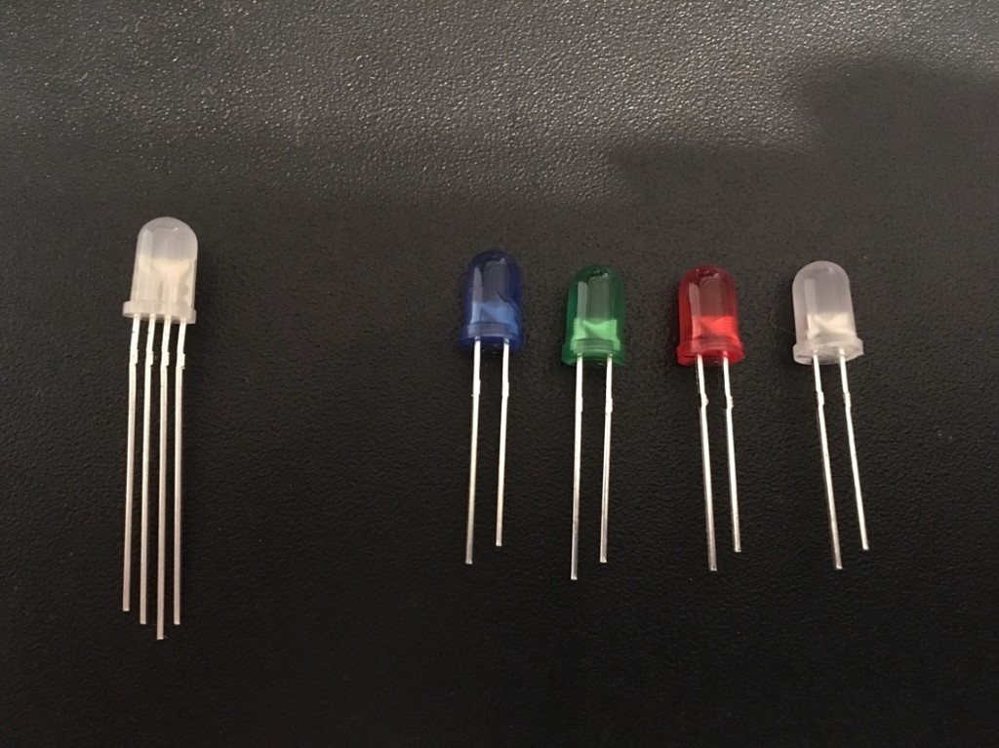

Image 3.4.1.a- Integrated RGB (left), 5050 LEDs (right). Notice the size of casing versus actual diode.

*Created by Mikey Garrity*

**Signal Lighting Elements Available-** This section will contain several specific examples of lighting elements being considered. All of the following are various types of LEDs as this technology is the most commonly used in integrated electronic devices. This section is primarily here to help with later selecting regulators and designing the PCB. As such voltages and amperages are compared to light output.

Table 1- Comparison of LED Brightness versus Power

|  |  |  |  |
| --- | --- | --- | --- |
| Name | Lumens | Voltage | mA |
| 5050 LEDs | 16-22 | 2.8-3.4 V | ~60 |
| 3528 LEDs | 6-8 | 2.8-3.4 V | ~20 |
| WS2812-B | 6-24 (Variable) | 3.33-5V | ~60 (RGB) |
| WS2812 | 6-24 (Variable) | 5-7 V | ~60 (RGB) |

**5050 LEDs (Basic)-** the quintessential dumb LED. These come in a variety of colors. These are bright and inexpensive. Unfortunately these only can be on or off.

**3528 LEDs (Basic)-** these are the little cousin of the 5050, less bright but also less power draw. Again these come in many colors.

**WS2812 (Fully-Integrated)-** These are the addressable “neo-pixels”. These LEDs are actually three LEDs in one wrapper. The red, green, and blue LEDs combine at varying brightness levels to make almost any color. These LEDs are usually daisy chained. For a 5 meter strip with three hundred LEDs a 5V/10A power supply is recommended. These neopixels have embedded controllers that keep an internal clock signal. This means that to communicate with these LED strips, only one data line is actually needed. The caveat of this internal clock is that a fairly robust MCU is needed to meet the minimum recommend clock speed of 8 MHz. This limit has to do with the MCU needed to synch easily with the 400 Hz clock internal to the LED. The neopixels use NZR, or non-zero conditions to generate 24-bit data packets where each color (RGB) is given 8 bits. The range of brightness for each of the RGB components is 0-255. Essentially (255, 255, 255) would be bright white and would draw the max 60 mA.

**WS2812-B (Fully-Integrated)-** These LED strips came to the market first and were generally meant to be paired/shipped with their own dedicated microcontroller and remote. Essentially the LEDs in these two strands are identical, however the controllers for each pixel differ in operating constraints. The WS2812-B is a variant of the original WS2812 addressable LED that operates at a lower voltage. Operating at 3.33-5V is more amenable to pairing with embedded MCUs that often furnish a 5V rail. Obviously, it is unwise to daisy chain many of these 60 mA LEDs off of a 1A MCU rail, however one could be powered. In image 3.4.2.a the WS2812 is pictured by a quarter. In image 3.4.2.b the same LED is pictured at 60 magnification. At this magnification traces are visible.

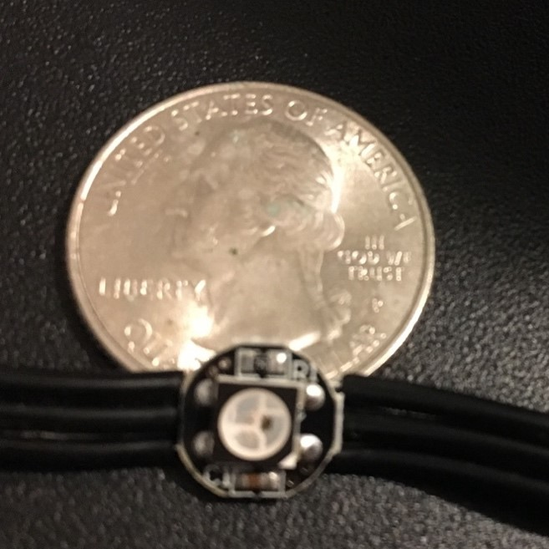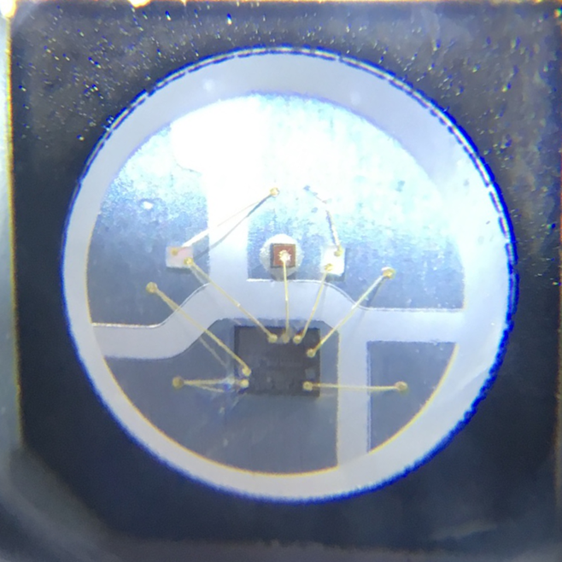

Image 3.4.2.a- Illustrates compact nature of WS2812-B

Image 3.4.2.b- is a 60x magnification of same WS2812-B

*Created by Mikey Garrity*

## 4.5 Human Perception

When designing a device with embedded lighting elements, it is necessary to be mindful of the way human’s perceive light so as to make the device non irritating to customers. Signal lighting in a table was the original inspiration for the project and continues to be a core goal.

**Color Vision-** Human vision offers a range of color from 390 nanometers to about 750 nanometers. Human vision relies on three different types of cones that perceive light most strongly at 430, 535, and 590 nanometers. For most people green light at around 545 nanometers can trigger all of the three types of cones in their eyes simultaneously. As a design consideration it is worth pointing out that intense green light may be more likely to be irritating for patrons. Additionally, color blindness of the Deuternomaly or “green weakness” is the most common of the types of color vision deficits. It would make sense to chose either red or green in the table design, but not a situation where a server has to differentiate between the two. A design featuring less obtrusive red light would be desirable as it is more difficult to perceive in lower light settings, thus potentially having less of a disruptive contribution to the overall ambient lighting. The other possibility is that red can be less visible, and less likely to get a waiter’s attention than green. Emergency vehicles were originally red, now, as a result of nocturnal collisions many vehicles are being painted chartruse a yellow green color around 500 nanometers. The ultimate color choices in the final design may be subjective choice.

**Refresh Rate-** Another consideration for the irritation of patrons is flickering, and state changes. In the display manufacturing research community there has been work in determining the upper thresholds of human perception in refresh rates. Humans potentially can perceive “flicker artifacts” at up to 500 Hz in certain special contexts!!!! INSERT REFERNCE ARTICLE!!!!! . The available technologies for signaling in a table would have too much latency to achieve refresh rates higher than 500 Hz, therefore the table design could not hope to smooth out flickering via high refresh rates. In theory keeping pixel updates to one or two Hz may be less jarring. !!!! INSERT REFERNCE ARTICLE!!!!! This paper also mentions that humans are most easily able to detect flickering in green light, followed by red light, and lastly blue light. This is further evidence that green might be avoided. It would seem that an ambient “nominal” status might be best in blue as tables would spend the majority of their time in this state.

**Light Volume-** A possible consequence of the table being designed for a low light restaurant, is the failure of color constancy. Color constancy refers to the human brain’s tendency to try and compensate for varying illumination to make colors seem consistent regardless of context. Color constancy can fail as seen in image 39.a. In this image one might perceive the two yellow dots as being of different colors when in fact they are the same color. . It is conceivable that while the signal lights are intended to be installed below the rim of the table, colored light could reflect back onto the food so as to make it less appetizing (see figure 39.b). The volume level of the lights themselves could make for “green fries” or an altogether bland meal of little contrast. The last and arguably most important norm to consider regarding lighting is the intensity. For a more romantic setting 5-15 foot candles is sufficient while more casual settings can tolerate upwards of 25 foot candles. !!!**{Dining Services Ergonomic Design Guidelines UofCalif}.!!!**

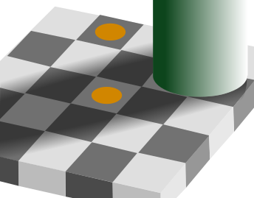

Figure 39.a,b- figure 38.a an example of color constancy, figure 38.b example of discolored food

## 4.3 Communicating with WS2812B LED Strip

The WS2812B LED units are individually addressable. They use single NZR communication mode, and the output signal of one RGB unit can be passed to the next unit as an input signal in a cascade. Each of the RGB colors are sent as 8 bits thus summing to 24 bits total for the signals. The WS2812 units actually only take one data signal and generate their own internal 400 Hz clock. The most common and supported way of communicating is with PWM or pulse width modulation. PWM involves the microcontroller using it’s internal clock to output high and low voltage pulses on data pins.

**Libraries-** The WS2812 units have many drivers and libraries available. The variation results from the number of units cascaded and the types of patterns desired. In addition to PWM, enterprising individuals have also managed to operate these units with UART, and SPI. Officially the WS2812 can only be paired with microcontrollers of at least 16 MHz It is technically possible to use slower setups, however there is difficulty in cascading many LED units and not accidently triggering a reset signal because of latency.

**Timing Constraints-** The 400 Hz internal clock means that input signals are subject to timing constraints. The official timing diagram for the NZR communication mode used in WS2812B strips can be seen below in figure 19.a. The high voltage time of the zero logic signal is the most concerning. Officially this signal time needs to be between 200 ns and 500 ns to be detected as a zero. The good thing about the pulse width modulation signals on the AVR are that they require no computation. These signal pulses are deterministic in nature and with the 16 MHz pre-scalar set, the ATmega328P should be able to achieve a pulse of 500 ns with exactly 8 cycles. There is indeed some latitude as seen in the differences between the recommended signal timings (table 19.b) and those reported by users (table 19.c).

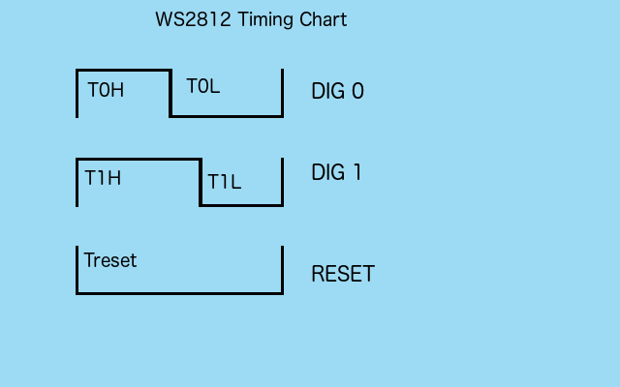

Figure 19.a- figure 19.a shows the official timings for WS2812’s NZR PWM communication mode

Created by Mikey Garrity

Table 19.b- table 19.b shows the officially supported timing windows for WS2812’s NZR signals.

|  |  |  |  |  |
| --- | --- | --- | --- | --- |
| Symbol | Parameter | Min (ns) | Typical (ns) | Max (ns) |
| T0H0 | High | 200 | 350 | 500 |
| T1H1 | High2 | 550 | 700 | 850 |
| TLD_data | Low | 450 | 600 | 750 |
| TLL_latch | Low2 | - | - | 50,000 |

Table 19.c- table 19.c shows more relaxed timing windows for WS2812’s NZR signals reported by other users.

|  |  |  |  |  |
| --- | --- | --- | --- | --- |
| Symbol | Parameter | Min (ns) | Typical (ns) | Max (ns) |
| T0H0 | High | 200 | 350 | 500 |
| T1H1 | High2 | 550 | 700 | - |
| TLD_data | Low | 450 | 600 | 5,000 |
| TLL_latch | Low2 | - | 6,000 | - |

**Unideal Cases-** Users have reported that while less than ideal, with the exception of the zero high voltage time, the strips are tolerant of delayed signals in the order of magnitude of seconds. As long as the 500 ns zero high signal can be achieved the strips should at least be able to light to a solid color that is a mix of RGB. Ultimately as the clock speed of the microcontroller goes down, the strips become “less addressable”.

## 4.4 Diffusing Light

LED lights are known for their bright and highly concentrated light emission. While these characteristics are desirable for creating a focused beam such as those found in a flashlight, LEDs can be obtrusive in a decorative application. To rectify this issue most decorative LEDs are mounted in some sort of semi-transparent housing. The benefit of having a housing is two fold, the light output is less jarring, but also the LEDs are protected from the elements. The biggest drawbacks of using a diffuser and housing are the inability of heat to escape and the energy lost in the semi-opaque film.

**Common Diffusers-** To achieve the desired effects the light output must be scattered. Traditionally this is achieved with semi-opaque films such as rice paper or etched glass. Materials used are chosen for several qualities: refractive index, temperature tolerance, flammability, UV stability. Finding a semi-transparent filter that softens output light by blocking it is relatively easy, but finding a suitable material that actually scatters the light is much harder. As synthetic materials were improved, new materials such as acrylic were developed. Most commercially developed LED housings with diffusers built in achieve results by using a filter made of rough acrylic that is bonded directly to the clear acrylic shell of the housing itself. The biggest issue for the implementation of such acrylic filters is that they typically have poor UV stability. Alternatively some manufacturers use a separate sheet of thin acrylic that slides into the shell of the housing but is not bonded. The advantage of a separate film is that as the filter is absorbing light it may discolor over its lifespan and need to be replaced. Replacement in this case would be as simple as sliding in a new filter.

**Alternative Diffusers-** In the table design, there are financial and practical stipulations on the housing used. Ideally the housing can be made in house inexpensively as much of the material will be cut and destroyed through the iterative design process. As a result of this constraint more classical diffuser materials such as rice paper or even cloth may be considered even if they have poor refractive properties. One positive consequence of the decision to mount the LEDs bellow the rim of the table is that users will not be looking directly into the LEDs and thus less effective diffusing is acceptable.

# 5.0 Functionality II Information Display

The purpose of the information display is to provide a medium to transfer information to the guest in the restaurant setting. There is a need to communicate with the guests at the table when asking whether they would like another pitcher of their beverage or to greet them at the time of arrival. It was decided that this project would implement some form of text display to achieve this information display functionality. Next we will discuss the different types of technologies considered.

To communicate this information to the guests a few different methods were considered, like specific color illumination with the light emitting diodes, LCD screens, OLED screens, and potentially LED matrix arrays to display text. These different technologies were considered due to the fact that they could convey the message to the guest that was needed in an effective manner. There are characteristics of these technologies that are beneficial, and also some that are not beneficial. We will discuss these aforementioned tradeoffs in the sections below.

## 5.1 Information Display Viewing Angle Analysis

*Figure 1- Information Display Viewing Angle Requirement*

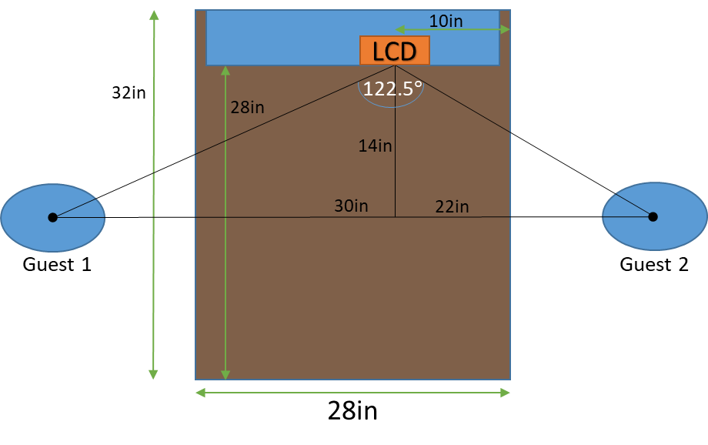

Table 1 above outlines the information display viewing angle requirement. Some trigonometric analysis was required to determine what the necessary viewing angle that the information display needed to satisfy. Provided that the geometric center of a guest would be, on average, a foot away from the table, it was estimated that the horizontal viewing angle of the information display should be 122.5 degrees. This information is critical for determining whether information display components could work well for the smart table experience, without the guests needing to lean forward to see the display.

## 5.2 TFT LCDs

The first information display technology that was researched for this project was the TFT touchscreen display. TFT touchscreen displays consist of three major components. The first component is a LCD screen, the second is a digitizer which detects the users touch presses, and the third is a driver IC that will power the two previous components. These screens are nicely packaged would provide a nice experience for our guest. Next the advantages and disadvantages of the technology will be discussed.

The advantages of the TFT touch display will now be outlined. TFT touch screen displays provide a very refined experience due to their relatively high resolution and the ability for the guest to interact with the screen with touch gestures. This capability was highly sought after because the nature of responding with touch is very natural to a person, especially in a world where touch screen phones are found in nearly every person’s pocket. These displays have a small power consumption, but not as low as something like a LCD character display. However the power consumption is still low enough to be considered low power consumption when compared to quality of the experience it will provide to the guests.

The disadvantages of the TFT touch display will now be outlined. As mentioned previously, these displays provide a very high resolution screen, which naturally must be powered by a high end processor of some sort. The processing power needed to push all those pixels means that microprocessors like those inside of the Raspberry Pi would be needed. This is a problem for this project because we were leaning toward using microcontroller, like those used on the Arduino Uno, which don’t have near enough processing power. Another critical disadvantage is that viewing angles on many TFT displays are very poor. This is a key problem because the guests at the table will be sitting at nearly a 90 degree angle from the display.

The particular component that was considered in regards this display technology is sold by Crystalfontz. Its part number is: CFAF480272C2-043T-TS. This particular displays is 4.3 inches diagonal, has a 480x272 high pixel resolution, and operates at roughly 3.3 volts, but can operate at up to 4.2 volts, and low as 3 volts. Typical current draw for this component is roughly 25 milliamps. The LCD backlight operates a 12.8 volts with a typical current draw of 40 milliamps.

## 5.3 OLED Displays

The second information display technology that was researched for this project was the OLED display technology, or organic light emitting diode displays. OLED display technologies are very similar to other LCD technologies, and they will enable us to achieve the same functionality as the other display technologies, which is why there have been considered. The advantages and disadvantages of the LED matrix display technology will now be discussed.

The advantages of the OLED displays will now be outlined. OLED displays are a relatively new technology and being such they have some nice advantages compared to the other information technologies that have been considered. OLED screens are extremely bright, especially compared to LCD and LED screens. This is partial due to the fact that OLED’s supply their own backlighting, as opposed to relying on a separate panel beneath the pixel to provide the backlighting brightness. The sheer brightness of this display would benefit environments like our restaurant setting where it is very important that he guest can see the screen easily.

There is also one other large advantage regarding OLED display technologies. OLED displays have extremely large viewing angles, which is important because our guests will be sitting at an almost 90 degree angle to the information display in a typical configuration. This large viewing angle is possible because OLED’s create their own backlighting, compared to a LCD where the way the light is emitted is through partially blocking the light, which reduces viewing angles drastically.

The disadvantages of the OLED display technology will now be outlined. One of the major disadvantages of the OLED technology is that their average lifespan in much lower compared to LCD technologies, with blue OLED’s only lasting up to around 14,000 hours. This is a major issue in regards to this product because the information display will likely be running many hours a day, and for many years. This means that the displays may encounter failures in as little as two years if used continuously.

There are two other disadvantages regarding OLED displays. OLED’s can easily be damaged by water, which is a concern because guests may spill beverages which could damage the screen. This is a very likely scenario in the restaurant setting. The last disadvantage is the fact that because this is a new technology, manufacturing cost is much higher than other more mature technologies. Cost is a concern because it is ideal to keep the unit cost of this product as low as possible, as restaurants will likely be purchasing many units at a time.

The particular component that was considered in regards to this display technology is sold by Crystalfontz, and its part number is: CFAL2004A-Y. The active area of the OLED panel is 3 inches by 1 inches and has four rows, capable of running 20 characters per row. The whole unit runs at 5 volts, as well as the logic controller. The typical current draw for this unit is 55 milliamps and the logic operates using a SPI interface.

## 5.4 LED Matrix Displays

The third information display technology that was researched for this project was the LED matrix display technology. LED matrix displays are very simple displays that consist of LED that are arranged in an array to form words of low resolution. These also rely on a driver to control the array of LEDs and provide the correct operating voltages and current. These displays would provide a nice experience for the guest of the table, which is one of the reasons this technology was considered. The advantages and disadvantages of the LED matrix display technology will now be discussed.

The advantages of the LED matrix display technology will now be outlined. LED matrix displays can provide a very bright message to the guest. Another advantage is that these displays tend to be large because the LED’s are much bigger than say pixels would be on LCD screen. It makes sense to have a large information display such that the guests can see it well. Additionally, unlike the TFT touchscreen the viewing angles on LED matrix displays are much better. The displays can also be “daisy-chained” together to provide higher resolution if necessary.

The disadvantages of the LED matrix display will now be outlined. LED matrix displays biggest issue is that in the size that we will be implementing for our project the character message is somewhat hard to read. This is due to the low resolution of the matrix display. The text strings that will be displayed will not fit on the screen unless we scroll the text through a loop, which is not desired. To have a LED matrix display that had a high enough resolution would mean that the display would not fit in the form factor of the table. Another disadvantage is that, aesthetically these displays also do not look as neat and refined as we would like for our project.

This technology also suffers from some of the same disadvantages as the TFT touch screen displays. It is necessary to employ relatively high end processor to run the display, as the technology has no pulse width modulation abilities, thus the characters must continually “redrawn” to maintain the display. This leads to high processor overhead, and when implemented with an Arduino Uno microcontroller, we could see processor usage above twenty percent, just for this component alone.

The particular component that was considered in regards to this display technology is sold by Adafruit, and its product ID number is: 420. The matrix panel is 7.6 inches by 3.8 inches and has a resolution of 16 by 32. The LED array operates at 5 volts, as well as the logic controller. The power draw with all the LED illuminated can reach up to 2.5 amps, which means an external power supply will likely be necessary. The viewing angle specification for this model is 150 degrees.

## 5.5 LCD 7-Segment Character Displays

The final information display technology that was researched for this project is LCD character display technology. This type of display works by illuminating 7 segments in order to display any common alphabetical letter or number. The major differences between character LCD’s and TFT LCD’s is that character LCD’s do not have capacitive touch capabilities. The underlying liquid crystal technology to display the actual visual image and text are similar, but character LCD displays lack the capacitive touch film that is used to detect touch input on TFT LCD’s. Next, the advantages and disadvantages of the LCD character display technology will now be discussed.

The advantages of the LCD character display technology will now be outlined. Due to the fact that LCD character displays have been around since the 1970’s these devices are very inexpensive. Upon research it has been found that these are the most affordable option for displaying characters on a screen of any technology type. Another advantage of character LCD’s is that they consume very little power, and also provide very bright backlighting if needed.

The disadvantages of LCD character displays will now be outlined. Many character LCD’s have a very low resolution, which is not variable. They rely on 7 segments that can be illuminated to produce a letter or character. This means that if we ever pushed an update to this product where we needed to display anything other than characters or numbers, it would require replacing all displays with a more advanced display. This is not a huge problem however, because as of now we only need the capability to display characters and numbers.

The particular component that was considered in regards to this display technology is sold by Smraza, and its product ID number is: 2004. The viewable active area is 3 inches by 1.1 inches and has four rows, capable of displaying 20 characters per row. The unit operates at 5 volts, as well as the logic controller. The typical current draw for this unit is 30 milliamps and the logic operates using an I2C interface.

## 5.6 Comparing Components and Final Display Selection

Table 2 above compares all of the particular components that have been researched with regards to the smart table information display. The left column contains criteria that has been deemed worthy to consider in regards to selecting an effective information display. The row at the top refers to the parts that were selected, meaning that the TFT LCD correlates to the Crystalfontz CFAF480272C2-043T-TS, OLED correlates to the Crystalfontz CFAL2004A-Y, LED Matrix to the Adafruit 420, and Character LCD to the Smraza 2004.

*Table 2 - Comparing Information Display Part Selection*

|  |  |  |  |  |
| --- | --- | --- | --- | --- |
|  | TFT LCD | OLED | LED Matrix | Character LCD |
| Cost | $49.99 | $23.15 | $24.95 | $14.99 |
| Pixel Resolution | 480x272 Pixels | 4x20 Characters | 16x32 LED Matrix | 4x20 Characters |
| Viewing Area | 4.3” Diagonal | 3” x 1” | 7.6” x 3.8” | 3” x 1” |
| Durability | Average | Low | Low | High |
| Life Expectancy | ~100,000 hr | ~14000 hr | ~50,000 hr | ~100,000 hr |
| Current Draw | ~65mA | ~55mA | 2.5A max | ~30mA |
| Operating Voltage | 3.3V Logic, 12V Backlight | 5V | 5V | 5V |
| Interface | DOT-CLK | 4-bit Parallel, 8-bit Parallel, SPI | 12 Digital Pins | I2C |
| Display Type | Pixel array | Segmented | Dot matrix array | Segmented |
| Viewing Angles | 6 o’clock | 175 degree | 150 degree | 150 degree |
| Processing Overhead | High | Low | Medium | Low |
| Other Considerations | Touch Capabilities | Bright | Immersive | Economical |

The information display research conducted allows us to weight the best options for selecting the best component for the smart table. The component that was ultimately selected was the Smraza 2004 Character LCD display. This component was selected because it was decided that affordability was a major concern. Additionally, the low power usage, and long life span where major considerations in selecting this component.

From the perspective of the guest the Smraza Character LCD will provide adequate functionality, and fulfil all the requirements, including the 122.5 degree viewing angle requirement that this component was needed to fulfil. The information display needs to greet the guests with a simple text greeting, and then ask the guest if they would like a refill of their beverage, upon detecting that the beverage was empty. To fulfil these requirements only a basic LCD Character display was needed, and thus the more expensive and sophisticated displays were discredited.

## 5.7 Smraza 2004 LCD Display Module

As mentioned in the previous section the display that was selected to be used as the smart tables information display is the Smraza 2004 LCD Display Module. This section will consist of an analysis of the component in further detail than was outlined in section 1.5. This module is composed of the 2004 LCD component, as well as a controller component which handles the logic communications for the display.

The Smraza 2004 LCD Display Module is comprised of a 2004 LCD screen component. 2004 is the model of the LCD screen that is manufactured from ELECHOUSE. This LCD each character has a resolution of 5 x 8 and features a super-twisted nematic (STN) which is a type of liquid crystal display technology which cheaper to manufacture than TFT LCDs, which is one of the reasons that the Smraza module is so affordable. Below is a table that outlines the voltage parameters for the 2004 LCD Display and it can be seen that the display will comfortable operate with a 5 volt supply voltage, but as low as 4.5 volts and up to 5.5 volts. These parameters are ideal for the printed circuit board design that will be discussed in later sections as it is ideal to avoid having component with many types of operating voltages.

Table 3 - 2004 LCD Module Voltage Parameters

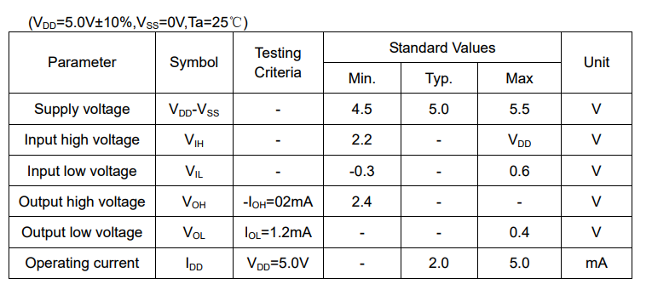

The Smraza 2004 LCD Display Module also includes a controller module that handles all of the logic and communication from the microcontroller to the LCD screen. The logic controller is manufactures from Philips Semiconductors, part number PCF8574. The PCF8574 is a Remote 8-bit I/O expander I2C data bus pins. This controller can operate from 2.5 volts to 6 volts, which is ideal because the 2004 LCD module that it is accompanied with operates at 5 volts. Additionally, this unit features an interrupt line which will likely be used with the interrupt logic on the smart table’s microcontroller.

Table 4 - PCF8574 Remote 8-bit I/O expander for I2C-bus Block Diagram

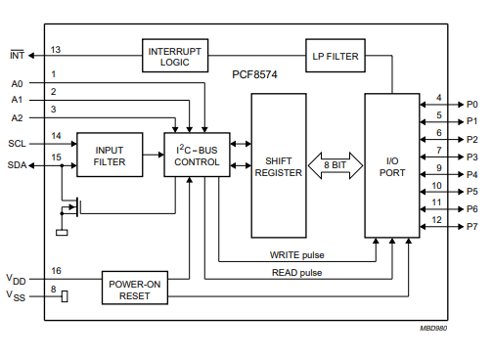

Table 4 above provides an overview for the PCF8574 controller. There are two pins that are used for the I2C interface, the serial clock (SCL) and the serial data (SDA) pins. I2C is ideal for peripherals where simplicity and low manufacturing cost are more important than speed. Therefore, this communication interface is ideal for the character LCD display. The voltage drain ( $V_{DD})$ and voltage source source ($V_{SS}$) pins provide voltage to the transistor logic component contained inside the block diagram. The aforementioned interrupt pin is also present where it can be found to be in series with a low-pass filter before being introduced to the I/O Port.

## 5.8 Touch Sensor FUCKED UP!!!

**“Yes/No Button”- Capacitive Touch Sensor**- To control user input for “yes or no” prompts provided by the LCD screen we have chosen to use a capacitive touch pad device. The device uses the presence or absence of static voltage on the capacitive input (usually in the form of the human body) to detect a “press”. This feature is very useful for our project because it always us to design a product that a person can interact with without worrying about damaging the device. The capacitive layer will be hidden from the outside environment, away from water and other potential hazards. The capacitive touch button will also allow the product to keep its modern minimalist design.   
  
**Theory of Capacitance**- Capacitive touch sensors work by measuring the changes in electrical properties of a given device. Capacitance describes how two conductive objects with a small space between them react to the voltage difference applied to them. The electrical field of the capacitive object can create positive and negative charges depending of the polarity of the voltage apply to it.   
  
**Theory and application of Capacitive touch**- Capacitive touch sensors use alternating voltage which causes the devices charge to reverse polarity continuously. The change polarity causes a small alternating current to occur which is detected by the sensor. The capacitance is directly proportional to the surface area of the conductive object. In our case, we will design a PCB board that uses exposed copper to create our conductive capacitive layer. The idea is, once the capacitance has built up on the capacitive copper layer that size is fixed and so is the capacitance; until something affects the charge. The change in voltage allows the IC to detect the distance at which the target is to the probe. The target being the human finger, and the probe being the copper layer leading to the pin of the specialized IC.  
  
**Effects of Target Size**- The target size greatly affects the consideration when selecting a probe to use for the capacitive layer. In our case the target size should be no more than 25.4mm^2. The suggested minimum target diameter for standard calibration is about 130% of the diameter of the sensing area. The further the probe is from the target though, the larger the minimum target size.  
  
**Range of Measurement**    
There are integrated circuits that are designed to detect a minute change in the capacitance. The amount of voltage changes for a given distance of the capacitive layer is called the sensitivity. A normal setting for the sensitivity is around 1.0V to 100um.   
  
**Maximizing Accuracy**  
Given the basic understanding of how capacitive touch sensing works, maximizing accuracy is important to create a quality product. Having an accurate device means to perform measurements that represent the similar result that was measured during calibration. You want repeatable measurements in repeatable conditions. Choosing which properties of the system will be variables and which will be constant is an important step for maximizing the accuracy. An important step in maximizing accuracy is to note that the expected target size will be larger than the sensing area by at least 30%. If this isn’t the case the capacitance may wrap around the target which will not affect the value being read by the capacitance IC. Also, measuring targets with a curved surface will cause errors because probes measure the average distance to the target. The behavior of the electric field with curved surfaces is different than flat. If calibration is used with curved surfaces, then a multiplying factor may be used to help correct this issue. There are many other contributing factors that can determine the quality of the capacitive sensor including the surface finish, parallelism, environment, and factory calibration of the IC.   
Source: http://www.lionprecision.com/tech-library/technotes/cap-0020-sensor-theory.html  
  
Capacitive Sensing Device Chosen  
  
Description: Preliminary TTP223  
The TTP223 is a capacitive touch sensor detector IC that offers 1 touch pad to detect. The purpose of the IC is to replace electromechanical buttons as a user input to a embedded system. The TTP223 allows for diverse capacitive pad sizes with low power consumption and a wide operating voltage for many different applications. This IC is used for a wide variety of consumer products, including water proofed electric products and button key replacement products.  
  
Features  
- The TTP223 can operate at voltages ranging from 2.0V to 5.5V  
- The operating current at an input voltage of 3.0V with no load is about 3.0uA. With a current draw of only 1.5uA during low power mode. The maximum current draw of this IC is 13.0uA  
- The response time of this IC is 60mS and 220mS during low power mode.  
- The fast mode or low power mode can be set by pad option (LPMB Pin).  
- This device has a low capacitance sensitivity of 50pF from outside environments.  
- There are two kinds of sampling length modes that can be set by pad option (SLRFTB pin)  
- There are different device modes that allow the engineer to design a variety of applications including simulating a button press as well as toggle mode by setting the pad option (TOG pin).  
- The IC can be set to active high or active low by pad option (AHLB).  
- There is a Timeout function of 100 seconds set by pad option (MOTB pin)  
- There are multiple device packages available for this surface mount IC.  
  
To calibrate the device, once the power is turned on do not touch the capacitive keypad, the calibration works every time the device is powered on. If you wish to calibrate the device that period is about 4.0sec, when the key has not been touched.

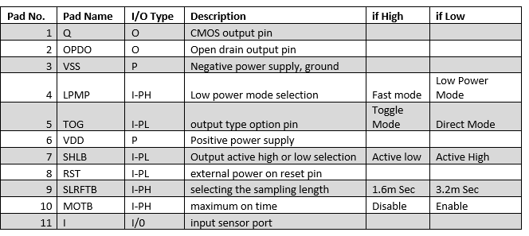  
   
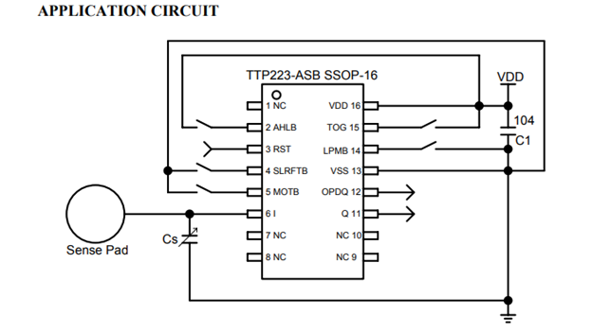

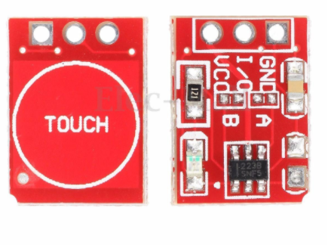  
   
Example PCB:  
   
Datasheet:  
https://infusionsystems.com/support/TTP223.pdf

# 6.0 Functionality III - Smart Beverage Detection

An important feature of our project is to allow the customer to quickly notify the restaurant staff that their beverages are almost depleted. The most effective and efficient way we came up with was to use a weight scaling device to accurately record and keep track of the weight of the beverage pitcher. The scale will be calibrated to the original weight of the pitcher once it is full. As the customer pours the drink out of the pitch the weight will decrease, and that data will be sent to the microcontroller to be processed. Once the weight falls below a certain threshold the microcontroller will trigger an interrupt to one of the peripheral modules including the LED module, the LCD display or the Bluetooth communication module. We will be creating a scale embedded into our design by using what is referred to as a load cell.

A load cell is made up of a few electrical and mechanical parts. Mechanically, the device is usually made up of an aluminum material machined in the space of a long-sided cube. In the center of the metal a large hole is drilled from the cube. This allows a bending motion to occur about the center most point of the metal block. Electrically there are usually a few resistive tapes, called strain gauges that are glued to the edges of the block near the center where the hole was drilled. The resistive tape is designed in what is called a wheat-stone bridge. The physics behind the load-cell mechanism is simple. Once a force is applied to the metal, the upper strain gauge is stretched, and the lower strain gauge is compressed. The Wheatstone bridge has multiple fixed (and known) resistor values with one resistor variable to the strength of the force applied to it. The difference of resistance is very minute though, so that voltage change is sent to an amplifier to be readable by the microcontroller.

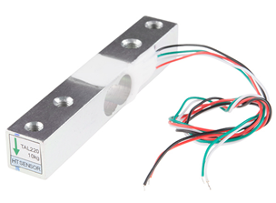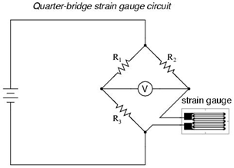

For this project we will not be creating our own load cell (including machining the aluminum block or gluing the strain gauges on the metal block. However, we will be controlling the voltage change that is sent from the load cell with an amplifier circuit.

Component Selection: AVIA Semiconductor HX711

The HX711 is a precision 24-bit analog to digital converter designed for weight scales and industrial control applications to interface directly with a resistor bridged sensor (our load cell). The input multiplexer selects either a channel a or b differential input to the low-noise programmable gain amplifier(PGA). The channels can be programmed with a gain of 32, 64 or 128 corresponding to the voltage differential. The chip needs analog power provided to allow for ADC and the sensor. The clock pin can be controlled from an external clock source, a crystal, or the on-chip oscillator. All controls for the HX711 is via pins. There is no programming needed for the internal registers.

Features of the HX711

- Two selectable differential inputs (Channel A and B)

- Selectable gain of 32,64, or 128

- On-chip power regulator for the load-cell

- Pin driven controls

- Current consumption 1.5mA

- Operating Voltage 2.6-5.5V

- Operation Temperature -40 to +85C

- 16 pin SOP-16 Package

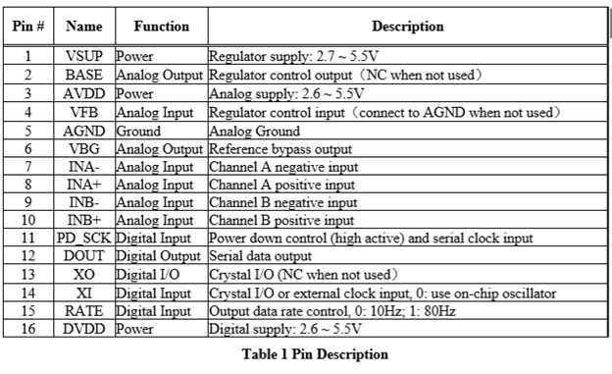

**Application notes:**

* The channel A differential input is designed to interface directly with a bridge sensor’s differential output. The large gains are necessary to track the small output from the sensor. When 5V is supplied the gains should correspond to a full-space differential of the input voltage give or take 40mV.
* The digital power supply (DVDD) should be the same power supply as the MCU power supply.
* If you use the internal analog supply regulator the dropout voltage of the regulator is dependent on the external transistor used. The output voltage can be determined by the equation below.

VAVDD=VBG*(R1+R2)/ R1.

* If avoiding using an external clock, connect pin XI to ground; this activates the on-chip oscillator.

**Serial Interface:**

* The HX711 uses a serial interface to communicate with a MCU. Pins PD_SCK and DOUT are used for data retrieval, input selection, gain selection and power down controls. When the output data is not ready for retrieval the digital output pin is high. The serial clock input PD_SCK should be low. Likewise with the DOUT goes to low, this indicates that data from the sensor has been amplified and is ready for retrieval. To retrieve the data 25-27 positive pulses must be sent to the PD_SCK pin, which shifts data out from the DOUT output pin. Each pulse from PD_SCK shifts 1 bit from the DOUT pin. On the last pulse, the 25th bit, the PD_SCK input to the Hx711 chip will pull DOUT pin back to high.

- Gain is selected by the number of input pulses as shown below.

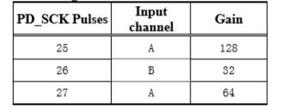

Device description, tables and figures were found via the HX711 datasheet.

<https://www.mouser.com/ds/2/813/hx711_english-1022875.pdf>

# 7.0 Functionality IV Waiter Tracker

The purpose of the waiter tracker is to provide a way for the server and the guests to communicate the need for assistance during the dining experience. This functionality will be achieved through a means of wireless communication, so that the server can know when the guest needs assistance, and to verify that the guests are finished being assisted. The waiter tracker functionality ties closely with other subsystems of the smart table, which will be discussed below as well as the array of wireless technologies that were considered to fulfil the waiter tracker functionality.

To achieve this functionality a few different technologies were considered, like radio-frequency identification (RFID), Bluetooth, and WiFi. The primary purpose of this wireless communication is to work alongside other subsystems of the smart table to allow a means of communication between the guest and server. The guest will have the ability to press a button which will signal the waiter that the guest needs assistance. Upon pressing the button the RGB LED lighting underneath the table will illuminate, prompting the server to come over. Additionally, a simple character message will be displayed on the information display that will inform the guest that the server will arrive shortly. Once the server is finished assisting the guest there is a need for the server to be able disable or acknowledge that the request has been finished, and thus where the need for wireless communication comes into play.

## 7.1 WiFi Protocol

The first technology that was considered for the waiter tracker was WiFi wireless communication. By integrating WiFi, the smart table would enter the large ecosystem of internet-of-things (IoT) connected devices. Wi-Fi is a wireless networking technology defined by the IEEE 802.11 standard. [1] WiFi was considered as a wireless communication medium for the waiter tracker because it has the ability to transfer packets of data over the air, via standardized high frequency waves, which will fulfil the needs of the waiter tracker communication. [1]

The advantages of the WiFi communication technology will now be outlined. WiFi communication is a widely used standard with a vast array of support, meaning that during integration any problems will be easy to diagnose because of how many resources available. Another advantage is that WiFi is a robust wireless protocol that can support up to 866.7Mbps of throughput multiplied over 8 simultaneous channels. [2] This means that if the smart table would ever evolve to a form where large throughput was needed, WiFi could easily facilitate this without major electrical design overhauling. Perhaps the biggest advantage of WiFi in the context of this project is that the range is very good. Good range will likely be needed in a restaurant setting where communications may be taking place across an entire restaurant.

The disadvantages of the WiFi communication technology will now be outlined. WiFi requires a fair bit of overhead and complex hardware to facilitate due to its more robust nature. This means that hardware and software development will require more resources compared to other wireless communication standards like Bluetooth. Another disadvantage is that WiFi requires much more power, up to 40 times, to run compared to other options like Bluetooth and passive RFID. [3] WiFi can consume on average 50 milliamps for a read and around 200 milliamps for a transmission.

A major consideration to weigh if WiFi is selected as the communication medium for the waiter tracker functionality is that inherently there will need to be multiple hosts for WiFi communication to function. This means that an integrated WiFi capable chip will be integrated into the main printed circuit board of the smart table. Additionally, there needs to be another WiFi host that the server would need to use to send and receive commands from the table. To achieve this a separate battery powered device could be developed for the server to receive and send commands to the table, or more likely a smartphone application would be developed to send and receive these commands.

The particular component that was considered in regards to this communication technology is manufactured by Espressif Systems, and its product number is: ESP8266EX. [4] The ESP8266EX is a highly integrated WiFi system on a chip (SoC) that would operate as a slave to a host microprocessor on the smart table PCB. Furthermore the chip has 802.11 b/g/n support in the 2.4 GHz band which will provide adequate throughput and range for the smart table. The operating voltage of the ESP8266EX is 2.5 volts to 3.6 volts, and has an average current draw of 80 milliamps.

## 7.2 Bluetooth Protocol

The second technology that was considered for the waiter tracker was Bluetooth wireless communication. Bluetooth is another method of networking and is defined by the IEEE 802.15.1 standard. [5] WiFi and Bluetooth both operate in the same ISM frequencies but are not compatible with each other. This communication protocol was researched because it can still fulfill the functionality necessary for the waiter tracker but with a different set of tradeoffs. The advantages and disadvantages of Bluetooth will be outlined below.

The advantages of the Bluetooth communication protocol will now be outlined. Like WiFi, Bluetooth can be a very robust wireless communications medium. In the context of the smart table, the throughput and latency far exceed what is currently needed for the waiter tracker functionality. Since the waiter tracker wireless communications will only need to send very basic notification flags and character strings over the air, the 1Mbps data rate is plenty sufficient. [5] Another large advantage to Bluetooth is that the power consumption is very low. Bluetooth communication is less sophisticated communication protocol that still meets the needs of the smart table.

The disadvantages of the Bluetooth communication protocol will now be outlined. The primary disadvantage with regards to the smart table is that Bluetooth has a lower range when compared to WiFi, which in a large enough restaurant setting, could be an issue with typical range of Bluetooth 2.0 at roughly 33 feet. [5][6] Additionality Bluetooth is more susceptible to radio frequency interference and signal drops would yield a negative experience for the guest.

Another consideration to take into account is that like WiFi, it will be necessary to develop some form of a host device in order for the Bluetooth communication to be functional. This means that additional development overhead will be necessary for the likely development of a server smartphone application. The alternative solution to developing an application would be to design a standalone device that would receive commands that the server would have access to.

The particular component that was considered in regards to this communication technology is manufactured by Cambridge Silicon Radio, and its product number is: BC417143B-IQN-E4. This device is a single chip radio and baseband integrated-circuit for Bluetooth 2.4GHz systems that supports enhanced data rates (EDR) to 3Mbps. The BC417143B-IQN-E4 is paired with a separate 8Mbit external flash memory to store the firmware and Bluetooth stack. [7] The chip operates from 1.6 volts to 3.6 volts and a maximum output current of 140 milliamps, but has support for a low power much with as little as a 4 micro-amp current draw.

## 7.3 RFID Protocol

The third technology that was researched for the waiter tracker functionality is radio-frequency identification (RFID). RFID uses electromagnets with electronically stored information, and operates at 13.56 MHz. [8] Many restaurants currently use RFID based card so that when a server with access a computer, they tap the RFID card and it will log the server in as that user. A similar approach can be implemented into the smart table design and as such this technology was researched.

RFID was researched for this project, however if selected to be used for the waiter tracker, the scope and functionality of the waiter tracker would need to be changed when compared to using Bluetooth or WiFi. Instead of relying exclusively on an application that we would need to develop, or using a separate host device for the server to us RFID would be implemented differently. The design of the smart table would include a RFID reader embedded into the surface, and the server would have at tag that can be used to acknowledge when a table has been assisted. This alternate approach has other tradeoffs that will be considered. The advantages and disadvantages of implementing RFID will be outlined below.

The advantages of the RFID communication protocol will now be outlined. The major advantages to RFID is the context of the smart table is that the need for a separate smartphone application would not be necessary. Although this would mean that the smart table’s functionality would not be as feature filled, it also still can work to signal off the RGB LED lighting when the guests have been assisted, which is the minimum requirement. Another advantage is that the RFID tag that the server would carry is a passive device and requires no electrical design or overhead to consider, and thus making this a much simpler solution. Finally, the throughput is substantial enough to transmit the data necessary to communicate that the server acknowledged a guest request.

The disadvantages of the RFID communication protocol will not be outlined. One of the disadvantages with RFID is that can suffer for interference, and when subjected to any magnetic interference can erase the data in the tag. [9] Additionally, like mentioned in the advantages, aside from not having to develop a smartphone application, the downside is that the smart table will be less feature filled. Instead of the server receiving notifications when the guests need assistance, they server will only be able to notice a table needing assistance from the LED illumination pattern.

The particular component that was considered in regards to this communication technology is manufactured by NXP Semiconductors, and its product number is: MFRC522. [10] This module provides contactless communication at 13.56 MHz, which is RFID’s operating frequency. This module operates from 2.5 volts to 3.6 volts and has typical current draw of 60 milliamps, with a maximum of 100 milliamps.

## 7.4 Comparing Components and Final Selection

|  |  |  |  |
| --- | --- | --- | --- |
|  | WiFi a/c | Bluetooth 2.0 | RFID |
| Cost | High | Low | Medium |
| Range | 200-800 ft | ~33 ft | Contact |
| Current Draw | ~80mA | 4uA (Low power mode), 140mA max | ~60mA |
| Operating Voltage | 3.3V | 3.3V | 3.3V |
| Security | Available | Available | N/A |
| Data Transfer Rate | Up to 866.7Mbps | 1Mbps | Up to 424 kbps |
| Latency | <1ms | 6ms | 1ms |
| Smartphone Application Development Needed | Yes | Yes | No |

*Table 5 - Comparing Waiter Tracker Wireless Communication Part Selection*

Table 5 above compares all the particular components that have been researched with regards to the smart table waiter tracker functionality. The left column contains criteria that has been deemed worthy to consider in regards to selecting an effective waiter tracker technology. The row at the top refers to the parts that were selected, meaning that the WiFi a/c correlates to the Espressif Systems ESP8266EX, Bluetooth 2.0 correlates to the Cambridge Silicon Radio BC417143B-IQN-E4, and RFID to the NXP Semiconductors MFRC522.

Based on the tradeoffs outlined above, the Cambridge Silicon Radio BC417143B-IQN-E4 was selected for the waiter tracker functionality. This chip will be implemented using a surface mount device that incorporates the bluetooth chip. Due to the fact that this device was selected means that a mobile application will need to be developed to support this device, therefore details on the mobile application will investigated in later sections.

# *8.0 Functionality V - Motion and Light Detection

A sensor is an electronic device which is used to detect the change in their surroundings. The purpose of motion sensors here is to provide a unique experience to customers when they sit down at the table. There will be different sensors implemented into the table which will create a unique lighting based on the environment.

**Infrared Sensor -** There will be an infrared sensor which will detect the object around the table. Infrared sensor which is also known as IR sensor have light sensors that detects the light wavelength in the infrared spectrum. It is made of 3 major components: Emitter, detector, and operational amplifier. The emitter is basically an infrared LED (diode) and the detector is an infrared photodiode which senses the rays sent via emitter shown in figure below.

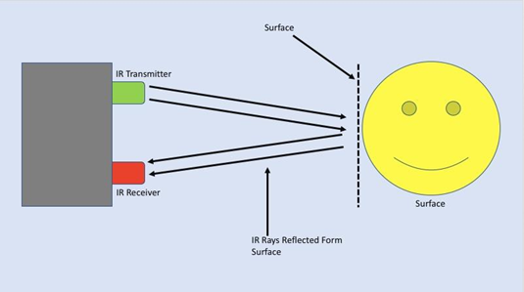

Figure 3.8.1 – Illustrates the functionality of an Infrared sensor when it detects the motion around the sensor.

There are different types of infrared sensors which are classified into two main types. The first are called Thermal infrared sensors which utilize infrared energy as heat. Thermal infrared is advantages because it does not require cooling, but it is disadvantageous because of its low detection capabilities and slow response time. Second type is known as Quantum infrared sensors which is better than Thermal infrared sensors when it comes to response time and detection capability. However, the only disadvantage about Quantum sensors have are that they require time to cool down in order to get accurate results.

For our project, we will be using Infrared analog distance sensor. The particular component that was considered in regard to this infrared sensor is sold by Sharp. Its part number is: GP2Y0A21YK0F shown in an image below. It senses the object within 80 centimeters (~ 32 inches) of its range. This particular sensor operates at roughly 4.8 volts, but it can operate at up to 5.5 volts, and low as 4 volts. Typical current draw for this component is about 30 milliamps. Another advantage of this particular sensor is it is compatible with Arduino. That way it can be customized, and it is versatile.

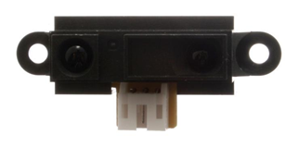

Figure 3.8.2 – Shows an image of the Infrared sensor designed by Sharp that we will be implementing in our table.

The other two infrared sensors that were researched for this particular task were also designed by the same manufacturer, Sharp (Part number is: GP2Y0D805 and GP2Y0A41SK0F). However, there were three disadvantages of the sensor. Mainly the insufficient sensing range. They both (GP2Y0D805 and GP2Y0A41SK0F) can sense only up to 30 centimeters. secondly, one of them (GP2Y0A41SK0F) was not compatible with Arduino. And lastly, it operates at 6.2 volts which was higher than the other one.

|  |  |  |  |  |  |
| --- | --- | --- | --- | --- | --- |
| Manufacturer | Model | Sensing Range | Input voltage | Dimension (mm) | Arduino Compatible |
| Sharp | GP2Y0A21YK0F | 80 cm | 4.8 V | 29 x 13 | Yes |
| Sharp | GP2Y0D805 | 4 cm | 6.2 V | 22 x 9 | No |
| Sharp | GP2Y0A41SK0F | 12 cm | 5.5 V | 29 x 13 | Yes |

Table 1 - Comparing Infrared Sensor Part Selection

We will be implementing the Infrared sensor in the box on the left side of table with other components. Infrared sensor will be connected to Arduino. As shown in figure above, the transmitter will send the signal. Once it detects the object, the receiver will receive the rays, and an Infrared sensor will send the signal to the second sensor which will change the lighting environment underneath the table which will be discussed next.

**Photocell Sensor -** We will be using Photocell sensor along with Infrared sensor to control the lighting system on the table. Photocell acts as a light sensor. There are different types of Photocells with varying uses. The first is called Photovoltaic. Photovoltaic cells convert solar energy into electrical power. Second one is called Charge – Coupled Devices. They are one of the most reliable and accurate photocell sensors. Charge coupled devices are mostly used by scientific community. The third is called Golay Cell which are used to detect Infrared radiation. Another photocell sensor to note is the Photomultiplier. Photomultiplier cells are extremely sensitive. Lastly, are Photo resistor. Photo resistor’s resistance decreases as the amount of light they are exposed to. A common use for photocells is turning lights on and off based on the brightness around the sensor. Photocell is simply a resistor that changes the value based on how much light it gets. Properties of Photocell vary from model to model. A simplistic approach to checking sensitivity is by measuring resistance as we subject it to dark and light shown in graph below.

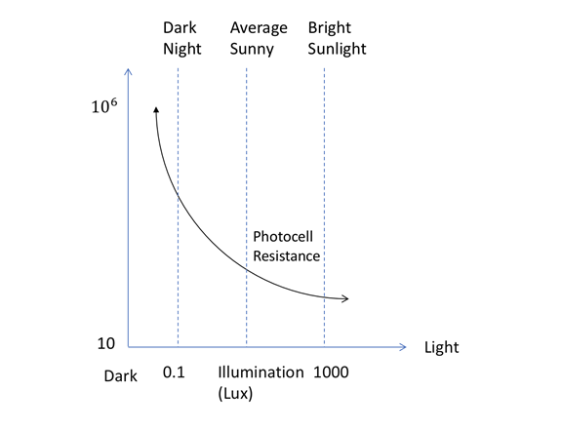

Figure 3.8.3 – Illustrates how Photocell sensors react when detecting the different levels of brightness around the sensor.

This type of sensor is commonly found in electronic devices such as smart phones, and computers. Ambient Light Sensors are mainly utilized to save energy and affect power consumption. In addition, Ambient Light Sensors also increase the life of the device. For example, Ambient Light Sensor can be found in Apple’s Macbook portable computers. It is implemented into the display enclosure along with front facing camera. It will detect the brightness around the device and it will adjust the display and keyboard brightness to save battery and also makes it easy to read on display by providing correct amount of brightness show in picture below.

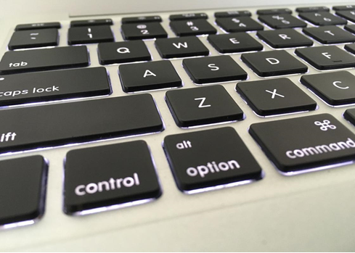

Figure 3.8.4 – is an image of Apple’s MacBook portable computer demonstrating the auto brightness of the keys based on built in Ambient Light Sensor.

We did research about what photocell sensor we should use for our project since they are different aspects such as resistance tolerance, speed of response, application for what photocells. There are two categories when it comes to photocells: Analog and Digital. We decided to use analog because it is more suitable when it comes to measurement types such as exposure control. Because Digital is mainly used for on – off function. There are also two different types of materials manufacturers use to manufacture photocell. One is type “[Symbol]” and second is type “3”. Type “[Symbol]” is generally used for automotive sensors and nightlights. Whereas type “3” can be found in streetlight controls and cameras.

We will be implementing Photo resistor by using Ambient Light Sensor along with Infrared sensor and connect them to Arduino board. We will be connecting Photocell in wired series with resistor that way Arduino can read the output in voltage. Few other advantages of photocell are low power, small size, and cost. They are also easy to use and do not wear out.

We looked into different Ambient light sensors to see which meets our requirements and fits best for our project. We decided to use Gravity Analog Ambient Light Sensor for this specific task. The particular component that was considered in regard to this Ambient Light sensor is sold by DFRobot. Its part number is: DFR0026. It can detect illumination from 1 Lux to 6000 Lux in response time of less than 15us. This particular sensor operates at roughly 3.3 volts, but it can operate at up to 5 volts, and low as 3 volts. It is also very small when it comes to the size. This particular sensor is 22 mm x 30 mm (0.87” x 1.18”).

The second infrared sensor that was researched for this particular task was designed by SparkFun (Part number is: TEMT6000). However, there were disadvantages utilizing this sensor. Mainly because it only detects illumination from 0 to 1000 lux. Its light sensing curve was very linear. And another disadvantage is it is also a little bigger in size than the one manufactured by DFRobot. In addition to that it also does not support Arduino, therefore, we considered using DFR0026 for our project.

|  |  |  |  |  |  |
| --- | --- | --- | --- | --- | --- |
| Manufacturer | Illumination | Response Time | Input voltage | Dimension (mm) | Arduino Compatible |
| DFRobot | 1 to 6000 Lux | > 15 us | 3.3 V | 22 x 30 | Yes |
| SparkFun | 0 to 1000 Lux | > 25 us | 4.5 V | 4 x 6 | No |
| ROHM Semiconductor | 0 to 65000 Lux | > 40 us | 3.6 V | 2 x 4 | No |

Table 2 - Comparing Ambient Light Sensor Part Selection

Ambient Light sensor will be implemented in the box on the left side of table along with Infrared sensor. An Ambient light sensor and Infrared sensor will be connected to the board. Initially the light will be off if there is no presence detected around the table. Once an Infrared sensor detects the motion around the table, it will turn the lights on. Once the lights turn on, photocell sensor will detect the brightness around the table and it will adjust the light based on the brightness around the table. If there is no movement for a long time around the table and infrared sensor doesn’t detect any motion, then it will turn the lights off. Below in flowchart 3.8.5 is the state machine for the Infrared and Ambient light sensors subsystems.

**Important Classes and Methods –** The “getStatus” class has methods tailored to determining what state the LED lights are in so that the information can be passed along to other subsystems as a simple public string**.** The “IR Handler” class has public integer variable called “IRsensorsIDList” that triggers IR sensor A and IR sensor B. The “IR Handler” class contains methods such as “getStatus”, “wakeSensor”, and “reset”. There is another important class called “Photocell Handler” which contains methods such as “setoff”, “reset”, and “wakeSensor”. “Photocell Handler” also contains method called “photoCellsID” and it communicates with “getStatus” to send and receive the updates regarding the photosensor A. The UML class diagram can be seen in figure 3.8.6 below.

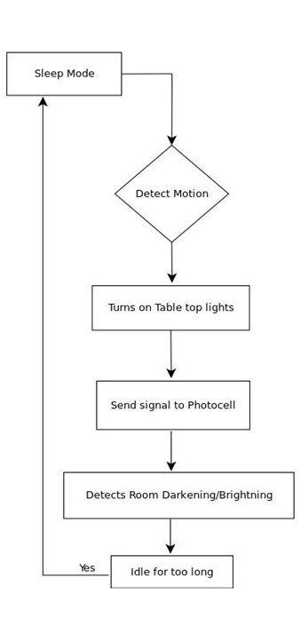

Figure 3.8.5 – State machine for Infrared and Ambient light sensors illustrate how both sensors interacts with board to control the lights around the table.

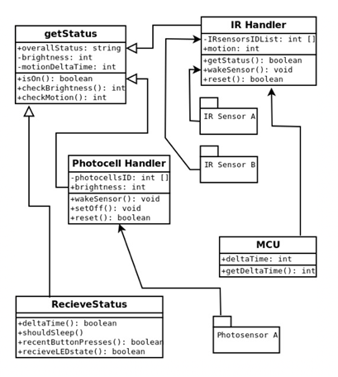

Figure 3.8.6 – UML class diagram for Infrared and Photocell Sensors

There are other products out there in market which only use one of the two sensors in the product. Some products use an Infrared sensor and not the Photocell sensor. And other uses Photocell sensor but not an Infrared sensor. There are couple reasons why we considered using both sensors and not just one. Main reason is user experience and second is power consumption. Hypothetically, if we only use an Infrared sensor, it will detect the object and turn the LEDs on around the table which only have one brightness setting and color option. In this instance LEDs might be too bright for some customers when it comes to color option which can create a bad customer experience overall. On the other hand, if we only implement Photocell sensor and not an Infrared sensor then Photocell will always keep the LEDs on regardless if there is someone around the table since it will not have an Infrared sensor to help detect the object around the table. This will use too much power overall and it will not be the best option when it comes to cost efficiency. Therefore, using one sensor instead of two will not be the best option when it comes to customer journey and power consumption. In addition to that, using two sensors together will save power. Based on research and part selection, the sensors we are considering implementing fits best when it comes to cost efficiency since they operate at very low voltage.

# 9.0 Functionality VI - Structure and Materials Research

The smart table is a combination of electrical and computer engineering design, but additionally it includes construction elements. The guests will be sitting at a table that fully integrates the smart table functionality, and as such research on material selection, finish and varnish, routing, and other consideration must be conducted. This section will outline this research to ensure that the guests are safe from the electronics and that the “smarts” in the table will not be damaged.

## 9.1 Materials Types

Research on selecting a primary table material was needed in order to decide which material would be the best for the project. The types of materials that were considered for the smart table were wood, glass, metal, and concrete. These types of materials were considered due to the fact that they could all be utilized to achieve the aesthetic that is desired, as well as conceal the smart table’s electrical components well. In the sections below the tradeoffs between each material selection will be discussed.

## 9.2 Wood

The first material that will be discussed as a material for the table is wood. Wood is a highly versatile material that comes in many different types, each with their own characteristics. Wood is the most common material for any type of furniture and as such it was a natural consideration for the project. Different types of wood include solid woods, engineering woods like plywood, and particleboards like medium density fiberboard. The advantages and disadvantages of using wood as a primary material will now be discussed.

The advantages of using wood as a primary material for the project will now be outlined. Wood is extremely easy to work with compared to other materials. It can be formed with saws, screws, and other woodworking tools without the need of welders, grinders, etc. Wood materials also have the bonus of being very durable especially when finished properly, and if selecting the proper type. [11] The abuse that guests from a restaurant will inflict on the table means that it needs to be durable. Perhaps the biggest advantage is that wood in non-conductive which means there is no electrical risk for the guests at the table.

The disadvantages of using wood as a primary material for the project will now be outlined. Depending on the types of wood, like walnut, it can be expensive. Additionally wood tables will require the need to apply a finish of some sort like polyurethane to ensure that it is water resistance and can protect the components beneath it. This requires more work that other materials that will not need any types of finish work to be completed.

|  |  |  |  |  |  |  |  |  |
| --- | --- | --- | --- | --- | --- | --- | --- | --- |
|  | Beech | Oak | Mahogany | Walnut | Pine | Plywood | MDF | Veneer |
| Cost | $$ | $ | $$$ | $$ | $ | $ | $ | $ |
| Durability | Medium | High | High | High | Medium | High | High | Low |
| Color | Light | Light | Red | Dark | Light | Varies | Light | Varies |
| Type | Solid | Solid | Solid | Solid | Solid | Engineered | Engineered | Engineered |
| Aesthetic Preference (1-5) | 3 | 2 | 4 | 5 | 2 | 2 | 1 | 3 |

If wood was selected as a primary material for the smart table then further consideration into the type of wood would need to be made. In table 6, the tradeoffs between various types of wood can been seen. Cost, durability, color, type, and aesthetic preference have been deemed worthy of consideration in regards to the smart table. Walnut will likely be selected as the wood of choice as it is durable, less expensive than others, is a solid wood, and the group prefers its overall aesthetic.

## 9.3 Metal

The second material that will be discussed as a material for the table is metal. Metal tables are on the opposite end of the spectrum from wood tables. They provide a completely different design aesthetic and considerations like finish do not apply. The advantages and disadvantages of using wood as a primary material will now be discussed.

The advantages of using metal as a primary material for the project will now be outlined. The primary advantage to metal tables are that they are far more durable than any wood or glass table. As a result, there will be no need to maintain the table after it is integrated. [12] Additionally, a metal tabletop is modern, stain resistant and cool to the touch. In the restaurant setting a metal table would be advantageous for its ability to be sanitary and cleaned easily.

The disadvantages of using metal as a primary material for the project will now be outlined. It is well known that metal or steel is very heavy, and it is common that restaurants may need to rearrange their tables. [12] In the context of electronics, metal tables run the risk of electrical shock to the guests if the electrical components short circuit because metal tables are conductive. One last disadvantage is that metal is harder to worth with and would require more specialized tools like welders and grinders to construct.

## 9.4 Glass

The second material that will be discussed as a material for the table is glass. Glass tables are not as common as wood tables however they offer some characteristics that may be desirable for the smart table design. The advantages and disadvantages of using glass as a primary material will now be discussed.

The advantages of using glass as a primary material for the project will now be outlined. Glass is easier to clean than the other surfaces in respect to a restaurant. It provides a very elegant look and can make a room appear bigger. When used in conjunction with the RGB LED illumination of the smart table, a glass table can enhance the lighting effects.

The disadvantages of using glass as a primary material for the project will now be outlined. Glass is a very expensive material for a table, which is why it is not as common in a restaurant. Additionally, there are risks involved because glass can break and injure guests or employees. Concealing hardware on a glass table would also prove to be difficult as the surface is clear, therefore other non-glass components would be needed. The biggest problem with glass in the context of the project is that glass is not malleable in anyway after it is manufactured, therefore construction some of the housings for the hardware could be very difficult.

## 9.5 Final Material Selection

Table 6 combines the information discussed in the previous section to help determine the best choice for the smart table. Considering all of the tradeoffs between wood, metal, and glass for the main material of the table has led us to choose MDF. The type of MDF that will be used in a ½” MDF sheet, which provides great durability, when coated with a clearcoat or paint. The priming and paint of the MDF will ensure that the material is waterproof and suitable for restaurant application.

|  |  |  |  |
| --- | --- | --- | --- |
|  | Wood | Metal | Glass |
| Cost | $$ | $$ | $$$ |
| Durability | Medium | High | Low |
| Sanitation | Good (With Varnish) | Good | Excellent |
| Safety | High | Conductive | Fragile |
| Ease of Construction | Easy | Medium | Hard |
| Aesthetic Preference (1-5) | 4 | 4 | 2 |

*Table 6 - Comparing Table Materials*

## 9.6 Wood Finishing and Construction Practices

As a result of selecting MDF as the primary design material, further research is necessary. By choosing MDF, considerations for the finish in the form of sanding and applying lacquers/paint will be discussed. Plane joining and construction practices need to be investigated to ensure that the table can be built effectively and incorporate the electronics nicely. Additionally, since glass will also be used in the design research will be presented in regards integrating that as well.

## 9.7 Sanitation Standards

In order to make a table suitable for placement in a restaurant or public establishment, it must be understood that while being indoors away from the elements, a table will be subjected to the rigors of its operating environment. Of particular interest is that types of sanitation used in industry can be quite abrasive. Additionally, the table must not only be made sanitary at its introduction, but must be able to be sanitized long into it’s prospective life cycle. In a nutshell, the construction of the table will need to avoid delicate maintenance such as needing oil, yet maintain desirable characteristics such as impermeability.

**Desirable Characteristics-** For what the FDA considers non-food contact surfaces the following desirable characteristics are considered: Smooth, Non-porous, Corrosion-Resistant, Chemically Inert, Modular, Free of Crevices/Sharp Edges. In the food service natural surfaces such as wood must be finished so as to be smooth enough that the amount of food material left on the surface after wiping is minimal, thus reducing the number of bacteria that can colonize the surface. Additionally certain materials such as less dense varieties of wood like pine are too porous, while denser woods such as teak could be virtually sealed with only a proper polish and no varnish at all.

**Chemistry Involved-** While many materials and finishes may seem suitable at first glance, in the food service industry it is necessary for surfaces to stay consistent despite repeated chemical exposure. In the food service industry it can be expected that a surface be able to withstand sterilization. The most common chemicals encountered when wiping non-food contact surfaces are bleach and quaternary ammonia soaps. Occasionally iodine solutions are sometimes employed. Solutions containing bleach would be expected to have between 25-100 MG/L of chlorine. Even a relatively dilute bleach mixture can promote corrosion and pitting of metals. Likewise, quaternary ammonia soaps emulsify any protective polishes or oils needed for the long term health of quality wood surfaces. Finally, iodine can easily discolor lightly colored materials over time. Finally warm water itself is the “universal solvent”. Even without a chemical reaction, water can even damage surfaces by causing them the swell, and contract (see figure 38a).

Another sterilization method frequently employed is surface decontamination with ultraviolet B lamps. It is conceivable that if sunlight can damage resins, and denature plastics over time that strong ultraviolet light from sterilizers in conjunction with sanitizers such as chlorine will contribute significantly to corrosion. Corrosion is undesirable primarily because over time it undermines a surface’s ability to be non-porous. Interestingly, there is also a concern in the food industry with eliminating corrosion because it increases the probability that particles of the surface might break off, contaminating food. Being a non-food contact surface, a table does not have the same standards as dining ware, however it is important to note that lead content is considered. While it is common sense to isolate the table’s electronics for safety reasons, it is also important to remember that those components are not made with “food grade” materials. Exposure to oxidizers, surfactants and even moisture could cause dangerous substances such as lead to leach out.

**Conveying Cleanliness-** It is also an industry norm for items to be modular, so as to be disassembled for cleaning. The difficulty involved with dissesembling milkshake machines in fast food settings creates down time and the potential for lost revenue. Unlike a milkshake machine, a table is needs to be cleaned many times in a day and is absolutely necessary in day to day operation. To pass a health inspection any creases or unnecessary projections should be avoided in the design.

Finally in regard to looking clean. Common sense would dictate that an establishment’s cleanliness is one of the first things a customer notices when they walk in. While the sanitation methods in industry render a surface safe to eat from, they may not appear clean. Materials utilized must resist stains from coffee and wine. Lastly food service worker’s typically need to spend about 15 seconds wiping a table. As the table is being designed to be showcased in a dimly lit location, the surface should avoid patterns and textures that obscure the waiter’s ability to clean. Tiled tabletops were popular as tabletops because of their aesthetics and durability, however the grout washes away over time allowing food particles to become lodged between tiles (see figure 38.b).

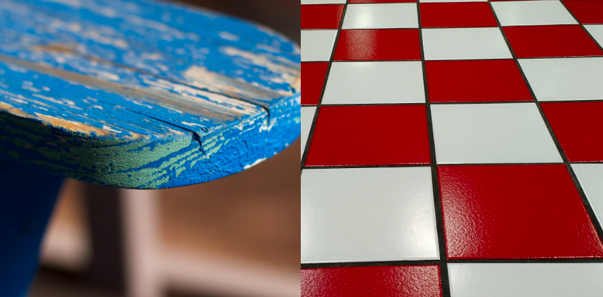

Figure 38.a,b- figure 38.a an example of water damaged wood, figure 38.b a tiled surface with food trapping grout.

CC4

Cite ME

# 10.0 Functionality VII - Power Considerations:

**Power Supply Unit**

This project is focused around low power embedded systems. The power consumption is relatively small except for the LED strip which at high power states will draw close to 2A of current. For this project, only logic level voltages (3.3V and 5V) are needed to supply power for all the electronics devices. Our final product is expected to be resting on a flat surface for its entire life cycle and will not need batteries to operate. The device will use a AC-DC converter down to 12V as our main input to the electronics board. The 12V input will be converted down into two separate voltages; 3.3V and 5V. The 3.3V will control electronic modules including the MCU, the BLE module, capacitive touch button, power FET signaling, and pull up resistors. The 5V line will source power to the LCD display, the LED strip, the load cell module, the RFID module, etc.

For the purposes of this project we have selected a switch-mode step-down voltage regulator. The input source will be converted from the wall AC supply to 12V DC. We will be using two identical regulators for two different output voltages 3.3V and 5V; which are determined by a resistor network external to the regulator IC.

After careful consideration and research using the TI Webench web software, we have chosen the Texas Instruments TPS563210. The TPS563210 is a simple, easy to use 3A step-down converter in a small 8-pin SMD package. The IC is optimized to operate with minimum external components and achieves this with low system current consumption. The switching frequency will be set to around 500KHz. The efficiency of the step-down regulator peaks upwards of 95% when the output current reaches over 1A.

To Determine the output Voltage a resistor network is needed on the feedback pin.

For 3.3V: R1= 33.2k ohm R2= 10K ohm

For 5V: R1 =54.9k ohm R2 = 10k ohm

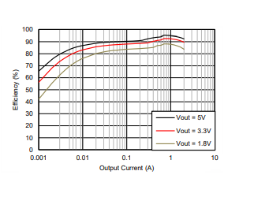

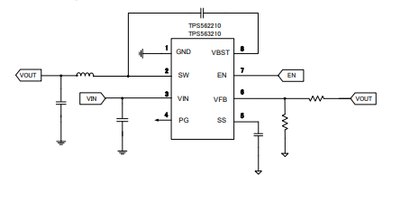

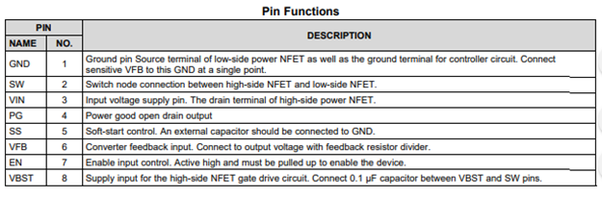

# 11.0 Functionality VIII - Misc / Creature Comforts:

**USB As A Standard -** The smart table aims to include the option of charging customer devices while they wait. As USB (Universal Serial Bus) port becomes pervasive, it is a well-defined standard with nearly two decades of existence it has established itself as a mainstream charging protocol.

**USB Cabling -** Since its launch USB has been composed of at least four wires: Hot, Ground, Data1 and Data2. Typically, the data lines exist as twisted pairs that may or may not be shielded depending on purpose and generation. For the earlier implementations of USB the maximum cable length is about 5 meters. This issue is because of signal latency to some degree, but primarily due to loss of power. Maximum cable length can be overcome with relay stations if latency is acceptable in the particular application.

**USB Launch -** The first generation of USB, the 1.1, was brought up to plug-and-play functionality following the launch of a Windows 95 service pack. Although the first generation was slow (11 MB/s), it established a standardized power infrastructure for the multitude of devices that are now powered by USB. In fact, many devices only tangentially related to computers use USB ports for power. Many smartphones are prohibited from being accessed directly by computers as mass storage, yet they still utilize USB charging. In fact, the contemporary iPhone doesn’t need to sync over USB, and most users sync over Wi-Fi, even for firmware upgrades. The USB 1.1 standard furnished up to about a half amp at 5V. Below in figure 12.a is the standard pin out for USB 1.1 / 2.0.

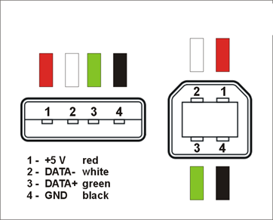

**Figure 3.11.1** - Shows a standard pin out for USB.

**USB High Speed -** USB 2.0 was backwards and pin compatible with most USB 1.1 devices. From a power delivery perspective USB 2.0 came in flavors outputting up to 1.5 amps at 5V towards the end of its lifespan. This bump in power output was to meet the demand of charging tablets. To achieve the faster 480 mb/s, USB 2.0 implemented shielding in the twisted pair data cables along with new communication protocols for sending packets.

USB 3.0 saw further changes to the way data was handled, but again backward compatibility remained. The 5V power and related total wattage stayed about the same as previous incarnations. The only real difference is yet a finer tolerance for the 5V output. In USB 3.0 the voltage drop/rise ranges from 4.45 to 5.25.

**USB-C -** USB-C marks the first real departure from the original USB design. The USB-C port is designed to be reversible and offers a whopping 24 individual pins. USB-C can potentially output up to 5 amps at 20V. USB-C is now the standard charging port for even full-sized laptops such as the MacBook Pro (image 14.a).

USB As Required- Many of the personal smartphone devices released in the European market have been required for some time to charge via standardized USB. More recently phones in the Chinese market have been required to conform to USB as a standard of charging.

**Charging-** A charging device identifies itself by putting a resistance no larger than 200 ohms across the two data ports. The USB devices vary the amount of current they pull down by having different voltages on each of the two data lines. When it comes to charging or how the whole process works, people always have one question that why is this taking so long to charge? According to research and consumer report consumers says that I charge my phone in x hours at home, but it takes all day to charge if I plug it into my work computer. This solely depends on the charger. The native charger which is also known as one comes with device often have a signature on it. It is specially designed for that model since it has custom data pins that tells the device that it is safe to charge with more current. This sometimes also prevents devices from charging if the host is unknown. This process is done by placing specific voltage on D+, or D-, or sometimes on both. The charging device recognize a charging port by using its own software or employ an integrated circuit that can interact with non-data signaling on D- and D+ terminal. Most of the devices these days have dedicated integrated circuit or microcontroller to manage port detection as well as current selection. Since devices mostly communicate with host over USB, it makes charging selection based on configuration. The device detects the port type and send appropriate signal to the charger. Once charger receives the signal, it handles the hardware and safety of charging since it has built in limit that prevents the battery from any danger.

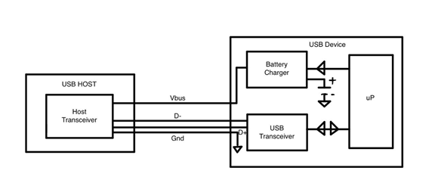

**Figure 3.11.2 -** Shows the design of a Nonenumerating charger. Here the microprocessor and USB transceiver handles the enumeration and microprocessor sets charger to right parameters.

Most devices comes with USB 3.0 technology now, but USB 2.0 uses configuration and enumeration that helps device learn how much current the port can source. Configuration and enumeration involves digital conversation between the host and device. Another important aspect is direct connection and load switch. One of the key design decisions involves whether a charge circuitry connects to the system load and battery directly, or an additional switch is required to disconnect the battery when an external power is connected. The schematic of this type of connection is shown in figure below.

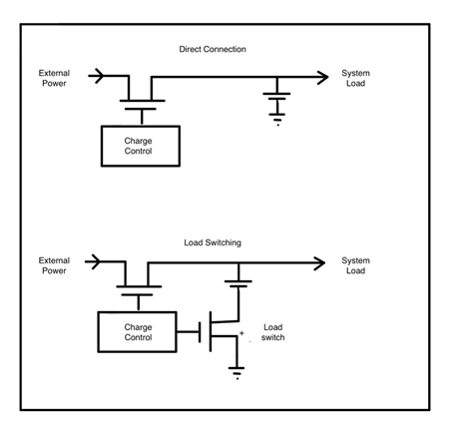

**Figure 3.11.3 –** Illustrate the difference between direct connection and battery load switch.

So far, we have talked about lot of important things such as sensors, software, and structure. We are also implementing some useful features to table. We are going to add wireless charger to the table where customer can just lay their phone while enjoying their meal. Wireless charger is not something new. It has been around for long time. There are basically three types of wireless charging technology in market. Wireless charging pads, charging bowls, and uncoupled radio frequency (RF) wireless charger which allow charging capability at distance of few feet. Principle of inductive charging can be found in devices like toothbrush.

Wireless charger uses resonant inductive coupling. It is basically a loop of coiled wires around bar magnet. Which is also known as inductor. It has very simple process. When the current passes through coiled wire, it creates electromagnetic field around the magnet, so it can transfer the voltage to charge the device around. Most of those wireless chargers these days uses mat with an inductor inside to make it simple. There is also a tiny transmitter inside the charger which communicates with receiver inside the device it is charging to ensure charger does not power an errant object.

We will be implementing a Qi wireless charger with PCBA circuit board with coil charging pad in our table. The particular component that was considered in regard to this wireless charger is sold by DataCaciques. Its part number is: CDQ0018 shown in an image below.

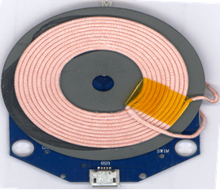

**Figure 3.11.4 –** is an image of wireless charging pad which will be implemented in our product.

It senses the object within 10 millimeters its range. This particular wireless charging pad operates at roughly 5 volts. Typical current draw for this component is anywhere from 500 to 100 milliamps. Another advantage of this particular charging pad is it is ready to use. All you need to do is plug in to power outlet with Micro USB cable and it is ready to use. It is also compact when it comes to size. It is 32 millimeters by 31 millimeters in size. This Qi wireless charger is compatible with any device that has built in wireless charger receiver. For example, smart phones like iPhone, Samsung, Motorola devices has built in capability which can be used with our Qi wireless charging pad.

There are couple reasons why we decided to implement wireless charger in our table. First and most important one is safety. As we mentioned that it uses inductive charging. Conducting material is sealed inside the device and charger and it is not exposed. Which means touching it with wet hands will not be an issue. Therefore, it would be better to use something like wireless charger specially if there are kids around the table. Second one is it is universal. Lot of devices these days has different pins when it comes to charging port. For example, Apple uses designs its own pin called lightning port. Samsung uses USB C technology, Motorola uses Micro USB. If we use regular charging cable, then it would be too many cables around the table and it is more clattery as well. Therefore, having one charger serves all devices is more practical. And last one is convenient. Charging device wirelessly takes zero efforts. All you do is set the device on top of mat and it does the job. That way customer does not have to worry about plugging the device to cable and worry about dropping the device of the table. It also increases life of device by not plugging and unplugging it so many times which can affect on device’s charging port over time.

**Smart speaker -**  Another important and useful thing we will be adding to our table besides wireless charger is a smart speaker. We did some research on why we should implement a speaker in our table and what would be the benefits of it. We have experienced that the moment you enter into restaurant, you will notice three key things. Sound, sight, and smell. Restaurants spend lots of money on an interior and decoration to appeal to sight. But what about sound? Research shows that music played during dining and shopping can affect customer’s attitude and mood. It also effect on customer’s impression of the brand when they visit. Music also helps indirectly when it comes to wait time. It makes waiting more pleasant. It is the easiest ways to enhance the vibe of the restaurant.

We looked into few different speakers to find which fits the best. We looked into regular wired speaker which can be plugged into any smartphone via 3.5-millimeter headphone jack. We found some wireless Bluetooth speaker which can be paired to any smartphone or tablets. And lastly, we looked into smart speaker which is getting very popular these days. There are few reasons why we decided to go with smart speaker over wired speaker and wireless speaker. First disadvantage of wired speaker is you have to plug the device using wire. Lot of smartphone these days are getting rid of headphone jack because of more and more use of wireless headphones and speaker. We figured that lot of customers will not have the devices with headphone jack, so it will not benefit the larger amount of people. In addition to that we also wanted to keep the table as simple and clean as possible. Having lot of wires around the table does not look good and can take some space as well.

The reason why we are not considering Bluetooth speaker is because of an inconvenience. The particular component that was considered in regard to this wireless speaker is sold by JBL. Its part number is: JBLCLIP2BLKAM. For example, most of the Bluetooth speakers can only let one device pair at a time. If there are group of people sitting around the table and they wanted to play different songs, then either one person has to pass around the phone which most of the people do not like to do due to privacy concern or one has to disconnect the phone, so other person can connect their phone which is hassle. Another disadvantage of these types of wireless speaker is charging issue. Most of the Bluetooth speakers in market has built in battery which requires charge time to time. If management forgets to charge the speaker then it will not be the good experience for customer. In addition to that, it is also a hassle to charge the speaker every day and go forth and back. Therefore, using traditional Bluetooth speaker will not be the best idea.

There are many benefits of using smart speaker. There are lot of different options out in market when it comes to smart speaker. The particular component that was considered in regard to this smart speaker is sold by Google. Its part number is: DHGA00210US and model name is Google Home Mini. This particular speaker operates at roughly 5 volts. Typical current draw for this component is about 1.8 amps. It has 802.11 a/b/g/n/ac Wi-Fi capability. It is 3.86 in by 1.65 in when it comes to size and weighs about 6 oz. All you need to do is just plug in to power outlet with provided Micro USB cable and it is ready to use.

We have also looked into other smart speakers such as Amazon’s Alexa Echo Dot and Apple’s recently released HomePod. Each of them basically does the same things at the end. It just they work on different platforms. After doing some research on these speakers, we found out it is limited when it comes to search request on Amazon’s Alexa Echo Dot and Apple’s HomePod. For example, you cannot ask Echo Dot to play other music services since it only offers limited streaming services. Same goes for HomePod. It only lets you stream music from your phone or Apple Music. On the other hand, Google Home Mini can answer any questions you have. We thought it would be an entertainment hub for customers and specially for kids. For example, it can play any music you ask for by simply saying “Hey Google”. It can also answer any of your questions from current weather to current traffic. Kids can play trivia or can laugh to some jokes by asking Google. Another important thing is cost factor. You can purchase Google Home Mini for $29 versus Amazon’s Echo Dot is almost $49 and Apple’s HomePod is $349. In addition to that Apple’s HomePod is so big that it will not fit into our box on side of the table since it is 6.8 in by 5.6 in and weighs 5.5 pounds. Therefore, after comparing the details shown below, we are considering Google Home Mini for our project.

|  |  |  |  |  |  |  |  |
| --- | --- | --- | --- | --- | --- | --- | --- |
| Manufacturer | Model | Aux | Requires Charging | Requires  Power | Size (W x H) | Weight | Price |
| Amazon | Echo Dot | No | N/A | Always | 3.3 in x 1.3 in | 5.75 oz | $49 |
| Google | Home Mini | No | N/A | Always | 3.9 in x 1.7 in | 6 oz | $29 |
| Apple | HomePod | No | N/A | Always | 5.6 in x 6.8 in | 5.5 lbs | $349 |
| JBL | Clip 2 | Yes | Yes | No | 3.7 in x 5.6 in | 0.4 lbs | $39 |

Table 3 - Comparing Smart Speaker Part Selection

Good part about this speaker is customer doesn’t need to pair their personal devices to public device and anyone at the table can access it easily without any hassle. Another advantage of the smart speaker is it also has endless opportunities. For example, we can connect it with Arduino and we can also let Google Home control the LED lights around the table by simply asking “Hey Google, turn off the lights”. These types of features can be implemented in future.

# 12.0 Command Center

This section is meant to clearly explain what the “command center” is and how it will be used in the design. Simply put the command center is a home for the major electronics in this project. This command center is essentially a box that sits on a table giving it all the desired “smart” capabilities. This command center houses the PCB which in turn contains, or at least is directly connected to all components with the exception of the external signal LED strips. The command center serves functionally to protect the delicate electronics, and enhances marketability by allowing a customer to retrofit any table. The signal LED strips are connected to the PCB via wiring, and are adhered to the bottom of a table. The LED strip is connected over one NZR data line peaking at 5V, and then to the 5V regulator on the PCB. Figure 4.0.1.a shows an artistic rendering of the “command center” along with its external signal LEDs relative to the table they are placed on.

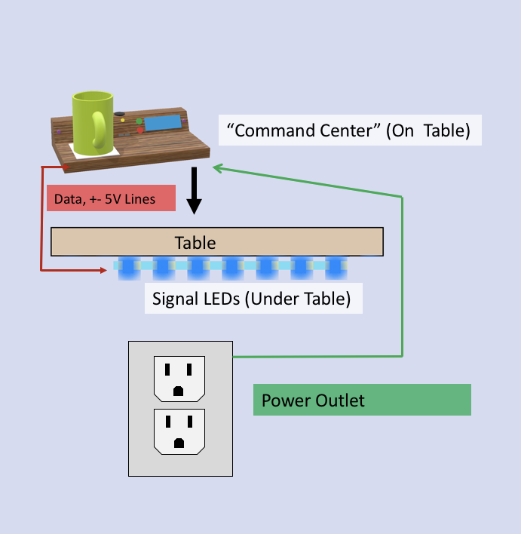

***Diagram 4.0.1.a****- Command Center relative to table.*

*Created by Mikey Garrity*

# 13.0 Hardware Design

To create the schematic of our project we used a CAD program called KiCad. KiCad is an open-source software which is maintained by CERN, used by electronics hobbyists and professionals around the world. KiCad allows the user to generate a schematic and then transfer that work to the PCB-layout view. The PCB-layout view handles the size and footprint of all of the components and gives the user the ability to move their location and orientation. Below are the screenshots of each subsection of our project.

## 13.1 Signal Lighting Design:

This section is meant to cover the decisions made regarding the selection of actual components for the signal lighting. Additionally, this section is a chance to cover the benefits and concerns of the particular components selected.

**WS2812-B-** These addressable RGB LEDs are the most sensible choice. These are the newer B-variant of the WS2812 “neopixels”. These B variant LEDs are designed to work better with hobbyist MCUs as they work with the 3.33-5 V found on most MCUs.

**Benefits-** They are more expensive at around $20 for 50, but only one strand is needed to show potentially 255*255*255 = 16,581,375 colors. Alternatively, two separate strips of single color basic LEDs could have been selected. Having one unified strip will simplify mounting. In the software design the addressable LED strips allow for more creativity and design merit as well. As far as power draw, a daisy chain of several meters could pull upwards of 10 amps, but our design calls for illumination in one solid color at a time (never bright white). Ideally when used in this fashion the units should pull about 25 mA rather than the full max of 60 mA.

**Concerns-** the biggest drawback of utilizing the WS2812-B is that these strips need the MCU to make the 400 Hz synchronization with LED’s internal clock for updates. Also being more than a simple “ON” or “OFF” these strips will need libraries that either take up an excessive amount of the 256 kb of memory on the MCU or simply not be portable (will be re-written). The biggest concern however will be the delicate nature of the WS2812-B units themselves. The chip controller is internal and does not have the benefit of robust regulators to condition power. It is generally recommended to pair a capacitor with the strip when testing to smooth input from the PSU. Physically the connections are just very small inside the package. In figure 13.1.1.a one can see just how small the internal connections are inside package. A hard drop could very easily sever a bridge. It is also conceivable that the units themselves could be manufactured to less than ideal quality. Reliability may become an issue.

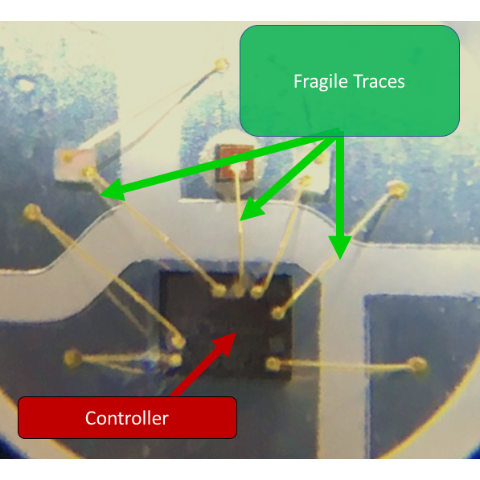

***Figure 13.1.1.a****- shows the fragile innards of the WS2812 at 100x magnification.*

*Created by Mikey Garrity*

There are two key factors relating to our lighting design. One is the user interface, where once the customer touches the keypad a light near the keypad will light up indicating a variety of different states. The second source of lighting in our design focuses more on the atmosphere of the table of which our product will rest on. This lighting source will be a strip of LEDs under the table and will change its color due to a variety of factors mentioned before in this paper. The LEDs we are using, both individually and in a strip as seen in figure 13.1.1b and 13.1.1c, are called the WS2812B which is a special RGB LED IC capable of being daisy changed to a large amount. All the LED ICs need are 5V to VDD, GND connections, and one single data line. The resistor shown in the circuit below sets the current limit for the LED. The capacitor is used to stabilize the supply voltage.

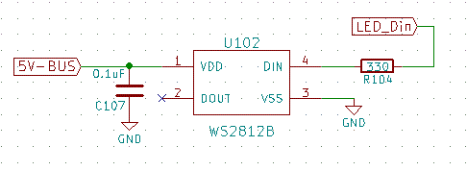

***Diagram 13.1.1b:*** *Schematic of single RGB LED circuit; WS2812B.*

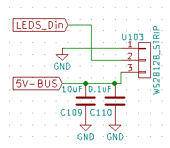

***Figure 13.1.1.c:*** *Schematic of RGB LED strip connections; WS2812B strip.*

## 13.2 Information Display Design (include cap buttons)

The LCD we choose for our project require 5V to operate. There are multiple signals needed from the MCU to operate the LCD. The brightness of the LCD can be determined by the resistance set on the VD line; We place a potentiometer there to adjust the brightness as we see fit. The pinout for the LCD screen can be seen below in figure 13.1.2.a.

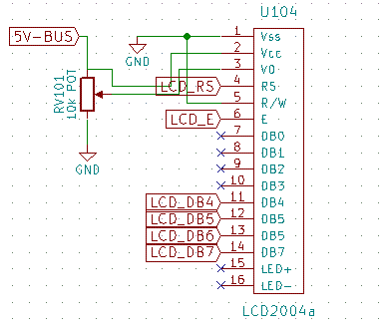

***Figure 13.1.2.a:*** *Schematic of LCD2004a pin connections/circuit.*

The user will need some why to control the options provided by the LCD screen. For the sake of sanitation, elegance, and simplicity we decided to use an array of 5 capacitive touch sensors as our keypad. The keypad will be arranged in a box with one capacitive touch sensor in the middle as demonstrated in the schematic screen shot below figure 13.1.2.b.

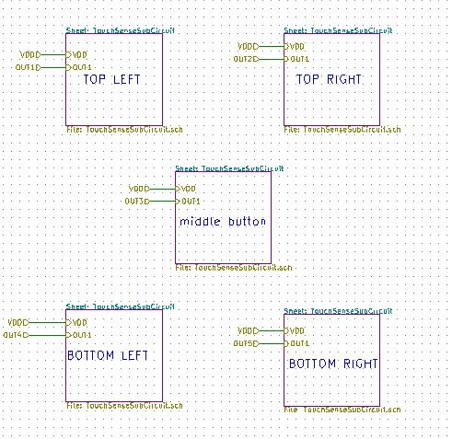

***Figure 13.1.2.b:*** *Schematic of the five capacitive touch modules inputs/outputs.*

Each capacitive touch module will contain the same circuit as shown in figure 13.1.2.c. The schematic design is focused around the AT4QT1010 IC which is an Atmel one-channel touch sensor chip. Changing the resistor values of components R503 and R502 will affect the amount of noise the IC will receive when a voltage (human finger) is applied to the capacitive pad. If there is a voltage signal applied to the pad the chip will output a high signal through pin 1 labeled Out. In turn, this will be sent to the MCU to be processed as well as turning on a small LED indicator of the key pad press (mainly for trouble shooting purposes).

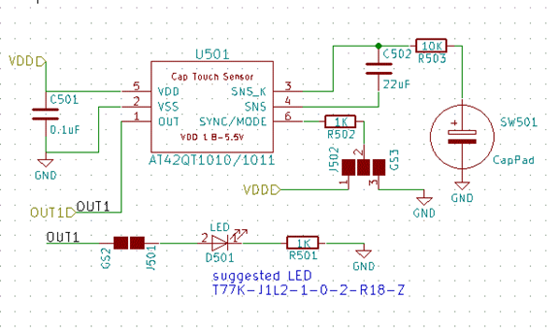

***Figure 13.1.2.c:*** *Schematic of the Capacitive touch sensor circuit; AT42QT1010.*

## 13.3 Smart beverage detection

We will be monitoring the weight of the beverage pitch resting on our devices platform. Underneath the platform will be a loadcell with 4 signal wires entering our embedded system. As shown below in figure 13.1.3.a; E+, E-, A+, and A- are the 4 signals loadcell will send/receive. The theory of how the loadcell and strain gauges work has already been discussed. What is important to understand now is that the signal that the stain-gauge generates needs to be amplified. That is where the HX711 comes in. The HX711 is an amplifier specifically designed for loadcell signals. The output of the amplifier IC is compatible with logic level voltages which is very useful with our selected MCU.

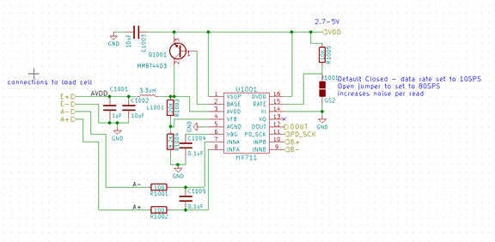

***Figure 13.1.3.a:*** *Schematic of weight sensor (load cell) amplifier circuit; HX711.*

## 13.4 Waiter Tracker Design

The waiter tracker design is focusing on Bluetooth 2.0 technology. The Bluetooth chip we are using is created by Texas Instruments. The SMD PCB module we will incorporate is called the HC-05. See figure 13.1.4.a. For the sake of this project, the circuitry for the Bluetooth module is very simple; 3.3V to VCC, ground connection, UART signals (TX and RX), and an enable signal to be able to turn on and of the device if necessary.

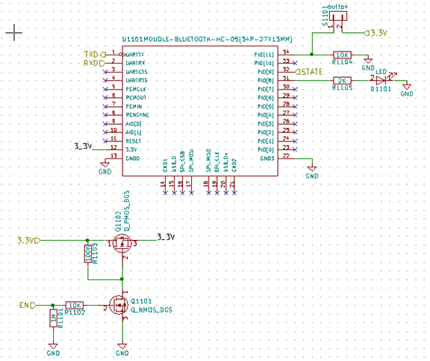***Figure 13.1.4.a:*** *Schematic of Bluetooth module circuit; HC-05.*

## 13.5 Motion / Ambient Light Detection Design

The motion detection circuit is simple. The IC pulse the infrared LED continuously and the infrared sensor will detect the light. The LM358 is a dual op-amp IC which acts as a comparator to determine if something has crossed over the infrared pair of devices. The MCU will pick up that change via the signal line as shown in figure 13.1.5.a.

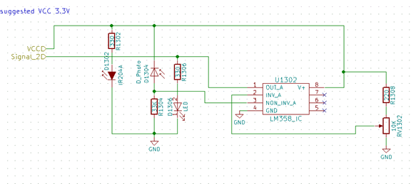

***Figure 13.1.5.a:*** *Schematic of the Infrared LED motion detector circuit; LM358 dual op-amp.*

## 13.6 Sound Buzzer Design

The piezoelectric buzzer is used to for many reason, mainly to act as an indicator of an event being triggered by either the user, table, or the waiter. A PWM signal can be sent to the buzzer from the MCU which will generate a tone. There are 256 different tones able to be generated by an 8-bit microcontroller. The buzzer only needs two connections; its signal/power and a connection to ground as seen in figure 13.1.6.a.

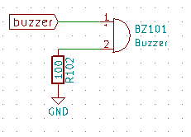

**Figure 13.1.6.a:** Schematic of Buzzer circuit.

## 13.7 Programmer Design

For programming our embedded system, we decided on two different approaches; using the ISP (In-Serial Programmer) and a USB-Serial connection. The ISP option works for most electronic hobbyist because a FTDI-serial module can be wired to the board to allow for easy programming as shown with figure 13.1.7.a. The issue is that it needs 6 wires and there isn’t a conventional plug into a computer that can access the FTDI signal. After installation is complete it would be a pain to try to wire 6 signal every time we need to program the board. Another option we are leaving available to our team is the USB-Serial programmer which we would only need a micro-USB cable to program. The downside is that it required a bit more circuitry to have it functionally preform. The chip that drives that circuit is called the FT231XS and is shown in figure 13.1.7.b.

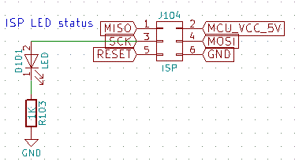

***Figure 13.1.7.a****: Schematic of ISP (In-System programming/ AVR programmer) circuit.*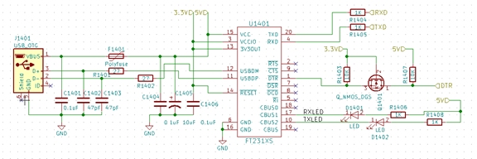

***Figure 13.1.7.b:*** *Schematic of USB-to-Serial circuit. FT231XS.*

## 13.8 Power Design

Our project will need two different voltage sources; 3.3V and 5V. After recorded our power constraints of the project we were able to use Texas Instruments Webench to find a quality buck step-down regulator that can output 3.3V and 5V depending on the resistor feedback network. Therefor we will be using the same regulator IC, TPS562210 as see in figure 13.1.8.a, for both our 3.3V and 5V supply.

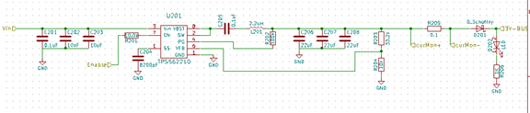

***Figure 13.1.8.a:*** *Schematic of the Buck Step-Down regulator; TPS562210. Using the TPS562210 for both 3.3V and 5V output.*

The input to our power regulator will take an input supply voltage of 12V (converted for us from AC to DC by the wall-wart). To maintain a steady voltage a pair of capacitors will be tied in parallel near the power input as shown in figure 13.1.8.b. There will also be a status LED to indicate that power has been received from the wall AC-DC adaptor.

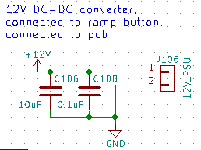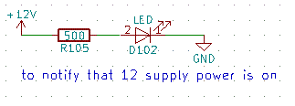

***Figure 13.1.8.b****: Schematic of the 12V input Supply and the status LED circuit.*

Our product will also allow users to be able to charge their devices via two external USB-A ports. The ports will possess a polyfused in case too much current is attempted to be drawn out of the USB port as shown in figure 13.1.8.c. Most professional USB devices prevent current from exceeded a certain level past 500 mA but it is important to protect our embedded systems from external sources.

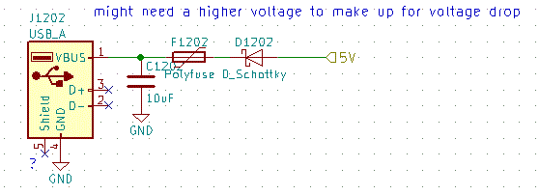***Figure 13.1.8c****: Schematic of the USB 5V output circuit.*

Monitoring the health of our product is necessary for provided a reliable service to our user. We need to continuously check and log how much current our devices are drawing. The embedded system will monitor the current consumption out of the 3.3V and 5V regulator. These ADC values will be sent to the MCU to be log in system memory as well as over the Bluetooth connect so that a system admin of the restaurant will be able to look back at a system fault with more information. The current sensing circuit is a very generic circuit. The Vin+ and Vin- lines come straight from the regulator output as seen in figure 13.1.8.d; separated by a 0.1ohm shunt resistor. The change in voltage over the shunt is transferred over to the op-amp where that signal is amplified to the power supply voltage scale (logic level 3.3V) and sent directly to the MCU ADC pin to be processed.

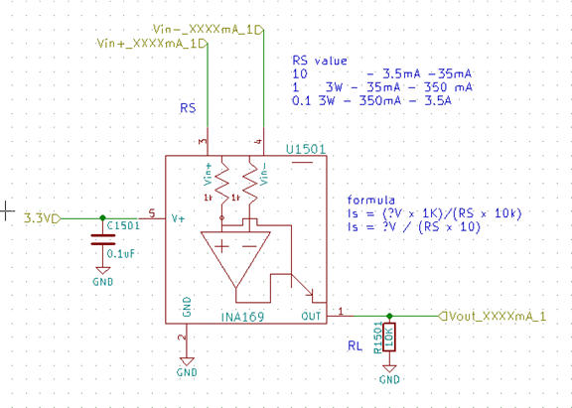

***Figure 13.1.8.d:*** *Schematic of current monitoring of the regulators circuit.*

## 13.9 Main Overview

The MCU ATMega2560 will send and receive digital signals to the rest of the circuit. The MCU will also have to process ADC signals as well as communicate with peripheral devices; including the Bluetooth IC. The MCU needs 3.3V power supplied to all the VCC pins as well a good ground connection to its corresponding pins. The MCU can run on an external clock of 16MHz as shown in figure 13.1.9.a. Programming signals are necessary for the firmware of the MCU to be uploaded.

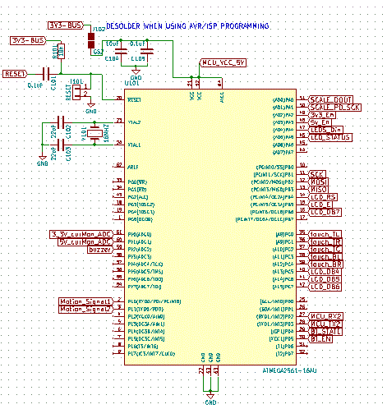

***Figure 13.1.9.a****: Schematic of MCU connections and circuit; ATMega2560.*

Each module discussed previously has inputs and outputs ended from their view. This is the high-level overview of what is entering and leaving each module. Most of the signals are sourced to and from the MCU, the only exception would be the power supplies from the two regulators. The high-level view of each of our modules inputs and outputs is shown below; figure 13.1.9.b.

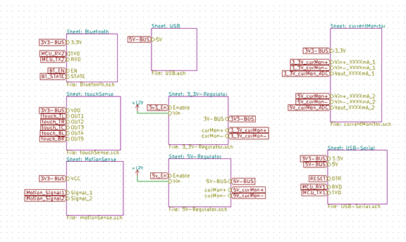

***Figure 13.1.9.b:*** *Schematic of each modules inputs/outputs.*

## 13.10 PCB Suppliers / Part Suppliers:

To produce our PCB (printed circuit board) we will be using a Chinese manufacturing company called PCB-Way. The company has a good reputation and delivers the boards with little cost and relatively fast shipping. The company offers a promotional deal to purchase 10 prototype boards dimensions 100mmx100mm for $5 (plus $20 shipping). Our PCB board will be 2-layered with a thickness of 1.6mm. Communication with the company is swift for their HR employees speak English well. The process to consists of a few steps. After the PCB layout is complete (We are using KiCad to create a layout), a DRC check must be performed with PCB-Way’s constraints (See figure 1). Basically, the only concern would be overlapping pads/components or the size of the pitch between pins. After the project passed the DRC check, next step is to generate the Gerber files (see figure 3). The Gerber files contain all the coordinate information about the bottom and top layer components including but not limited to the size and placement of; the silk screen, copper pads, vias, mounting holes, through-holes, board outline, ground fill zones, etc.

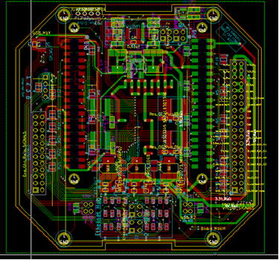

Figure 1 : This is a screenshot of KiCad’s PCB layout view of a personal board (Theodore Cox created) to showcase a complete and ready PCB.

Once the Gerber files have been created, we will upload them to PCB-Way. The online platform will give us a quote of the final cost within a few business hours. The company will double check that our Gerber’s can generate a PCB (meaning that the project passed the DRC on their end). Once everything has been checked off we will be asked to confirm the shipping address and payment and will then be able to monitor the progress of the production. The production process usually will only take 24 hours to complete. Shipping for the PCB may take up to a week.

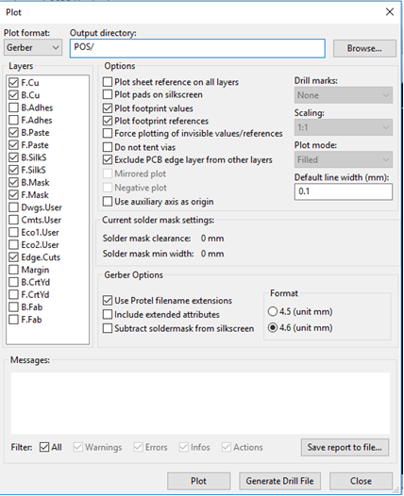

Figure 3: View of KiCad’s window to generate the Gerber files. Notice what is checked off on the left.

**Electronic Part Supplier-** Our electronic parts will be gathered from a variety of distributors. For small passive components including resistors, capacitors, inductors and other small components we will be purchasing them from distributors such as Mouser and Digi-Key. For the MCU and larger ICs we will be requesting samples from the companies that own them. For the devices such as the LCD display and the 12V power supply we will be purchasing them from Amazon.

## 13.12 Bill of Materials

It is necessary to compile a list of all the components needed to construct a single unit for the smart table design. In this section the bill of materials will be discussed, which contains this information. Upon designing the electrical schematic and construction design a list of components was compiled and can be found in the bill of materials below in Table 2. The primary distributer for the electrical components is Mouser, while Amazon and Aliexpress are used only a few times for components. The construction materials were primary sourced from Home Depot for ease of acquiring. The Kicad value is given so that the part can be coreference to the schematic design to provide a quick lookup table.

*Table 2 – Smart Table Bill of Materials*

|  |  |  |  |  |  |
| --- | --- | --- | --- | --- | --- |
| **Description** | **Qty** | **Part Number** | **Kicad Value** | **Notes** | **Distrb.** |
| Capacitor SMD/SMT 16V 20pF 5% | 2 | [0603YA200JAT2A](https://www.mouser.com/ProductDetail/AVX/0603YA200JAT2A?qs=sGAEpiMZZMs0AnBnWHyRQKdiqyDPVQdA6LLqx6KXMCE%3d) | 20pF | 25VDC | Mouser |
| Capacitor SMD/SMT 47pF 10% 25V | 2 | [C0603C470K3RACTU](https://www.mouser.com/ProductDetail/KEMET/C0603C470K3RACTU?qs=sGAEpiMZZMs0AnBnWHyRQG1RinhVX0EYW3ljLbZ352rMwHHyZ6ioxA%3d%3d) | 47pF | 25VDC | Mouser |
| Capacitor SMD/SMT 8200pF 25v 20% | 2 | [VJ0603Y822MXXCW1BC](https://www.mouser.com/ProductDetail/Vishay-Vitramon/VJ0603Y822MXXCW1BC?qs=sGAEpiMZZMs0AnBnWHyRQGuekufMepD5dbzlw0df3sA%3d) | 8200pF | 25VDC | Mouser |
| Capacitor SMD/SMT100000pF 10% 25V | 25 | [885012206071](https://www.mouser.com/ProductDetail/Wurth-Electronics/885012206071?qs=sGAEpiMZZMs0AnBnWHyRQEGbLOF2VP1iprT3n4FXsKyn%252b5OoMJVgRQ%3d%3d) | 0.1uF | 25VDC | Mouser |
| Capacitor SMD/SMT 1uF 20% 25V | 2 | [885012106022](https://www.mouser.com/ProductDetail/Wurth-Electronics/885012106022?qs=sGAEpiMZZMs0AnBnWHyRQEGbLOF2VP1issYJf5wWNqidR49W7Sdttw%3d%3d) | 1uF | 25VDC | Mouser |
| Capacitor SMD/SMT 10uF 16V 20% | 12 | [EMK212ABJ106MG-T](https://www.mouser.com/ProductDetail/Taiyo-Yuden/EMK212ABJ106MG-T?qs=sGAEpiMZZMs0AnBnWHyRQIHQ3Mw87cdoX0kCo5cFD0tiJk%2f2e8a2GQ%3d%3d) | 10uF | 25VDC | Mouser |
| Capacitor SMD/SMT 22uF 16v | 12 | [GRM219R61C226ME15L](https://www.mouser.com/ProductDetail/Murata-Electronics/GRM219R61C226ME15L?qs=sGAEpiMZZMs0AnBnWHyRQFv7x1xn%252bYFdlpx3rHjqsYGFGOccM8ifgQ%3d%3d) | 22uF | 25VDC | Mouser |
| LED - SMD RED WATER CLEAR | 4 | [AP2012EC](https://www.mouser.com/ProductDetail/Kingbright/AP2012EC?qs=sGAEpiMZZMusoohG2hS%252b14Cqh8raw9evBsCVpQ0LEb0%3d) | RED LED |  | Mouser |
| LED - SMD GREEN WATER CLEAR | 4 | [APT2012SGC](https://www.mouser.com/ProductDetail/Kingbright/APT2012SGC?qs=sGAEpiMZZMseGfSY3csMkeytxqHAv00AGb4ncJXLQok%3d) | GREEN LED |  | Mouser |
| LED - SMD YELLOW WATER CLEAR | 4 | [APT2012YC](https://www.mouser.com/ProductDetail/Kingbright/APT2012YC?qs=sGAEpiMZZMusoohG2hS%252b11XB%2fqj1D52Q8vg4LHKiq5Y%3d) | YELLOW LED |  | Mouser |
| LED - SMD WHITE WATER CLEAR | 4 | [HT-191TW](https://www.mouser.com/ProductDetail/Inolux/HT-191TW?qs=sGAEpiMZZMseGfSY3csMkY6I0nEzxA6OEbLdwesbyiw%3d) | White LED |  | Mouser |
| SCHOTTKY RECT 40V 2A | 4 | [PMEG4020ER,115](https://www.mouser.com/ProductDetail/Nexperia/PMEG4020ER115?qs=sGAEpiMZZMtQ8nqTKtFS%2fHAZexCLi7dOLaMEWTWwwEs%3d) | Schottky | IF 2A | Mouser |
| Resettable Fuses - 6V 0.5A SMD | 4 | [PTS12066V050](https://www.mouser.com/ProductDetail/Nexperia/PMEG4020ER115?qs=sGAEpiMZZMtQ8nqTKtFS%2fHAZexCLi7dOLaMEWTWwwEs%3d) | Poly-fuse | H 0.5A, T 1A, 6V | Mouser |
| MOSFET FET 50V 3.5 OHM SOT23 | 4 | [BSS138L](https://www.mouser.com/ProductDetail/ON-Semiconductor-Fairchild/BSS138L?qs=sGAEpiMZZMtWZAo%2fKf1JUPJG6UTNeL7usB5HmdXkB94%3d) | NFET |  | Mouser |
| MOSFET 1.2V Drive Pch MOSFET | 2 | [RZM001P02T2L](https://www.mouser.com/ProductDetail/ROHM-Semiconductor/RZM001P02T2L?qs=sGAEpiMZZMshyDBzk1%2fWi5brl1xcCtmLC2Mq%252brqhxE4aWyoIiu38IQ%3d%3d) | PFET | low Ids 100mA | Mouser |
| Current Sense Resistors - SMD 0.1 Ohm 5% 1W | 2 | [RL2512JK-070R1L](https://www.mouser.com/ProductDetail/Yageo/RL2512JK-070R1L?qs=sGAEpiMZZMtlleCFQhR%2fzSNV8he%252bm1g8Q%2fi4JORJXLM%3d) | 0.1 | current sense | Mouser |
| Thick Film Resistors - SMD 27ohm 5% | 2 | [CR1206-JW-270ELF](https://www.mouser.com/ProductDetail/Bourns/CR1206-JW-270ELF?qs=sGAEpiMZZMtG0KNrPCHnjfC2zYK6Lg3%2fNrw8o4zgFaM%3d) | 27 | low cur. Rate. | Mouser |
| Thick Film Resistors - SMD 100 ohm 1% 200V | 2 | [RC1206FR-10100RL](https://www.mouser.com/ProductDetail/Yageo/RC1206FR-10100RL?qs=sGAEpiMZZMtG0KNrPCHnjW0BEZmmc%252bDpE6c4FWyI72L1A6GQnhtxlQ%3d%3d) | 100 | Ids 100mA | Mouser |
| Thick Film Resistors - SMD 220 ohm 5% 75V | 2 | [RC0603JR-10220RL](https://www.mouser.com/ProductDetail/Yageo/RC0603JR-10220RL?qs=sGAEpiMZZMtG0KNrPCHnjW0BEZmmc%252bDpTNN6cP6gTvaMFULQPfel%252bg%3d%3d) | 220 |  | Mouser |
| Thick Film Resistors - SMD 330 ohm 5% 75V | 2 | [RC0603JR-10330RL](https://www.mouser.com/ProductDetail/Yageo/RC0603JR-10330RL?qs=sGAEpiMZZMtG0KNrPCHnjW0BEZmmc%252bDpyBVNZHaq%2fqaorKovv0W2%252bA%3d%3d) | 330 |  | Mouser |
| Thick Film Resistors - SMD 330 ohm 5% 75V | 2 | [RN732ATTD5000B25](https://www.mouser.com/ProductDetail/KOA-Speer/RN732ATTD5000B25?qs=sGAEpiMZZMtG0KNrPCHnjXpemsKSY0V9QI6EsrmF%252bK4%3d) | 500 |  | Mouser |
| Thick Film Resistors - SMD 1/16watt 1Kohms | 14 | [CRCW04021K00FKEDC](https://www.mouser.com/ProductDetail/Vishay/CRCW04021K00FKEDC?qs=sGAEpiMZZMtG0KNrPCHnjXEaY7S8QU1xTZ1rTPmVTHo7xhRDhpgUIw%3d%3d) | 1K | small package | Mouser |
| Thick Film Resistors - SMD 2K ohm 5% 75V | 2 | [RC0603JR-102KL](https://www.mouser.com/ProductDetail/Yageo/RC0603JR-102KL?qs=sGAEpiMZZMtG0KNrPCHnjW0BEZmmc%252bDpNOQzyU4b41m0xE%2fLe5egZA%3d%3d) | 2K |  | Mouser |
| Thick Film Resistors - SMD 1/10watt 8.2Kohms 5% | 2 | [CRCW06038K20JNEA](https://www.mouser.com/ProductDetail/Vishay/CRCW06038K20JNEA?qs=sGAEpiMZZMtG0KNrPCHnjeyV5TU2VJyG7PKyiyCOu%252b4%3d) | 8.2K |  | Mouser |
| Thick Film Resistors - SMD 1/16watt 10Kohms 1% | 20 | [CRCW040210K0FKEDC](https://www.mouser.com/ProductDetail/Vishay/CRCW040210K0FKEDC?qs=sGAEpiMZZMtG0KNrPCHnjXEaY7S8QU1xDaVXkvqGFkKtFuEQ7AdwVg%3d%3d) | 10K | small package | Mouser |
| Thick Film Resistors - SMD 33.2K ohm 1% 50V | 1 | [RC0402FR-1333K2L](https://www.mouser.com/ProductDetail/Yageo/RC0402FR-1333K2L?qs=sGAEpiMZZMtG0KNrPCHnjW0BEZmmc%252bDp0PRzlto9kYiHAiNsu7P6Xw%3d%3d) | 33.2K |  | Mouser |
| Thick Film Resistors - SMD 54.9K ohm 1% 75V | 1 | [RC0603FR-1054K9L](https://www.mouser.com/ProductDetail/Yageo/RC0603FR-1054K9L?qs=sGAEpiMZZMtG0KNrPCHnjW0BEZmmc%252bDptR%252b6Hsjl5bYIAhEr39OhPg%3d%3d) | 54.9K |  | Mouser |
| Thick Film Resistors - SMD 0402 100Kohms 5% | 10 | [ERJ-2GEJ104X](https://www.mouser.com/ProductDetail/Panasonic/ERJ-2GEJ104X?qs=sGAEpiMZZMtG0KNrPCHnjSOOg5ypiLdnxj%252b0CMYfC%2fA%3d) | 100K | small package | Mouser |
| Thick Film Resistors - SMD 1M OHM 5% | 10 | [CR0402-JW-105GLF](https://www.mouser.com/ProductDetail/Bourns/CR0402-JW-105GLF?qs=sGAEpiMZZMtG0KNrPCHnjfC2zYK6Lg3%2fjF9WB9wD34Q%3d) | 1M | small package | Mouser |
| Trimmer Resistors - SMD 10KOHMS 25% 0.1 WATT | 2 | [TC33X-2-103G](https://www.mouser.com/ProductDetail/Bourns/TC33X-2-103G?qs=sGAEpiMZZMvygUB3GLcD7vlYyyor7jZzTcLyrv4FnX8%3d) | 10K | potentiometer | Mouser |
| MCU 256kB Flash 4kB EEPROM 86 I/O Pins | 1 | [ATmega2560-16AU](https://www.mouser.com/ProductDetail/Microchip-Technology-Atmel/ATmega2560-16AU?qs=sGAEpiMZZMtkfMPOFRTOl4TPj%252bk4h3O1) | MCU |  | Mouser |
| 6.4ft WS2812B Individually Addressable LED Strip | 1 | WS2812B | LED IC |  | Amazon |
| LCD - 20x4 White Characters on Blue Background | 1 | LCD2004a | LCD |  | Amazon |
| Switching Voltage Regulators 17 V Input, 2A | 2 | [TPS562210DDFR](https://www.mouser.com/ProductDetail/Texas-Instruments/TPS562210DDFR?qs=sGAEpiMZZMtitjHzVIkrqU99irDpZcy8ugFEQi5ycFkH5%2fcgJpSkww%3d%3d) | Regulator |  | Mouser |
| Capacitive Touch One-Channel Touch Sensor IC | 5 | [AT42QT1010-MAH](https://www.mouser.com/ProductDetail/Microchip-Technology/AT42QT1010-MAH?qs=sGAEpiMZZMv%2fbGM7XKYHK%252b0NDZ2i1W%252bX) | Touch Sensor |  | Mouser |
| Weighing Sensor 24-bit | 1 | HX711 | amplifier | IC / not board | Ali-  Express |
| SMD Bluetooth 2.0 EDR | 1 | HC-05 | Bluetooth | SMD board | Amazon |
| Dual OpAmp | 2 | [LM358ADR](https://www.mouser.com/ProductDetail/Texas-Instruments/LM358ADR?qs=sGAEpiMZZMtYFXwiBRPs0zFXHJUd7gdT) | Dual Op Amp |  | Mouser |
| Current Shunt Mntr Crnt Otp | 2 | [INA169NA/3K](https://www.mouser.com/ProductDetail/Texas-Instruments/INA169NA-3K?qs=sGAEpiMZZMuo%252bmZx5g6tFD8TTXQDX2ot) | Current Sense |  | Mouser |
| USB Interface IC USB to Full Serial UART IC | 1 | [FT231XS-R](https://www.mouser.com/ProductDetail/FTDI/FT231XS-R?qs=sGAEpiMZZMvVkErl6zY%252bqfBUiQa5NfR7) | USB-Serial |  | Mouser |
| Crystals 16MHz 20pF 0C 50C | 1 | [LFXTAL033808Reel](https://www.mouser.com/ProductDetail/IQD/LFXTAL033808Reel?qs=sGAEpiMZZMsBj6bBr9Q9af1kE%252bXo19x3D66o2Mb0OuifZBqfW0Zkgw%3d%3d) | Crystal | 16MHz 20pF | Mouser |
| Photodiodes 60V 215mW 950nm | 1 | BPV23NFL | Photodiode | 60V 215mW 950nm | Mouser |
| Standard LEDs - Through Hole Blue Round LED | 2 | C503B-BCS-CV0Z0461 | IR Sensor |  | Mouser |
| Audio Buzzer 12.2mmx6.5mm 4kHz Vin=3V | 1 | [PS1240P02BT](https://www.mouser.com/ProductDetail/TDK/PS1240P02BT?qs=sGAEpiMZZMs%252b6Ea5iKw4JnKB8rEmL0Rz) | Buzzer | Vin 3V 4kHz | Mouser |
| MDF Sheet 4'x8' | 1 | SKU#201504 | N/A | 4'x8' MDF board | Home Depot |
| Fine Threaded Drywall Screws #6 1in | 12 | SKU#105848 | N/A | 1lb box | Home Depot |
| Elmer Carpenter Glue | 1 | SKU#796553 | N/A | 8oz | Home Depot |
| KILZ Spray Primer | 1 | SKU#822388 | N/A | Grey | Home Depot |
| Rustoleum Clear Coat | 1 | SKU#617046 | N/A | Waterproof | Home Depot |
| Rustoleum Spray Paint - White | 1 | SKU#445592 | N/A | White | Home Depot |
| Alex Plus Silicon Caulk | 1 | SKU#984590 | N/A |  | Home Depot |
| Everbit Rubber Feet | 4 | SKU#101032 | N/A | 4 per/box | Home Depot |
| Power Adapter 12V, 5A max, 60w max | 1 | B01461MOGQ | N/A | 12V, 5A max, 60w max | Amazon |

Figure: Schematic of Bluetooth Module circuit; HC-05

# 14.0 Software Design

## 14.1 MCU Software Design:

This section and accompanying diagrams attempts to convey the way the software for the various peripherals used in the smart table will communicate, along with a general overview of the logic cascade. Diagram 4.2.1.a is below and is helpful for understanding the order that triggers should be checked by the MCU.

**Diagram 4.2.1.a “Begin” (Red)-** One might notice that the entrance for the main loop in diagram 4.2.1.a is highlighted in red. The main loop should enter in a waiting “sleep mode” in which the MCU is awaiting a signal from the motion tracker. The MCU will also take in the relative ambient brightness levels from the restaurant at this time. This brightness value will be used later to determine how bright the various LEDs should be when the table is woken from sleep mode, and is thus illuminated.

**Diagram 4.2.1.a “Initialization” (Yellow)-** Following this red section in the diagram is a yellow section that is essentially the “initialization” logic. In this portion of logic the table should signal all the lighting elements to turn on. Specifically the signal lighting should turn red to indicate that this new party needs their drink orders taken. At this point the table will be waiting for the server to respond to notifications within the mobile smart device application. At this point the table should expect that the beverage pitcher be filled and placed on the table. Additionally the LCD should offer any useful prompts to customers like “would you like to see the special of the day” and check the touch buttons adjacent to the LCD screen inside the command center. Eventually this logic should transition to a nominal state where the table turns blue and executes its default checks in a loop.

**Diagram 4.2.1.a “Default” (Green)-** Following the yellow initialization section in the diagram is a green section that is the default logic that will loop continuously while the table is awake, and running. At this point the signal LEDs under the rim of the table should be either red (alert) or blue (nominal). When in an alert state the table should be actively trying to get back to nominal mode by asking the user if they want to cancel a request for assistance, or ideally the server responding. At the conclusion of responding to a notification the table can then expect the server to dismiss the notification on their Bluetooth enabled device (within our application). During execution of this logic contained in the green section the MCU should be keeping track of time elapsed since initialization as well as the status of the smart beverage pitcher. At any point that the beverage pitcher becomes empty, the table should ask the customers want a refill, give them perhaps 30 seconds to respond before changing to an alert state.

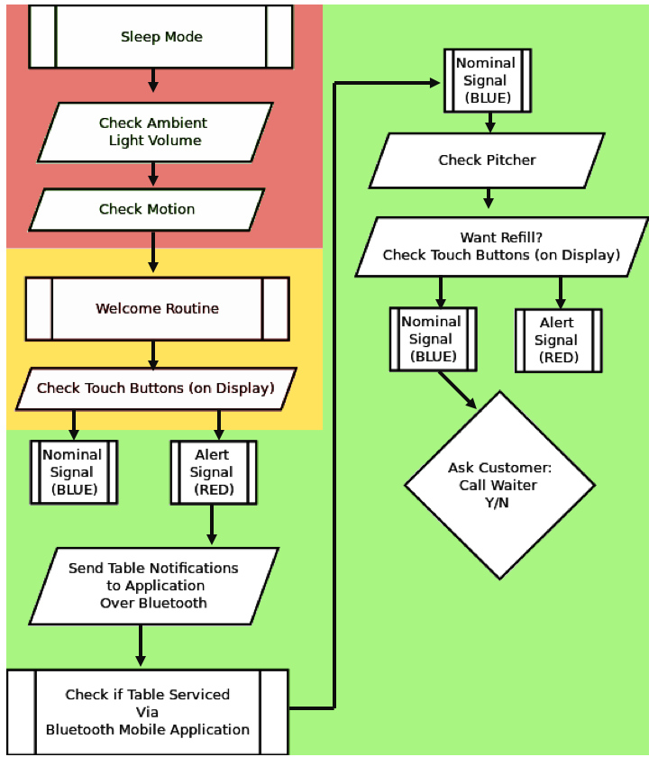**Diagram 4.2.1.b**- shows a high level overview of all major software modules and their logic flow. Main loop is entered in the red section from “sleep”.

## 14.2 Mobile Application Design

The section below will outline the design and user interface of the smart tables accompanying mobile application. The mobile application adds very robust functionality to the smart table, and allows the server to continuously be aware of the status of their tables. There are three key screens associated with the smart table mobile application, and they will be outlined below. In addition to this, the backend coding will be outlined in the sections below.

## 14.3 Application User Interface

First, the functionality of the mobile application will be discussed and the overall user interface. Figure 1 demonstrates the three screens that will be available in the mobile application. The goal of the application is to have a medium so that the server can being in communication with their guests even when she is away. The mobile application will have three primary screens, the home screen, table notification screen and the add table screen. These will be discussed in detail below.

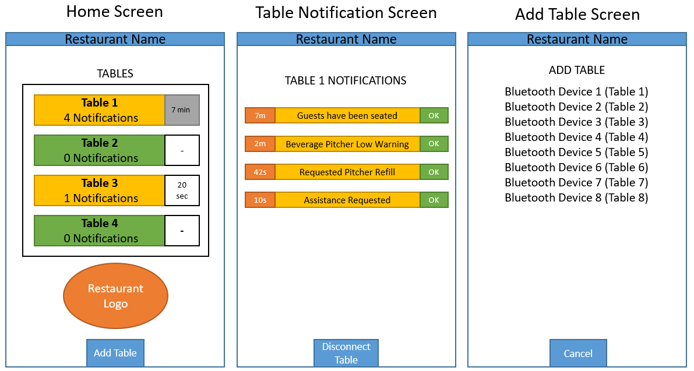

Figure 1 - Mobile Application User Interface

The first screen that will be discussed in the home screen, which is the first screen the user will be presented with upon opening the application. The home screen will have a list of all of the server’s tables that they have been assigned. The list will scale based on how many tables the server currently has. If there are any notifications from a particular table, the table’s tile will be highlighted yellow so that the server can quickly access which tables need to be addressed. Additionally, the number of notifications that the table has will be listed in the table’s tiles and just to the right of each table tile there will be a timer that indicates how long the oldest notification is for the table. The table that has the oldest notification will have the timer lit in grey so that the server can easily distinguish which tables notifications to prioritize. Next the table notification screen will be discussed.

The table notification screen allows the server to see a list of the notifications from the smart table. On the home screen, when the server selects a table tile, the table notification screen will be displayed. Once the notification screen in displayed, a list of all the notifications will be presented to the server. These notifications include anything that the smart table is capable of detecting with its array of sensors. This includes detecting when guests are seated, detecting when a beverage pitcher is low, and signaling when the call waiter button has been pressed. The time that the notification has been present will be listed to the left of each notification, and the notifications will be in chronological order, with the oldest notification on the top. The server will then have the ability to press the OK button next to the notification, which will dismiss the notification and remove it from the list. Finally, the server will have the ability to disconnect from the table with a button at the bottom of the table notifications screen. Next the add table screen will be discussed.

At the bottom of the home screen the server will have the choice to add a new table by selecting the add table button. Upon selecting the add table button a new screen will appear that facilitates this functionality. The add table screen will show a list of all the Bluetooth devices in the area and will also display their respective table number next to them. The server will be able to select the table then receive a toast notification that the table was added. Upon returning to the home screen of the application, the table will now appear as a table tile on the list. Additionally, there will be a cancel button on the add table screen which will return the user to the home screen without adding any of the tables from the list of available devices.

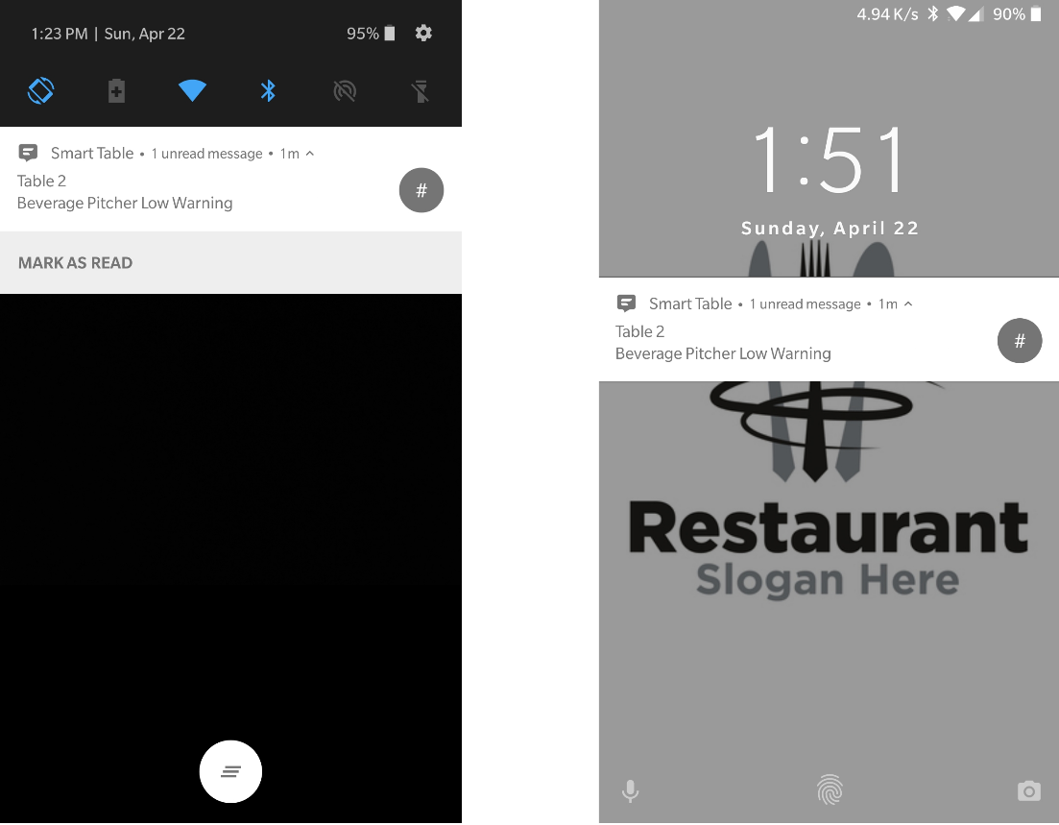

Figure 4.2.2.1-1 – Notification Demonstration for Mobile Application - Permission to use ‘Restaurant Slogan Here’ image in accordance with the Creative Commons (Attribution 3.0) License

The final portion of the User Interface will now be discussed, the Android Notification Feature. This functionality provides an efficient way for the server to know when they have received a notification from their table. Even when the server is not currently inside the mobile application there will be notifications that the android smart device will use. Therefore, the server can have the device on their person and hear a notification. This notification system will be incorporated with the existing Android notification system and is showcased in Figure 2. When the notification is pressed the mobile application will be launched on the smart phone.

## 14.4 Backend Mobile Application Development

The smart table mobile applications user interface was outlined in the section above. To achieve this user interface requires application development and design. To achieve development of a mobile application that supports these features and can communicate with Bluetooth may require a lot of development time. Due to this time constraint a mobile application development toolbox called MIT App Inventor 2 will be used to develop the mobile application. This toolbox is an open-sourced web application that allows you to create android applications. [13] In Figure 4.2.2.2-1 the Bluetooth stack logic is shown for the application that was developed in MIT App Inventor. [13] Using this the Bluetooth stack software can communicate with the server app and vice versa.

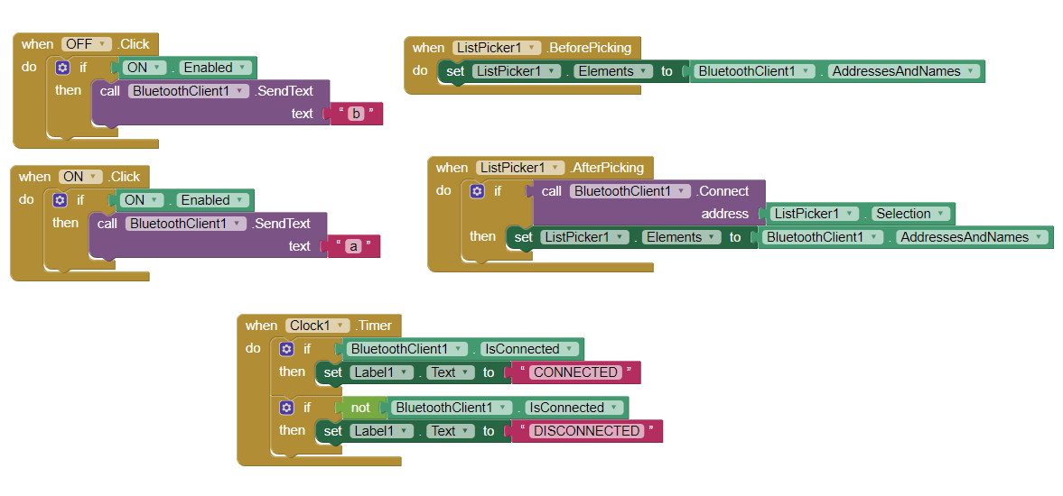

Figure 4.2.2.2-1: MIT App Inventor 2 Bluetooth Logic Stack (Pending permission from MIT App Inventor)

The software and Bluetooth backend will be coded and handled using the MIT App Inventor 2. The design and flowchart of the mobile application is demonstrated in Figure 4.2.2.2-2. The flowchart begins at the launch of the application which places the server on the home screen. If there is a connected table then the user can select the table tile and view its notifications, if not then the user can connect to a table on the add table screen. On the add table screen the server selects from all the smart tables in the area and connects to it from Bluetooth. Back again on the home screen the user can now click on the connected table, which brings the server to the table notification screen. On the table notification screen the server can view any notifications for that given table. Additionally, the server can dismiss the notifications, which sends a Bluetooth AT command to the smart tables MCU and dismisses the notification.

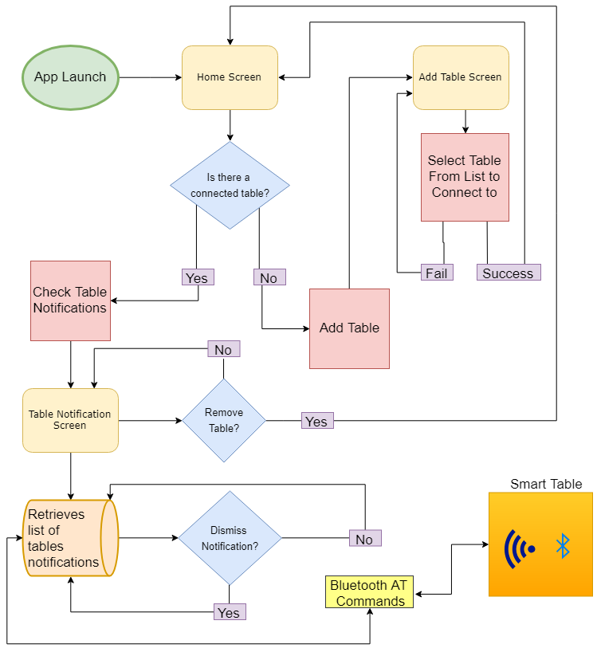

*Figure 4.2.2.2-2: Mobile Application Design and Flowchart*

## 14.5 Signal LED Logic:

As the LEDs desired are “smart” and addressable a variety of states can be achieved. The main states of the LEDs will be “nominal” when attention from the server is not needed, and “alert” when the table must be visited. The nominal state and alert state will be represented by solid blue illumination and solid blue illumination respectively. The signal LEDs can be set from alert back to nominal by the server visiting the table and pressing the corresponding button on their Bluetooth device. Additionally the alert status can be changed back to nominal by the user cancelling the request for service via buttons embedded in table/hub. Most importantly, the nominal state is when the other subsystems are pinged for their status. Other external classes that belong to other hardware such as the ambient light sensors have public methods that pass status information back to the microcontroller ad by extension the signal LED classes. Below in flowchart 4.2.3.a is the state machine for the signal LED subsystem.

**Important Classes and Methods-** The smart LEDs come in addressable RGB “pixels” that are initialized and updated in a daisy chain fashion where the output of one pixel becomes the input of the next pixel. As such, a count of the pixels has to be retained.

The “getStatus” class has methods tailored to determining what state the LED strip is in so that this information can be passed along to other subsystems as a simple public string.

The setNumPixels class contains methods such as “addPixel” to increase the number of pixels being signaled. It is important to note that these add/remove pixel methods return a true Boolean if they update was successful so as to maintain stability. The class has a public integer variable called “numPixels” that can be shared with the “SetPattern” class as needed.

The SetPattern class is the class that actually drives the LED strip via several private methods. This class monitors the status strings it receives to decide which pattern should be selected. This class tells the brightnessAndColor class which methods to call. The setPattern also crucially tells the brightnessAndColor class how many pixels to illuminate. The UML class diagram can be seen in Diagram 4.2.3.a below.

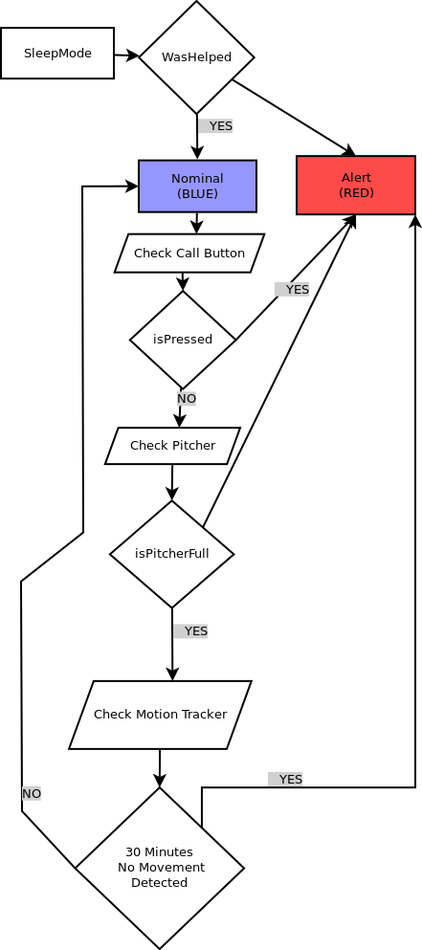

**Flowchart 4.2.3.a**- State machine for signal LEDs that shows logic.

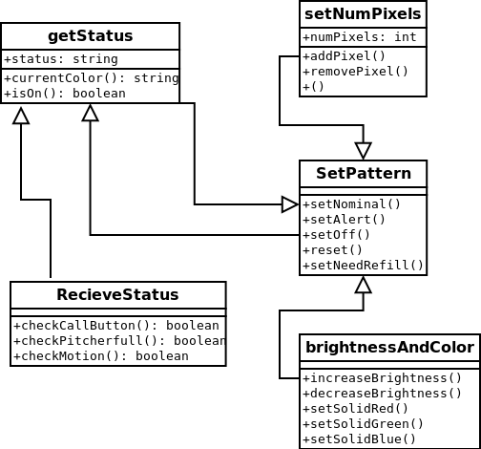

**Diagram 4.2.3.b**- UML class diagram for signal LEDs.

# 15.0 Construction Design

In this section we will discuss the construction and physical design of the smart table hub, including construction practices, dimensions, and wood finish design. Also, the selection of the dimensions and where the dimensions were derived will be discussed in the sections below. The construction design incorporates the materials researched in the previous sections. First, we will discuss the dimensions of the smart table hub.

## 15.1 Smart Table Hub Dimensions

The smart table hubs dimensions will now be discussed. The dimensions of the hub were considered based on a few different factors like, the size of the average restaurant pitcher, the size of the electrical components, and the size of the average restaurant table. The dimensions that were derived based on these factors can be found in Figure 2 and Figure 3. The design for the 3-D model was created using 3D Builder which comes included with Windows 10 Fall Creators update. The model shown in the figures below are very close (within ~15%) but not completely sized to scale.

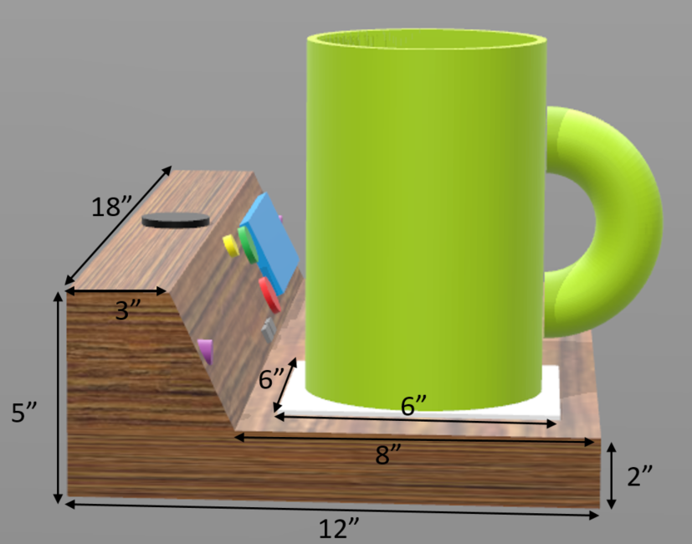

Figure 2 - Smart Table Hub Dimensions (Side View)

The first factor that was mentioned with respect to choosing the dimensions of the smart table hub was the average size of a restaurant pitcher. Upon conducting research, it was found that the average size of a pitcher’s base diameter is between 4.5-5.5 inches. These findings influenced the dimensions of the square white plate that the beverage pitcher rests on at 6 inches by 6 inches, to give more than enough space for any pitcher. Although hidden from the figures in this section, the loadcell sensor sits directly below the aforementioned square white plate and is fastened using 2-part epoxy to the inside of the smart hub box. This positioning of the load-cell enables it to read the weight of the pitcher by using the square white plate as a “diving board” to balance off, which is necessary for the function of the load-cell sensor. Additionally, as seen in Figure 2 above, two inches was selected for the vertical height of the bottom plane of the hub, so that the load-cell would have enough room for installment.

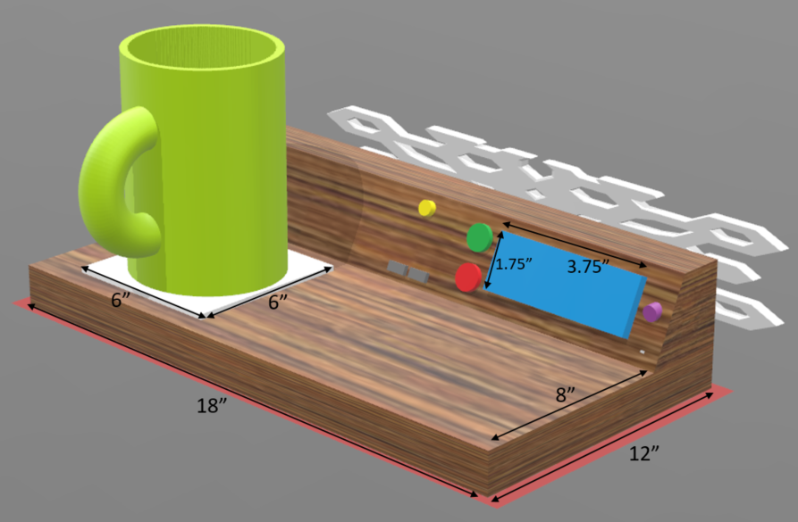

Figure 3 - Smart Table Hub Dimensions (Front View)

The second factor that was mentioned with respect to choosing the dimensions of the smart table hub was the size of the custom printed circuit board design, and other electronics. The printed circuit board is projected to be 100 millimeters by 100 millimeters, which is converted to 3.93 inches by 3.93 inches. The tallest electrical component will be less than ¼ of an inch, therefore by providing two inches on the bottom plane of the hub, the PCB can sit nicely on the bottom toward the back center of the box. The LCD and other sensors were given a generous 3 inch depth on the top plane of the device so that they could easily be integrated into the box.

The third factor that was mentioned with respect to choosing the dimensions of the smart table hub was the average size of a restaurant table. [14] The smart table hub is designed to fit on the smallest tables and all the way to the largest tables. It was found that by having a bottom plane dimension of 18 inches by 12 inches the device would likely fit on nearly any table it would be integrated onto. The open area next to the pitcher will be repurposed as an area for the user to place their smartphones that can be charged with the available USB ports nearby.

## 15.2 Smart Table Waterproofing, Sealing, and Ventilation

Further considerations regarding the construction design were considered. One major consideration was the fact that the MDF material used will be ½ inch in thickness, which is actually much closer to 3/8-inch actual width after the milling process. This means that the internal dimensions of the smart hub will be slightly smaller than the external dimensions, and thus this consideration was made about the electrical components that must be integrated inside.

The nature of medium density fiberboard is that it may be prone to splitting and swelling due to the manufacturing process. To alleviate these concerns a few precautions were made in the construction design. The first precaution is that for every joint that is fastened together with a screw, we ensured that the screw was fine thread and that a predrilled hole was used to alleviate splitting. Additionally, wood glue will be used to ensure that the joints are tight and more importantly water proof.

To alleviate MDF’s tendency to swell the outside of the hub will be primed and coated with a layer of paint and waterproofing. The layering of primer and paint will create a barrier from water which is a likely environment for the smart hub. Rubberized pads will also be placed underneath to raise the smart hub off the table slightly to ensure that it would not be sitting in water where prolonged exposure could cause problems. Before the primer and paint will be applied a layer of silicone caulking with be added to all joints to further reinforce the waterproofing properties of the design.

The last construction design choice is the integration of a backplate that will have a perforated pattern. This perforated backplate is shown in Figure 3 on the back of the hub. The need for ventilation is required due to the electrical components within and if the hub was completely sealed it would likely reduce the life of the electronics and make repairs more difficult. This design also effects the ability for the Bluetooth to transmit its wireless information and provide better range for the server to use the mobile application.

## 15.3 Modularity, ease of replacement, access, and repairs

Repairs and ease of replacement are very important things when designing a product. Not keeping these things in mind can cause some pain when products starts having any issues. We designed our product with these things in mind. We believe if you want to have a product last for long term, then easy access to parts and repairs are very important. We designed the table in a way that anyone can easily replace any parts or troubleshoot the device without deep technical knowledge.

Based on our research and observing few products in market, we have found that replacing certain parts inside the unit was exceedingly laborious due to lack of modularity. Initially we have decided to install the parts underneath the table surface, but that raised some safety concern since parts can be all around the surface and can cause harm. Therefore, keeping modularity in mind, we redesigned our product. We designed a box which can be mounted on the side of table. The box will have all the parts inside and the side panel will have access to components such as touch capacitive buttons, LCD display etc. Box is made of 4 panels. One of each side. Right panel will let users access to components that is needed. Top panel will act as door to open the box in case of troubleshooting. Parts such as PCB and sensors will be installed on left panel so that it can accessed easily for repairs, and bottom panel will be mounted with the table surface. The box will be made of wood to reduce the total weight and it can be detached from the table to use it on another table or in case of repair.

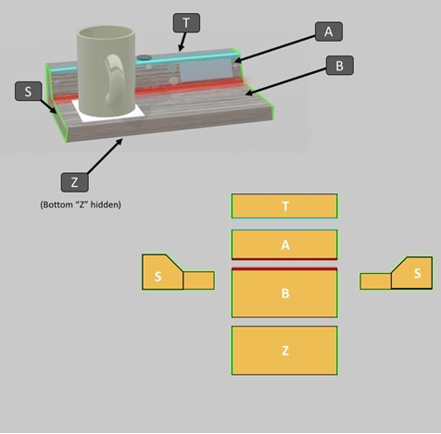

Figure 4.4.1a – illustrate the modularity of the table.

## 15.4 Aesthetic Decisions:

The research that was necessary in designing this project narrowed down the original aesthetic goals from the broad ideas proposed initially. The aesthetics have changed to suit the new materials settled upon during the design process. As such a new “touchstone” was chosen for inspiration. Rather than the original organic skeuomorphic features of a vintage radio, the project has moved towards a still dated, but more minimalistic style common in the 1980s.

**Minimalism-** In the 1980s, new cheaper plastics were becoming more common along with a shift towards primitive computer aided design. The overall effect was a trend away from organic shapes to hard edges and obvious corners. In image 4.4.2.a The 1982 corvette interior has none of the wood grain from its predecessors yet enjoys none of the intense computer aided design to make complex shapes. Almost everything is oriented at 90 degrees relative to one another. The only really standout feature of the rather spartan interior is the way depth is conveyed. The various gauges have decorative bolts on each corner along with deep grooves that only succeed in exacerbating the presence of the horizontal/vertical lines that dominate the style. Really with the exception of a little fake chrome rimming a few of the bezels, the entire instrument panel is a flat matte black (even on metal panels).

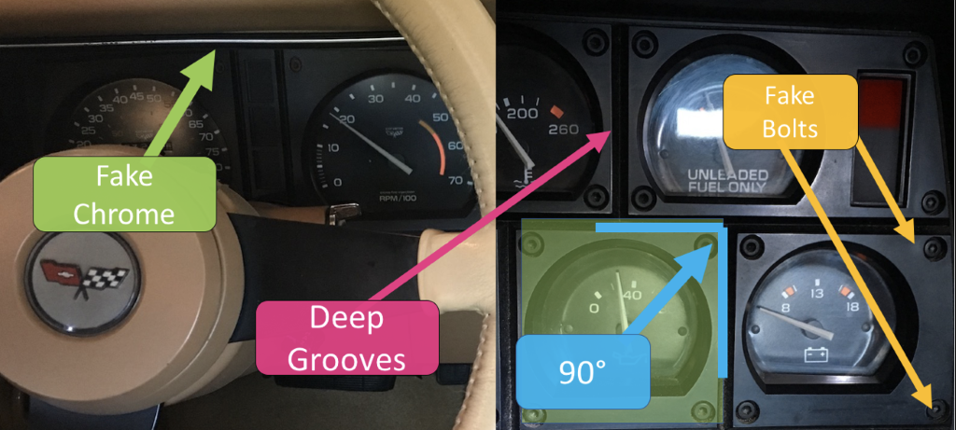

**Figure 4.4.2.a** shows minimalism and hard edges in 1982’ Corvette interior that was a result of material/manufacturing limitations of the era.

Created by Mikey Garrity

Minimalism is not an arbitrary choice, the fiberboard construction proposed cannot be sanded into organic shapes. Even fusing this material can lead to warping. Hard edges with simple angles, i.e. 90 or 45 degrees is essential. In all honesty, the limitations of materials utilized will be fairly similar to the work by engineers in the 1980’s with fiberboard, and brittle plastics. Injection molded plastics were available, the issue was that without computer aids, it was difficult to make modular panels that fit together unless they were simple shapes. One of the goals of the prototype is to be modular enough to be cleaned.

Looking backwards to the minimalistic style of this era is the only route to arriving at a polished device in a prototype situation while retaining modularity. Cost is also obviously a factor. Flat black is inexpensive.

**Wood Textures-** The biggest and perhaps most inevitable change considering the prototype nature of this project is the decision to move away from utilizing natural wood grain. While a wooden veneer is still technically possible, the command center will be getting its structural rigidity from the fiberboard core. The aesthetic impacts are a result of the lack of consistent wood grain in synthetic fiber board. This means that having a natural wood look will be impossible.

**Warm Light-** Due to the technical limitations involved in using incandescent and more analog type hardware the lighting will be less warm and more neon. As the ambient lighting in the command center panels will be taken care of by a few addressable LEDs (separate from signal LEDs) the quality of light will be diminished. Additionally the user interface buttons chosen will have a “phosphorescent glow” to them in neon yellow, neon magenta, and finally neon cyan. To better match the buttons and other elements of the command center the warm lighting planned will be replaced with a crisp cyan light.

**Plastic-** Initially the aesthetic desired would have required significant amounts of glass bezels to cover components. It has been decided that a result of the transition to a more modern aesthetic that transparent plastic can and should supplant glass. Additionally, to smooth certain joints, sand-able epoxy to plastic compounds are being considered. Lastly plastic is desired as opposed to glass because the fiberboard is already very dense and heavy. Any weight savings will be beneficial at this point.

# 16.0 Realistic Design Constraints

Following section outlines the ABET design constraints that we will be following in order to achieve success with our Senior Design project. It includes some key constraints such as Economics, time, social, ethics, safety, sustainability, manufacturability, and many more. These constraints will keep the project within realistic scope. We have discussed how we will be implementing them in our project below.

## 16.1 Economics and Time Constraints

Any project needs proper planning. It is important to set time limits and realistic estimates about project. You do not want to aim too high or too low. Lot of things depends on how much time you have to complete the task, how much knowledge, tools, and resource do you have. These things are really important when you have to pick a project. For example, if you have pick a project that takes three times more time than what you have then spending normal amount of time on that project will not deliver and it will not meet the expectations.

We had several meetings in a week once we found out our Senior Design group, at the suggestion of Dr. Richie. We had so many different ideas about what we wanted to create for our Senior Design project. It was hard to pick one as lot of them were really good ideas and some of them were never done before. We decided to follow some clear guidelines to filter out some ideas and find that fits into our guidelines. We decided to work on something that can be done in given amount of time since we have to deliver it in 12 weeks instead of 16 weeks due to Summer semester. Therefore, time management was our main goal. We wanted to pick something that is feasible. We considered picking something that most of us have some background in that particular area and not something that is completely out of our field of study. We decided to pick something that presents a challenge and gives our group the opportunity to do something that we have never done before while at the same time we have enough foundational knowledge to make it work. The final part of our guideline was the budget of project. Since it was a self-funded project, we also wanted to make sure we do a little research about parts and cost to get a clear idea. Based on these guidelines, we narrowed it down to three ideas. First one was Blind spot detector for older vehicles. Second one was pet door for pet where they can go out from pet door as long as they have tag on their collar unless owner decide to lock the door remotely in certain time of the day. And last one was smart table for restaurant where user can get a quick service and great environment. We decided to remove Blind spot detector due to risk management and ask Dr. Richie for recommendation and finally, we settled on the smart table idea.

For the first few weeks we met on campus after class to discuss the design of the table. We also discussed about what features we should implement on table and if it is possible. For example, we wanted to have a hot plate on table which keeps your food worm, but it was not possible as none of us have knowledge into heat transfer and field of thermal. We talked about sensors and RFID and how we should implement that in our table. We talked about different LEDs, light sensors, and hardware design such as printed circuit board (PCB).

From this point, we divided work among four of us based on prior knowledge and interest. We spent over a week researching different components that we would need a clear idea what we could build ourselves and what we have to buy from market. After researching our components, we found out that our sensors and LED lights are not expensive. Therefore, we decided to purchase LEDs and few sensors from market since none of us have required expertise in designing those components. In addition to that we would have spent just as much money trying to create them ourselves as we would have if we use the amount of money on them. After spending lot of time on components, we agreed to spend around $600 in total for our project since it is not funded by any company. We agreed to split the cost in even with around $150 being contributed from each member of group.

In order to keep spending and purchasing part smooth, we also decided to split the components based on the part of project that individual is working on. That way that member of the group is responsible for researching, purchasing, and working on the component and part of project. And it is also easy to keep track of which member purchased which part. After we felt like we did enough research on components, we ordered them. Once we received them in mail we started meeting in Senior Design Lab in Engineering 1 building, room 456. Reason behind that was based on our guidelines. We thought it would be better to start testing our components once we start receiving them. Which is part of our risk management. Because if we do not test our parts now and wait until next semester then there is a chance something might go wrong. If we wait to test the parts and if they do not work, then we might not have enough time to reorder the parts since most of the manufacturing companies operate overseas and that can lead shipping to get delayed by couple weeks. If that happens then implementing them in project could cause a huge problem if we do not get the parts on time. Therefore, meeting in Senior Design lab serves both purposes.

As of documenting this, the semester is coming to an end soon. So far, we have already ordered most of our parts, so we can do functional tests on each and every single component to confirm their functionality. Not only that, but we have also tested most of our components and so far, they all passed the functional test. At the same time while two of us were working on functional test, rest of the group members started working on hardware side such as designing schematics printed circuit board (PCB) and housing that protects the PCB board and other electronics components since designing the PCB is not an easy process and it can take lot of time. So far, we have divided work evenly amount four of us and only thing we have left is to design and construct the actual table. We decided that we all should work on that together since it is not only one person’s responsibility and that way we can also get done quickly.

## 16.2 Safety, Ethics, and Social

We designed our product with safety as a core value. Using our product should not put anyone at risk. The smart table will have safety measures to ensure that it does not put anyone in danger. We will be using safe practices of Computer and Electrical Engineering to ensure the electronics work minimize the risk to our users. We will be considering a temperature monitor system that can monitor the temperature of the internal components to make sure it does not go above that level. We are also considering a fan inside the box to maintain the normal temperature and for an air movement. If the level hit the certain threshold, the table will act to avoid damage by shutting the system down and display a warning message on the LCD display installed on the left side of table. We are also considering implementing rubber gasket to keep any liquid or dirt out and keep components safe. Having heat pipe can help heat leaves heatsink shown in figure 4.5.2a below. Keeping safety in mind, components will be installed under one box on side of table instead of underneath to maintain safety measurements. That way if the kids are playing around the table, they do not get hurt by components or wires underneath the table.

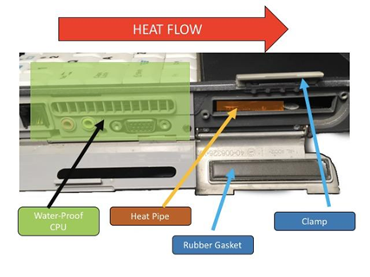

Figure 4.5.2a – Shows how to keep liquid and dirt away using rubber gasket and control heat by implementing heat pipe.

**Ethics –** When it comes to ethics, our product will work as promised. All of the work that has been done in our project is our own except the one is used under the licenses from open source community. We have picked the best components with safety and quality in mind. We have not used cheap parts to resell our product at high cost for personal gain.

**Social –** Our product will benefit the society by meeting user needs of self-actualization. This product should not be modified in a way that it becomes unidentifiable when It comes to social standpoint. At last, it will also help us in our respective fields and help us gain knowledge and experience while helping the users.

## 16.3 Manufacturability, Sustainability, Portability, and Ease of Assembly

Our project currently does not exist in market. It is a great concept since no one has come out with something like this before. Components that we are using such as LEDs and RFID already exists in restaurants and bars but they all are used separately and not under one box. We will be combining the technology that already exists and add them to our table to get unique and seamless experience.

Another good part of our smart table is modularity and portability. We spent lot of time on research and design, so we can come up with something that is also easy to maintain in long term run. For example, it is easy to make something right now without thinking too much about design and maintenance but later down the road if table faces any issues and require repairing or replacing components, then that has to be done easily on your own without damaging other components. And clients can easily upgrade the firmware with minimal efforts. We will be implementing our components in to a secured box on the side of table that way it does not come in customer’s way and all the components stays under the same box. Another advantage of that would portability. By putting all the components together in a box, it can be installed on another table as well without a big hassle. That indirectly also helps when it comes to sanitizing. Because that way cleaning the table will be really easy since they are no wires hanging around the table. We also designed this by keeping safety in mind. There will be kids playing around the table and having wires around the table can be a safety concern. And same goes for food and beverages. If a customer spills a drink on the table, it may damage the components and more importantly it can cause short circuit. Therefore, our goal is to make table electrically isolated. We spent extra time to think about all the elements especially when we want our product to last for long term and continue our production of the system.

We also took shipping into our consideration. Our product is large when it comes to shipping and handling. Therefore, packing and safety of the product is very important. We knew we have to pack our product well since it is fragile because of the material and components we have used inside. That also forced us to make table as simple as possible to assemble and provide clear instructions, so the client can set it up without spending too much time. After all, it is all about customer satisfaction, quality, minimizing cost, and profitability.

## 16.4 Facilities and Equipment

To realize the objectives of the project, various design facilities and equipment will be required. These are enumerated in section below.

**Facilities-** as certain equipment is prohibitively expensive student teams must rely on their institutions to furnish them with many of the tools necessary to complete their projects. Due to their sensitive nature, not to mention awkward form factors, much of this professional grade equipment cannot be moved easily. As such the facilities listed in tables 4.5.4.a will be utilized.

Table 4.5.4.a- Facilities enumerated

|  |  |  |
| --- | --- | --- |
| **Name** | **Location** | **Purpose** |
| UCF Senior Design Lab | UCF EGN 1 456 | Contains professional grade electronic workstation to test designs. |
| UCF ECE PC Lab | UCF EGN 1 274 | Contains computers loaded with necessary software. |
| UCF Communications Lab | UCF EGN 1 468 | Contains equipment to test compliance of communication protocols. |

**Equipment-** Many items have already been purchased by team members for personal use, however some items reside in institutional facilities. Equipment is listed below in table 4.5.4.b.

Table 4.5.4.b- Equipment enumerated

|  |  |
| --- | --- |
| **Equipment** | **Location** |
| Multi-Meter | EGN 456 |
| Oscillator | EGN 456 |
| Function Generator | EGN 456 |
| DC Power Supply | EGN 456 |
| Arduino Uno Dev Board x 2 | Personal |
| Breadboard x 4 | Personal |
| Jumpers x 30 | Personal |
| 5V DC PSU x 2 | Personal |
| Computers with IDE x 4 | Personal, UCF EGN 1 274 |
| Soldering Iron x 2 | Personal, EGN 1 456 |
| Workbench x 4 | Personal, UCF EGN 1 456, 274 |

# 17.0 Standards

This section exists to discuss the relevant standards that apply to the project. Standards dictate how devices should be designed an operate so as to ensure the safety of users.

## 17.1 General Safety Standards

Engineers and designers are never alone in determining the proper safety features of their products, they can rely on a multitude of safety and standards organizations who have catalogued the lessons learned from nearly a century. The major players in this field are: American National Standards Institute, Underwriter’s Laboratories, National Fire Protection Association, and the International Electrotechnical Commission. Together these organizations have authored many documents exceeding thousands of pages. The smart table project will be a device with enclosed/isolated electronics used in a non-hazardous environment. As such the design will have to meet certain standards with regard to undefined behavior, fire hazards, and electrical isolation. Table 4.6.1.a describes the relevant standards applicable.

Table 4.6.1.a- describes safety standards for electronics and wiring.

|  |  |
| --- | --- |
| **Standard** | **Relevance** |
| UL 50 | Dictates norms for enclosed electronics used in non-hazardous locations. This document describes the specifics of isolating components from contact from users. |
| NFPA 70 | Covers virtually every aspect of electrical wiring and components. Was originally conceived to advise designers of the overheating and fire hazards involved in component wiring. Specifically related to the project is the sections concerning the changing impedance values of common conductors due to corrosion over their lifespan. Essentially connections and wiring can overheat when their conductivity leaves their designed specs due to age. |
| IEC 61508 | Relates to functional safety and how to determine when implement failsafe’s in regard to undefined operation. This document is relevant because it recommends active safety measures in addition to the passive measures already in the table design. |

## 17.2 Component Standards

**Coupling Standards-** The project will entail several internal connections and furnish USB ports for battery charging. Table 4.6.2.a describes the relevant standards applicable.

Table 4.6.2.a- description of standards on physical connections.

|  |  |
| --- | --- |
| **Standard** | **Relevance** |
| ANSI C119.6-2011 | Covers the standard electrical connectors/sockets for any systems rated under 600 volts. |
| USB Battery Charging 1.2 Compliance | Covers virtually ever aspect of electrical wiring and components. Was |

**Communication Standards**- in any device that uses radio frequency signals to communicate, even in a short-range capacity there are safety considerations. Additionally, standards have been set out by various organizations to ensure interoperability of devices regardless of manufacturer. Lastly, as many radio frequency signal devices are active devices, standards help to maximize efficiency by homogenizing handshake operations and data passing protocols across manufacturers. Table 4.6.2.b lays out the relevant radio frequency standards.

The smart table project is not intended to broadcast signals beyond its local proximity (less than 50-foot range). Some components may even be passive in nature. Regardless these standards and documents will help in ensuring that the finished project will be safe and use energy as efficiently as possible.

Table 4.6.2.b- description of standards on physical connections.

|  |  |
| --- | --- |
| **Standard** | **Relevance** |
| IEEE 802.15.1 | Covers the physical layer and media access control specifications for Bluetooth devices. This information is helpful in setting up initialization and data sharing in the project. |
| ISO 18000-6C | Related to passive RFID tags used for identification. |
| ICES-003-B | Describes limits and measurement techniques for radio transmission in information technology equipment. |
| FCC-Part15-ClassB | Governs interference in devices that produce and respond to radio frequency signals. |

**Lighting Standards**- The smart table project will be using visible lighting extensively to communicate with servers. Additionally, the prototype will react to ambient light in the visible spectrum. In designing the smart table particular attention has been paid to relevant norms regarding light intensity. Table 4.6.2.c lists and describes the relevant standards associated with visible light.

Table 4.6.2.c- description of standards on physical connections.

|  |  |
| --- | --- |
| **Standard** | **Relevance** |
| IEEE 802.15.7 | Covers many topics relevant to using visible light as a communication medium. This project does not use visible light as a communication medium between components, however this information is helpful in highlighting safety and issues related to visible light. |
| IES LEM-3-13 | This document provides guidelines o lighting intensity in commercial buildings and information about upgrading to newer lighting technology such as LEDs |

# 18.0 Prototyping and Testing

This section is to outline the testing procedures and methodology for each subsystem. The testing procedure of each subsystem will be tailored to test for their specific role in the system. Finally, an overall system test will be presented that incorporates each subsystem and ensures that they will all function properly in conjunction.

## 18.1 Signal Lighting Test Plan:

The relevant capabilities to be tested for lighting elements chosen shall be the following: Illuminate in Red (255, 0, 0), Illuminate in Green (0, 255, 0) Illuminate in Blue (0, 0, 255), measure surface/housing temperature at the middle lighting element in serial array, and an estimate of total wattage. Finally the lighting elements will have to have pass a subjective ascetic test based on appeal in by characteristics such as light intensity and color constancy.

The testing will be done in three phases. First the LED strip purchased will be paired with an Arduino Uno (contains ATmega328P) This first test is nothing more than bread-boarding to verify that the component is functional, and to establish what nominal behavior looks like. Later the strip will be tested again with the custom designed PCB (contains an ATmega328P and additional custom pins). This second test will be the “integration testing”. The last test will be the strip wired into the PCB and mounted to the table. The purpose of the last test is to verify that the part chosen is reliable even when potentially encased.

**Procedure for testing of illumination-** This test will be done on the ATmega328P with the CPU clock pre-scalar set to mode 1 or 16 MHz. Each color will be enabled for about 5 seconds before switching to the next color. The completion of these procedures will consider this test successful.

**Procedure for monitoring temperatures-** As the strip contains 50 individual RGB units, the middle unit # 25 will be tested for temperature spikes. Temperature will be measured by taping unit #25 to a flat thermometer using masking tape. The initial temperature will be recorded. The strip will be then run for twenty minutes and the temperature recorded.

**Procedure for wiring diagram and setup-** the LED strip will be connected to the data pins on the Arduino and later to data pins furnished in our PCB (includes ATmega328P). The development board (Arduino Uno) was run off of USB which provides the needed 5V. As the development board has 5V rails for peripherals it would be convenient to power the LED strip directly. Unfortunately, the board can only power devices less than a half amp, thus the LED strip was powered by an external 5V power supply. To smooth out the power delivered by the inexpensive AC to 5V DC power supply, a 0.1 uF capacitor was added between the ground and the rest of the system as recommended. An overview of the wiring can be seen in figure 17.a bellow.

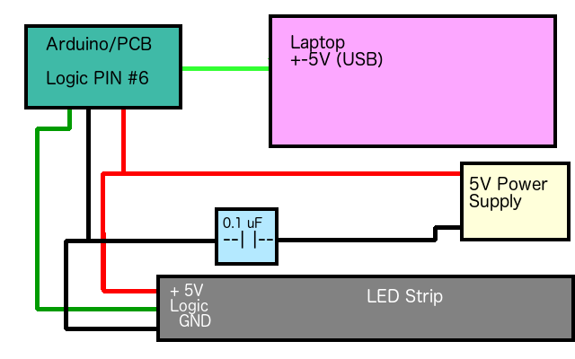

**Figure 17.a**- figure 37.a an overview of the wiring for the LED strip testing.

## 18.2 Signal Lighting Initial Test Results

The initial test results after obtaining the WS2812B LED strip are outlined below. The remaining testing that will be performed on this subsystem will be conducted as during the next phases of this projects development, as outlined in the previous section. The next phases will include lighting element testing after the customer PCB design is in hand, and then again after the full system in constructed during the final integration testing.

**Illumination Results-** The strip was run with a modified equivalent of “Hello World” code made for LED strips. Each of the three colors in the RGB unit was cycled on for about five seconds. RED: PASS GREEN: PASS BLUE: PASS

**Temperatures Results-** In a warm ambient temperature of 25* C the LED strip, power supply, and development board are wired as described above. The temperature of the LED housing at the twenty-fifth unit was recorded before energizing and was found to be 25*C. The LED strip was set to cycle RGB colors. After twenty minutes the LED strip was measured at the twenty-fifth unit to be 26* C. A slight increase of only one degree. Subjectively the LED strip did not feel any warmer after running.

## 18.3 Motion and Light Detection Test Plan:

We have received our Infrared and Photocell sensors, therefore, we decided to test our parts to make sure they are reliable. The sensors will have to pass a subjective ascetic test based on appeal in by characteristics such as motion and illumination detection.

The testing will be done in three phases. In first phase, we will be connecting purchased sensors with an Arduino Uno board which contains an ATmega328P. First phase of testing is very basic since we are only bread-boarding the sensors to verify few things such as components are properly functioning and to observe the normal behavior. Once we successfully finish the first phase of testing and validate the components, we will be going through second phase of testing. We called second phase as “integration testing” since we will be testing the sensors with the custom designed PCB which contains an ATmega328P and few additional custom pins. Once we validate the components in integration testing, we will test them one last time before we start integrating them into our product just to make sure that the parts we have chosen are reliable even when potentially encased.

**Testing of Infrared Sensor –** will be done on the Arduino Uno ATmega328P with delay 2000. Same distance will be measured twice for an accuracy and check for errors.

**Monitoring Distance and time –** As the chosen part can measure up to 80 centimeters, the middle distance will be tested first to check an accuracy. The initial distance with response time will be recorded. Once finding the initial reading, distance will be increased gradually up to 80 centimeters to check for any errors and response time.

**Wiring –** The Sharp infrared distance sensor will be connected to the data pins on the Arduino Uno and later to data pins on customer designed PCB which will include ATmega328P. The testing board (Arduino Uno) was run off of USB which provides the needed 5V for testing. An infrared sensor has connected directly since an Arduino Uno has 5V rails for peripherals. There are three wires attached to the sensor. Black wire is ground, red wire is connected to 5V, and yellow wire is for an output. This sensor transmits different voltages corresponding to the measured distance, therefore, we need an analog input to read the data. We will be using analog A0 since it is using 5V and everything else is ground. An overview of the wiring can be seen in figure 4.a below.

## 18.4 Motion and Light Detection Test Results

**Distance measurement –** The GP2Y0A21YK0F sensor was run with a modified equivalent of “Hello World” code made for the distance measurement. Sensor was tested five times at 20 centimeters of distance.

20 centimeters: Distance detects at 100% accuracy.

40 centimeters: Distance detects at 100% accuracy.

60 centimeters: Distance detects at 100% accuracy.

80 centimeters: Distance detects at 100% accuracy.

100 centimeters: Distance detects at 81% accuracy.

**Response time and output voltage –** Upon testing, it was observed that the GP2Y0A21YK0F output voltage is maximum when the distance is the closest. Average response time to measure the distance was 3 milliseconds. Maximum distance 100 centimeters was measured at 5 milliseconds

**Testing of Photocell (Ambient Light) Sensor –** The GP2Y0A21YK0F will be tested next after successfully testing an infrared sensor. Testing will be performed in same manner as infrared sensor test on an Arduino Uno (containing ATmega328P). Same brightness level will be tested twice to check for an accuracy.

**Monitoring illumination (Lux) –** GP2Y0A21YK0F Testing will be started at low brightness to obtain initial reading. Brightness will be gradually increased until reading start showing an error. This will be done twice to compare result with first test for accuracy and errors.

**Wiring –** The Ambient Light sensor will be connected to the data pins on the Arduino Uno like previous test of an Infrared sensor. There are 3 pins (signal output, ground, and power) on the photocell sensor. Red (pin 3) will be connected to 5V on the board, black will be ground, and blue (pin 1) will be connected to analog A0. An overview of the wiring can be seen in figure 4.a below.

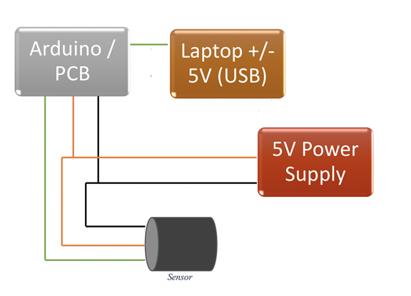

Figure 5.1.2.1 – is an overview of the wiring for the Infrared / ALS sensor testing.

**Illumination –** The DFR0026 sensor was run with a modified equivalent of “Hello World” code made for Photocell sensors to calculate Lux. Same brightness level was tested twice to check the accuracy of reading.

83.00 Lux: PASS

236.00 Lux: PASS

347.00 Lux: PASS

425.00 Lux: PASS

## 18.5 Information Display Test Plan:

The relevant capabilities of the information display that are needed to be tested are as follows: Connection to the MCU, displaying of characters on the LCD, and backlight illumination, power draw measurement. This test plan will ensure that the LCD device that was selected for the project will function properly in a test environment, so that once the device is integrated in the final system design it will function properly. Next, the testing method and procedure will be discussed.

The procedure to test the 2004A LCD module and PCF8574A LCD controller module will now be outlined. The first stage of the testing is to test that the component will function correctly in a breadboard test environment with an Arduino Uno (ATmega328P), which tests the basic functionality of the part. The second phase of the testing will occur once the custom PCB design is finished and has arrived, where the unit will be tested on a bench using the new PCB. The third testing phase ensures that the integration of the component works with the final system, therefore it will be tested in the “command hub” of the final smart table build.

**Procedure for connection to the MCU / Backlight Illumination-** This test will be done using the Arduino Uno (ATmega328P). Connecting the GND, VCC, SDA, and SCL on the PCF8574A LCD controller module pins to the GND, 5-volt rail, A4, and A5 pins on the Arduino Uno respectively. The A4 and A5 pins support the I2C interface that which the PCF8574A communicates with. Once connected the Arduino will be powered up and if the backlight illuminates on the device then we can assure that the device is receiving power. Finally, using the Arduino serial monitor, we will try and run the test code to ensure that the device is transmitting the I2C data to the module.

**Procedure for string printing test-** In this test we will ensure that the LCD screen can properly displays the characters on the screen. To test the functionality, a basic ‘Hello World’ test script will be ran on the Arduino Uno. This script ensures that the LCD function library functions properly. If the expected characters are displayed on the screen, then this test will be considered successful.

**Procedure for typical current draw analysis-** The typical current draw of the LCD screen must be tested before the production of the custom PCB design so that power draw considerations can be determined. The typical current draw of all components has been previously derived from datasheets, however actual current draw measurements using a multimeter are the only way to get completely accurate numbers. A multimeter will be used to measure the current draw of the LCD across the Vcc pin. The results of the test are expected to be in the range of 25milliamps to 30 milliamps with maximum screen brightness based on the LCD and controller logic’s datasheets.

## 18.6 Information Display Initial Test Results

The initial test results after obtaining the 2004LCD and PCF8574 logic control module are outlined below. The remaining testing that will be performed on this subsystem will be conducted as during the next phases of this projects development, as outlined in the previous section. The next phases will include lighting element testing after the customer PCB design is in hand, and then again after the full system in constructed during the final integration testing.

**Results for connection to the MCU / Backlight Illumination-** The LCD was connected per the procedure in the section above. Upon powering up the device the backlight illumination on the LCD module illuminated, therefore per the procedure this test is a success. Backlight illumination levels can be adjusted using the potentiometer that is integrated in the logic controllers circuit on the back of the device.

**Results for printing a string to the LCD and current draw analysis-** Using a basic “Hello World” test script and provided code library the LCD successfully displayed the character string, “Hello World” on the LCD screen. Furthermore, using a multimeter is was found that the average current draw of the LCD screen at full brightness is ~29milliamps. This current is in the range of the expected current draw for the device.

## 18.7 Smart Beverage Detection Test Plan

The relevant capabilities of the Smart Beverage Detection that are needed to be tested are as follows: Connecting the load-cell to the MCU and reading the weight of an object. This test plan will ensure that the smart beverage subsystem that was selected for the project will function properly when integrated into the final system in the restaurant setting. Next, the testing method and procedure will be discussed.

The procedure to test the smart beverage detection subsystem will now be outlined. The major component that this subsystem is comprised of is the load cell module, which includes the AVIA Semiconductor HX711 Analog-to-Digital converter for weight scales. The first stage of testing to ensure that the candidate loadcell component will function correctly in a breadboard test environment with an Arduino Uno (ATmega328P), which tests the basic functionality of the part. The next phase will occur after customer PCB is designed and has arrived, and the final will be during integration at the end of the design phase.

**Testing of load-cell connection to the MCU / Taking a measurement-** This test will be done using the Arduino Uno development board. Connecting the VCC, GND, DT(Data), and SCK, on the HX711 breakout board to the 5V, GND, Digital Pin 7, and Digital Pin 8 respectively we can connect the HX711 to the Arduino. Next, we connect the E+, E-, A-, A+ pins on the HX711 breakout board to the corresponding wires on the strain gauge attached to the aluminum load cell as seen in Figure 4. Once connected the test script is flashed to the Arduino and measurements can begin. By polling the digital pins that the HX711 breakout board was connected to, we will obtain a value for the weight of an object.

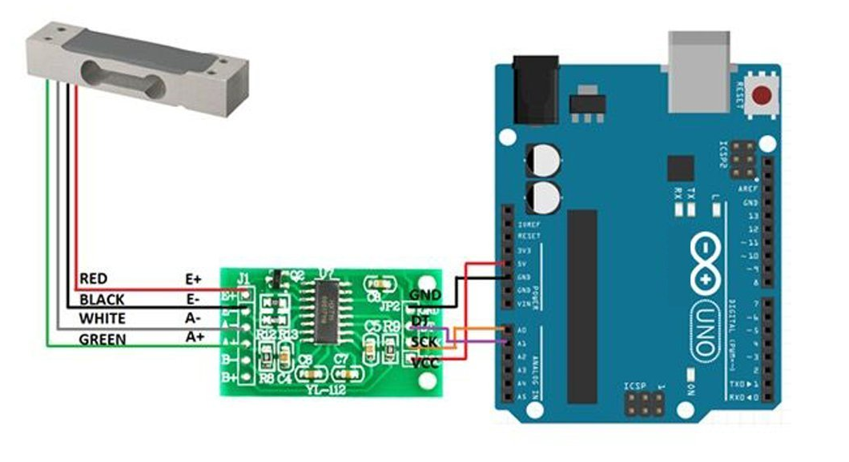

*Figure 5 - Load-cell test setup (Waiting for permission)*

Furthermore, the mounting of the platform that the restaurant pitcher will rest on is needed to be tested to ensure that the platform doesn’t interfere with its measurements. Results of the testing will be taken once the components have arrived that are needed. Further testing will also be conducted that is needed to “zero” the measurements by using an object that has a known weight, which includes the zeroing of the platform.

## 18.8 Waiter Tracker Test Plan:

The relevant capabilities of the Waiter Tracker that are needed to be tested are as follows: Connecting the Bluetooth module to the MCU, sending a AT command to through the Bluetooth module with a mobile application, and testing the current draw. This test plan will ensure that the Waiter Tracker subsystem that was selected for the project will function properly in a test environment, so that once the device is integrated in the final system design it will function properly. Next, the testing method and procedure will be discussed.

The procedure to test the waiter tracker subsystem will now be outlined. The two components that the waiter tracker subsystem is composed of is the HC-05 Bluetooth 2.0 module, and the waiter tracker server mobile application. The first stage of the testing is to test that the component will function correctly in a breadboard test environment with an Arduino Uno (ATmega328P), which tests the basic functionality of the part. The second phase of the testing will occur once the custom PCB design is finished and has arrived, where the unit will be tested on a bench using the new PCB. The third testing phase ensures that the integration of the component works with the final system, therefore it will be tested in the “command hub” of the final smart table build.

**Testing of Bluetooth pairing-** This test will be done using the Arduino Uno (ATmega328P). Connecting the VCC, GND, TXD, and RXD pins of the HC-05, 5-volt rail, GND, RX(0), TX(1) on the Arduino Uno respectively. The RX(0) and TX(1) pins support the digital interface that which the HC-05 communicates with. Once connected the Arduino will be powered up the HC-05 should have a red blinking LED light if it is receiving power. Then, using an Android smartphone we will pair to the Bluetooth module, if this is successful then we can consider the test a success.

**Testing of transmitting Bluetooth AT commands-** In this test we will ensure that the Bluetooth module can be used to transmit the necessary AT commands for the project. This involves the use of a test mobile application that has already been developed. This test mobile application allows the toggling of a LED by use of Bluetooth commands. If the LED can successfully be toggled using the application then the test can be considered a success. As shown in Figure 2 below, the mobile application toggled the LED, demonstrating that this test was successful.

**Testing of typical current draw-** The typical current draw of the HC-05 must be tested before the production of the custom PCB design so that power draw considerations can be determined. Actual current draw measurements using a multimeter are the only way to get completely accurate numbers, therefore a multimeter will be used to measure the current draw of the HC-05 across the Vcc pin.

## 18.9 Waiter Tracker Initial Test Results

The initial test results after obtaining the HC-05 Bluetooth module are outlined below. The remaining testing that will be performed on this subsystem will be conducted as during the next phases of this projects development, as outlined in the previous section. Note that the development of a basic test android application was necessary to complete this testing, which is shown in Figure 5.1.6.a.

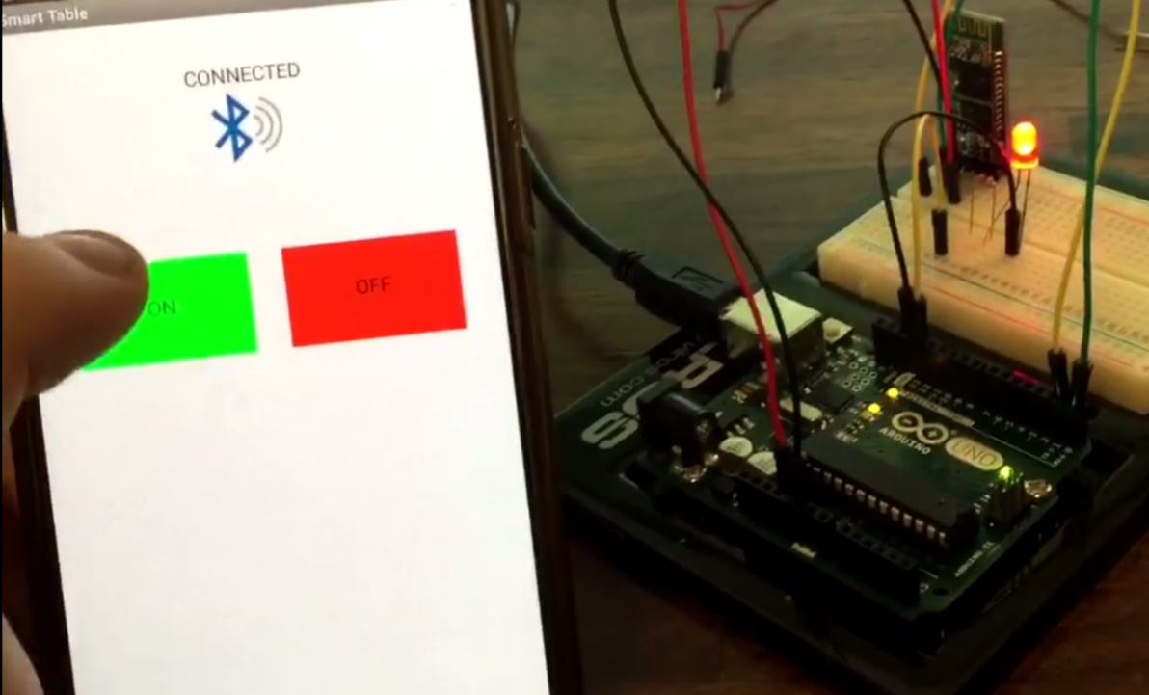

Figure 5.1.6.a: Testing the Waiter Tracker with the mobile application (Created by Christopher Corley)

**Results for the Bluetooth module connecting and pairing-** The HC-05 Bluetooth module was connected per the procedure in the section above. Upon powering up the device the red LED’s on the HC-05 illuminated. Next my Android smartphone was used to connect to the Bluetooth module. Upon connecting the red LED on the module illuminated in a pattern that indicated that we have successfully paired to the device.

**Results for transmitting Bluetooth AT commands and current draw analysis-** Using a basic test mobile application that sent a text string over a AT command to the Arduino, this test was conducted. The LED on the breadboard was illuminated once that ON button in the mobile application was pressed, and the opposite for when the OFF button was pressed. This test ensured that we were able to send commands over Bluetooth in a similar way that will be utilized for the final design. Additionally, current draw analysis was conducted with the following results: ~39milliamps during pairing, ~2milliamps during low power standby mode, and ~22milliamps typical.

## 18.10 Overall System Test

This section will outline the rationale and procedure for performing an overall system test. The purpose of the overall system test is to ensure that every component still functions properly after they have all been connected to the same MCU and PCB. Anomalies may arise that would cause conflicts where some components will not work when tested in conjunction with other. The test plan to accompany this will rely heavily on each subsystem individual testing. The procedure will be outlined in the Table 1.

*Table 2 - Overall System Test Procedure*

|  |  |
| --- | --- |
| **Testing Step** | **Testing Procedure** |
| Step 1 | Ensure that all sensors are connected to the Arduino on individual pins. (photocell, infrared, LCD, loadcell, Bluetooth, and LEDs) |
| Step 2 | Perform the test procedure for the addressable lighting subsystem. |
| Step 3 | Perform the test procedure for the information display subsystem. |
| Step 4 | Perform the test procedure for the smart beverage subsystem. |
| Step 5 | Perform the test procedure for the waiter tracker subsystem. |
| Step 6 | Perform the test procedure for the motion / ambient light subsystem. |
| Step 7 | Run final overall system test script that polls each subsystem's pins in a loop. Test each pin, by using built in polling tool. |

By performing all seven test steps the overall system test can be considered successful. The test script mentioned in the last step is still under development, but its basic subsystem loop is as follows: Change the LCD string, then change the pattern of the LED illumination, print the weight the loadcell detects to the LCD, send a string through Bluetooth AT commands to the Android mobile test application, then ping the photocell and infrared sensors and check for a change in voltage readings. Running this loop continually will perform a full system check for all major subsystems. After integrating the subsystems into the custom printed circuit board, the same test script will be used to perform the test at that phase in development.

# 19.0 Product Operation

Smart table is mainly designed for commercial use with keeping restaurants in mind. Our goal is to make a smart device with advance technology that can be implemented into any surface or table and it will make that table a smart table. Installation of the device is very simple, but it would require safe use of appropriate tools.

## 19.1 Safety Precautions

Overall, the smart table is a safe device to use in restaurants environment with certain applications but to ensure safe practice, read the following safety precaution before connecting to power source and start using the device.

1. Keep the device away from any form of liquid to prevent physical damage of the equipment.
2. Unplug and do not turn on the device if device comes in contact with any form of liquid.
3. Ensure that all wires are covered by insulation and no wires are exposed to elements to prevent electrical shock.
4. Do not use bleach or any other liquid to clean the area around the control center.
5. Do not spray directly on the control center to remove any hard stains.
6. Use microfiber cloth to clean the LCD display and touch capacitive buttons.
7. If the device needs to be opened, check the power is disconnected and wait few minutes to discharge electricity before opening the device.
8. Do not wear jewelry when coming in contact to device and use safety gloves before operating any electrical components.

## 19.2 Using the Smart Table

The device follows routine set of instructions to provide convenient and pleasant service in timely manner. For better results, please follow the guidelines as these guidelines have been tested for best performance:

1. Before using the device, ensure the hands are not wet to prevent any electrical shock.
2. Read safety precautions provided above to minimize any risk and injuries associated with use of the product.
3. To turn on the device, first plug in all the cables coming out of the electrical enclosure to power outlet and device will turn on its own.
4. Once the device turns on, it will display welcome message on the LCD display and prompts to connect with the smart phone to use extra features.
5. Go to device settings on the smart phone and turn on Bluetooth feature so the built in Bluetooth module on table can communicate with the smart phone.
6. Smart phone should discover the smart table Bluetooth device in few seconds once it is turned on.
7. Tap on the appropriate Bluetooth device that you are trying to connect with your phone to ensure that connection between phone and table has been established.
8. Once the phone successfully pairs with the table, search for “Smart Table” application in the app store on your Android device and install the application.
9. After successfully installing the application, open the application. Application will detect the table automatically from the connected Bluetooth device.
10. Now the device is ready to receive notifications from the table.
11. Once table detects any motion around the table using infrared sensors, it will automatically turn the lights on. It will adjust the brightness of LEDs based on the brightness around using the built in Ambient Light Sensors.
12. There are two touch capacitive buttons and LCD display is located on the left side of the command center in case of assistants and any updates.
13. If the pitcher on table is about to get emptied, the built-in pitcher sensor on table detects that and it will prompt a massage on the LCD display if another pitcher is needed.
14. In this case, customer has an option to press a red button to cancel the request or pressing green button will notify the server on the smart phone application for an assistant and LED lights under the rim turns to red until server completes the request.
15. Customer also has an option to call server by pressing the red button for any reason without waiting for the pitcher to get emptied.
16. To use a wireless charging feature, simply place the compatible smart phone on the charging mat and it will start charging the device.
17. Built in smart speaker on the table can play any songs from your phone by your smart phone or asking, “Hey Google, play XYZ song” and it will use the restaurant WIFI to fulfil the request.
18. To turn off the device, disconnect the Bluetooth connection from the smart phone and unplug the power cable from the outlet.
19. Place device at room temperature in dry storage.

## 19.3 Troubleshooting Tips

If user requires assistance in using smart table, Table 1 below can be utilized in diagnosing and troubleshooting the device to resolve the issue. This table outlines the most common issues that a user may encounter.

Table 1 – Troubshooting

|  |  |
| --- | --- |
| **Issue** | **Solution** |
| **The device does not power on.** | * Ensure there are no loose cables and power cable is properly connected to the power outlet. * Check for any liquid damage around the electrical enclosure. * Ensure there is current coming out of the power outlet by plugging the device to different outlet. |
| **The device is not sending notifications to smart phone.** | * Ensure there is a Bluetooth device connected with the smart table. * Turn off the Bluetooth feature on phone and turn it back on. * Check if the smart phone is connected to WIFI. * Check if the smart phone has “Smart Table” application installed. * Unpair and repair the smart table Bluetooth device from the smart phone. |
| **The LED lights around the table is not functioning.** | * Ensure the LED lights are connected to the power source. * Check to see if there are any obstacles in front of Infrared and Ambient Light Sensors. * Disconnect the table from the power source and reconnect it to power source for reset. |
| **The smart speaker is not playing music.** | * Ensure the speaker is connected to power source. * Check if the device user is trying to play music from has Bluetooth connectivity. * Check to see if there is successful connection between the source phone and speaker. * Ensure the headphone jack is plugged in to speaker and device if playing through wired connection. |

# 20.0 Administrative Content

This administrator content section will outline three aspects that are important the success of the project. The first aspect is the finances and budget, which will outline the cost breakdown of the project and discuss why our budget is important to the project. The second aspect is the milestone chart and project timeline, which is important because it will drive the progress of the development and is needed to help us stay on track to meet project deadlines. The third aspect is the personnel section which will describe each of the four group members and their particular roles in the development of the smart table.

## 20.1 Finances and Budget

The finances and budget of the smart table project will be discussed in this section. The smart table will be designed according to the idea that this product would be eventually distributed to restaurants for mass sale, therefore keeping the unit cost low is extremely important. In regard to the cost of components, prices listed are slightly higher than actual prices. This is to account for price fluctuations and to provide a financial buffer for any inadvertent circumstances. Additionally, this project was not sponsored by anyone therefore we are self-funded. Affordability during development and because we are paying for our own components we need to ensure that the smart table is not over an agreed maximum budget of $150 per group member for a total of $600 combined.

As seen in table 1, the bill of materials was taken and priced out so that the total cost of a single smart table unit could be determined. The total cost is $130.16, that does not include tax or shipping, or the cost of the custom printed circuit board. By adding an additional 20% to the original total cost for an estimate of shipping and tax, the total estimated cost is $156.19. This total cost is uses roughly a quarter of the total budget of $600. Furthermore, the cost of development parts and the physical table the smart device will be placed on will be calculated next.

*Table 3 – Price of Materials of Command Center*

|  |  |  |  |
| --- | --- | --- | --- |
| **Description** | **Qty** | **Price** | **Total** |
| Capacitor SMD/SMT 16V 20pF 5% | 2 | $0.29 | $0.58 |
| Capacitor SMD/SMT 47pF 10% 25V | 2 | $0.24 | $0.48 |
| Capacitor SMD/SMT 8200pF 25v 20% | 2 | $0.10 | $0.20 |
| Capacitor SMD/SMT100000pF 10% 25V | 25 | $0.04 | $1.00 |
| Capacitor SMD/SMT 1uF 20% 25V | 2 | $0.09 | $0.18 |
| Capacitor SMD/SMT 10uF 16V 20% | 12 | $0.18 | $2.16 |
| Capacitor SMD/SMT 22uF 16v | 12 | $0.45 | $5.40 |
| LED - SMD RED WATER CLEAR | 4 | $0.13 | $0.52 |
| LED - SMD GREEN WATER CLEAR | 4 | $0.14 | $0.56 |
| LED - SMD YELLOW WATER CLEAR | 4 | $0.13 | $0.52 |
| LED - SMD WHITE WATER CLEAR | 4 | $0.17 | $0.68 |
| SCHOTTKY RECT 40V 2A | 4 | $0.38 | $1.52 |
| Resettable Fuses - 6V 0.5A SMD | 4 | $0.30 | $1.20 |
| MOSFET FET 50V 3.5 OHM SOT23 | 4 | $0.22 | $0.88 |
| MOSFET 1.2V Drive Pch MOSFET | 2 | $0.22 | $0.44 |
| Current Sense Resistors - SMD 0.1 Ohm 5% 1W | 2 | $0.58 | $1.16 |
| Thick Film Resistors - SMD 27ohm 5% | 2 | $0.10 | $0.20 |
| Thick Film Resistors - SMD 100 ohm 1% 200V | 2 | $0.10 | $0.20 |
| Thick Film Resistors - SMD 220 ohm 5% 75V | 2 | $0.01 | $0.02 |
| Thick Film Resistors - SMD 330 ohm 5% 75V | 2 | $0.01 | $0.02 |
| Thick Film Resistors - SMD 330 ohm 5% 75V | 2 | $0.71 | $1.42 |
| Thick Film Resistors - SMD 1/16watt 1Kohms | 14 | $0.10 | $1.40 |
| Thick Film Resistors - SMD 2K ohm 5% 75V | 2 | $0.01 | $0.02 |
| Thick Film Resistors - SMD 1/10watt 8.2Kohms 5% | 2 | $0.10 | $0.20 |
| Thick Film Resistors - SMD 1/16watt 10Kohms 1% | 20 | $0.10 | $2.00 |
| Thick Film Resistors - SMD 33.2K ohm 1% 50V | 1 | $0.01 | $0.01 |
| Thick Film Resistors - SMD 54.9K ohm 1% 75V | 1 | $0.01 | $0.01 |
| Thick Film Resistors - SMD 0402 100Kohms 5% | 10 | $0.02 | $0.20 |
| Thick Film Resistors - SMD 1M OHM 5% | 10 | $0.10 | $1.00 |
| Trimmer Resistors - SMD 10KOHMS 25% 0.1 WATT | 2 | $0.26 | $0.52 |
| MCU 256kB Flash 4kB EEPROM 86 I/O Pins | 1 | $14.22 | $14.22 |
| 6.4ft WS2812B Individually Addressable LED Strip | 1 | $0.40 | $0.40 |
| LCD - 20x4 White Characters on Blue Background | 1 | $10.00 | $10.00 |
| Switching Voltage Regulators 17 V Input, 2A | 2 | $1.55 | $3.10 |
| Capacitive Touch One-Channel Touch Sensor IC | 5 | $0.60 | $3.00 |
| Weighing Sensor 24-bit | 1 | $0.25 | $0.25 |
| SMD Bluetooth 2.0 EDR | 1 | $4.00 | $4.00 |
| Dual OpAmp | 2 | $0.36 | $0.72 |
| Current Shunt Mntr Crnt Otp | 2 | $2.22 | $4.44 |
| USB Interface IC USB to Full Serial UART IC | 1 | $2.12 | $2.12 |
| Crystals 16MHz 20pF 0C 50C | 1 | $0.24 | $0.24 |
| Photodiodes 60V 215mW 950nm | 1 | $1.03 | $1.03 |
| Standard LEDs - Through Hole Blue Round LED | 2 | $0.21 | $0.42 |
| Audio Buzzer 12.2mmx6.5mm 4kHz Vin=3V | 1 | $0.72 | $0.72 |
| MDF Sheet 4'x8' | 1 | 24.25 | $24.25 |
| Fine Threaded DrywallScrews | 12 | $0.53 | $6.36 |
| Elmer Carpenter Glue | 1 | $3.34 | $3.34 |
| KILZ Spray Primer | 1 | $5.98 | $5.98 |
| Rustoleum Clear Coat | 1 | $3.87 | $3.87 |
| Rustoleum Spray Paint - White | 1 | $2.67 | $2.67 |
| Alex Plus Silicon Caulk | 1 | $2.38 | $2.38 |
| Everbit Rubber Feet | 4 | $0.64 | $2.56 |
| Power Adapter 12V, 5A max, 60w max | 1 | $9.59 | $9.59 |
| **SUBTOTAL** |  |  | **$130.36** |
| **TOTAL (SUBTOTAL +20% for shipping and tax):** |  |  | **$156.43** |

As seen in Table 2, the additional costs associated with development, testing, prototyping, and other materials in outlined. Before the custom PCB was designed the need for each group member to have an Arduino development board was necessary. Later the electrical design changed for the PCB and thus four more ATmega2560 Arduino boards were needed to be purchased. The largest item on the list is the budget for a custom-built table that will showcase the smart tables features in the best manner was added to the list. The rest of the items on the list include breadboard friendly test modules that could test each subsystem.

*Table 4 - Price of prototype, development, testing, and other materials*

|  |  |  |  |
| --- | --- | --- | --- |
| **Description** | **Qty** | **Price** | **Total** |
| Non-Command Center Table Construction Budget | 1 | $150.00 | $150.00 |
| ATmega328 Arduino Development Boards | 4 | $12.19 | $48.76 |
| ATmega2560 Arduino Development Boards | 4 | $14.68 | $58.72 |
| LED Lights Test Module | 1 | $27.99 | $27.99 |
| Loadcell Test Module | 1 | $12.14 | $12.14 |
| Photocell Test Module | 1 | $11.11 | $11.11 |
| Infrared Sensor Test Module | 2 | $6.41 | $12.82 |
| RFID Test Module | 1 | $3.57 | $3.57 |
| Bluetooth Test Module | 1 | $9.67 | $9.67 |
| Speakers/Audio Components | 1 | $0.00 | $0.00 |
| Restaurant Drink Pitcher | 1 | $7.22 | $7.22 |
| **SUBTOTAL** |  |  | **$342.00** |
| **TOTAL (SUBTOTAL +20% for shipping and tax):** |  |  | **$410.40** |

To ensure that all budget and financial goals are met the final cost breakdown for the entire project is shown in Table 3. By combining the cost for the parts listed in Table 1 and Table 2, the total cost of the entire project was calculated as $566.83. When taking this total and subtracting it from the budget we are left with +$33.17, which means that the goals for the finance and budget have been met. This however does not calculate unpredictable financial costs and may mean that these totals will likely change.

*Table 5 – Total Cost Breakdown of Entire Project*

|  |  |  |  |  |  |  |
| --- | --- | --- | --- | --- | --- | --- |
| Price of Materials of Command Center | | | | | | **$156.43** |
| Price of prototype, development, testing, and other materials | | | | | | **$410.40** |
|  |  |  |  |  |  |  |
| BUDGET FOR ENTIRE PROJECT | | | | | | **$600** |
| TOTAL PRICE OF ENTIRE PROJECT | | | | | | **$566.83** |
| BUDGET MINUS COST: | | | | | | **$33.17** |

## 20.2 Milestones

This section will outline the major timeline and milestones for the smart table project. As seen in Table 4, the milestones have been presented for the duration of senior design 1 and senior design 2. Senior design 1’s milestones show that everything has been completed except for the final document submission. The milestones are reflective of the syllabus and are not necessarily representative of the progress of our development of the project in entirety. The senior design 2 portion of the table has many dates that have yet to be determined (TBD). This is because the set dates for those have not yet been made available, therefore this milestone table will be updated when they are available. By strictly meeting the deadlines for the milestones will ensure a successful project.

*Table 6 - Milestones*

|  |  |  |  |  |
| --- | --- | --- | --- | --- |
| Task Number | Task | Start | End | Status |
| **SENIOR DESIGN 1** | | | | |
| 1 | Ideas | 1/10/2018 | 1/20/2018 | Complete |
| 2 | Project Selection | 1/20/2018 | 1/25/2018 | Complete |
| 3 | Initial Document | 1/20/2018 | 1/28/2018 | Complete |
| 4 | Table of Contents | 2/10/2018 | 3/20/2018 | Complete |
| 5 | First Draft (60 Pages) | 3/20/2018 | 4/9/2018 | Complete |
| 6 | Final Document | 4/10/2018 | 4/27/2018 | In Progress |
| **SENIOR DESIGN 2** | | | | |
| 8 | Critial Design Review | TBD | TBD | Not Started |
| 9 | Custom PCB Integration | 5/14/2018 | 4/30/2018 | Not Started |
| 10 | Finish Design | 4/20/2018 | 7/30/2018 | Not Started |
| 11 | Peer Report | TBD | TBD | Not Started |
| 12 | Final Documentation | TBD | TBD | Not Started |
| 13 | Final Presentation | TBD | TBD | Not Started |

## 20.3 Personnel Overview

This section will outline the members of the smart table team. The four members of the group are Christopher Corley, Theodore Cox, Dhaval Desai, and Mikey Garrity. Each member’s background will be discussed as well as their major role within the project. The members of the group will be presented alphabetically, starting with Christopher Corley.

Christopher Corley is a computer engineering student at the University of Central Florida, with an expected graduation date of summer 2018. Christopher’s background with embedded electronics, computer programming, circuit analysis, and systems engineering make him a value asset to the team. His focus in regard to the smart table design is the development of the mobile application, information display design, and Bluetooth integration to provide the waiter tracker capabilities. In addition to the technical design he will be assisting in preparing the necessary documentation and working to meet project deliverable goals.

Mikey Garrity is a graduating computer engineer at the University of Central Florida. Graduating in summer 2018 with interest in pursuing a career in simulation. Mikey's skill set includes working with complicated state machines such as those found in game engines along with more hardware oriented skills such as circuit diagnostics. Mikey also has interests in the human psychology related to computer graphics and human vision. In this project Mikey's focus will be getting the smart table to communicate with servers through visual means. In particular, an emphasis will be placed on implementing the signal lighting subsystem, and overall software logic. In addition to the technical issues, Mikey will be responsible for crafting the look and feel of the table, and associated housings.

# 21.0 Project Summary and Conclusion

The smart table project was chosen because it could positively impact the dining experiences of nearly every restaurant goer worldwide. The design and development process of this project has been challenging at times, however due to a strong team we have put together a very robust system. This design process has given the team a very good opportunity to apply the skills that we as students have been studying in our college curriculum.

Using the research and work that we compiled we designed a system that will integrate a very nice set of features for the restaurant setting. By using an array of sensors, the guests at a restaurant will have, at their fingertips, a way to call their server remotely, enjoy lighting effects to suit their desires, be prompted when their beverages are empty, charge their smartphone devices, be greeted upon arrival, automatic ambient lighting, and more. While this design provides many benefits for the guest, this project also provides features that makes the life of a server much easier as well by the use of the mobile smartphone application. The design idea for the project was inspired by a group member who had dreamed of a system like this during their time as a server, therefore this insight was leveraged in every aspect of the design.

The smart table team has leveraged their personal strengths to design a sound design. Each of the members did their best to split the work load that that no one member was pulling more weight than the other. An interesting dynamic that has strengthened this project is that every member of the group is majoring in computer engineering. This means that we all have a wide breadth of knowledge from programming to electrical design. One member in particular has vast experience in PCB design as well, which fulfilled the primary role of an electrical engineering major in the group. Our teams experience is important to the success of the smart table project

All things considered, we feel confident as a team that this project will be successful and that this has potential to make its way into the restaurant realm to make a positive impact. As we move closer the completion date the smart table with continue to mature and reach a state where the product is ready to produce some meaningful results.

# 22.0 Appendices

This appendix section is comprised of two sections. The first section is the references, where each citation that was used in the body of this document is listed. The second section contains copyright permission that have been obtained to ensure that we have permission to use any images that were gathered from external sources.

## 23 References

[1] “Wi-Fi.” *Wikipedia*, Wikimedia Foundation, 23 Apr. 2018, en.wikipedia.org/wiki/Wi-Fi.

[2] Lendino, Jamie. “What Is 802.11ac Wi-Fi, and How Much Faster than 802.11n Is It?”*ExtremeTech*, 24 Aug. 2016, [www.extremetech.com/computing/160837-what-is-802-11ac-and-how-much-faster-than-802-11n-is-it](http://www.extremetech.com/computing/160837-what-is-802-11ac-and-how-much-faster-than-802-11n-is-it).

[3] Vogler, Elise. “Bluetooth vs. Wi-Fi Power Consumption.” *It Still Works*, 13 Apr. 2017, itstillworks.com/bluetooth-vs-wifi-power-consumption-17630.html.

[4] “ESP8266EX Datasheet.” Feb. 2018, [www.espressif.com/sites/default/files/documentation/0a-esp8266ex_datasheet_en.pdf](http://www.espressif.com/sites/default/files/documentation/0a-esp8266ex_datasheet_en.pdf).

[5] “Bluetooth.” *Wikipedia*, Wikimedia Foundation, 24 Apr. 2018, en.wikipedia.org/wiki/Bluetooth.

[6] Peshin, Akash. “What Is The Range of Bluetooth And How Can It Be Extended?” *Science ABC*, Science ABC, 10 Jan. 2018, [www.scienceabc.com/innovation/what-is-the-range-of-bluetooth-and-how-can-it-be-extended.html](http://www.scienceabc.com/innovation/what-is-the-range-of-bluetooth-and-how-can-it-be-extended.html).

[7] “BC417143B-IQN-E4 Datasheet.” July 2005, cdn.sparkfun.com/datasheets/Wireless/Bluetooth/CSR-BC417-datasheet.pdf.

[8] “Radio-Frequency Identification.” *Wikipedia*, Wikimedia Foundation, 16 Apr. 2018, en.wikipedia.org/wiki/Radio-frequency_identification.

[9] “RFID and Interference - The Risks of Interference.” *CoreRFID*, [www.corerfid.com/rfid-technology/technology-issues/rfid-and-interference/](http://www.corerfid.com/rfid-technology/technology-issues/rfid-and-interference/).

[10] “MFRC522 Datasheet.” 27 Apr. 2016, [www.nxp.com/docs/en/data-sheet/MFRC522.pdf](http://www.nxp.com/docs/en/data-sheet/MFRC522.pdf).

[11] “Five Advantages of Wooden Furniture.” *Make It Wood*, makeitwood.org/articles/woodenfurniture.cfm.

[12] “The Pros and Cons of Metal Furniture.” *HOG Furniture*, 18 May 2017, hogfurniture.com.ng/blogs/news/the-pros-and-cons-of-metal-furniture.

[13] “App Inventor for Android.” *Wikipedia*, Wikimedia Foundation, 23 Apr. 2018, en.wikipedia.org/wiki/App_Inventor_for_Android.

[14] “Seating Expert, Inc.” *Restaurant Furniture from The Seating Expert*, www.seatingexpert.com/help_design.asp.

## 24 Copyright Permission

